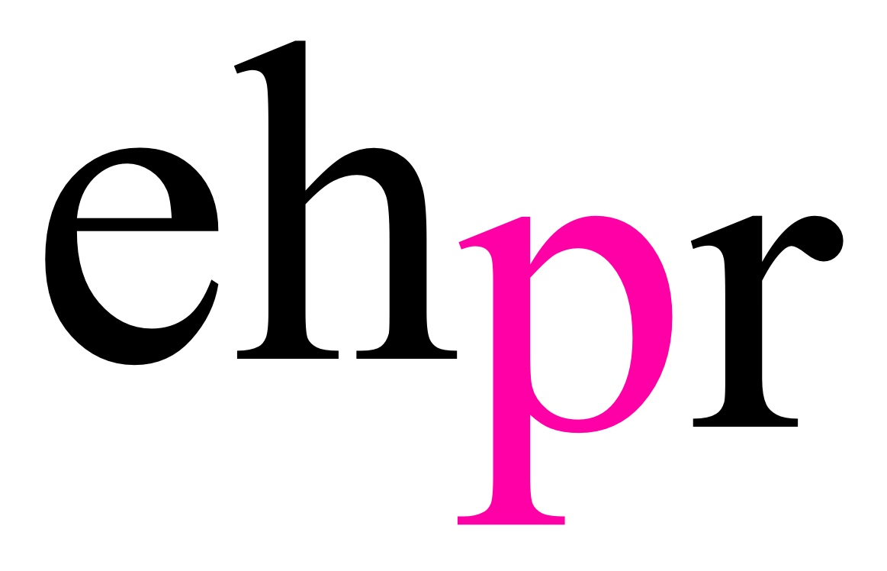
THE SMASH HIT MUSICAL INSPIRED BY THE LIFE OF
GLAM ROCK LEGEND MARC BOLAN

20TH CENTURY BOY

RETURNS TO THE STAGE TO MARK THE 40TH ANNIVERSARY OF THE ICONIC STAR’S UNTIMELY DEATH

FEATURING OLIVIER AWARD-WINNING WEST END STAR GEORGE MAGUIRE

ON NATIONAL TOUR FROM 8 MARCH 2018

“A glorious colourful evening which had the audience on its feet and dancing in the aisles” Evening Star

“Definitely West End worthy” – What’s On Stage

“A visual, aural and multimedia feast!” – The Stage

The hit musical inspired by the life of rock legend Marc Bolan, 20th Century Boy, returns to the stage on a UK-wide tour to mark the 40th anniversary of the iconic star’s untimely death. Opening on 8 March at G-Live in Guildford, the production will enjoy a 20-week tour, visiting 27 theatres through to Saturday 30 June.

Following critical acclaim for his portrayal of Marc Bolan in the show’s highly successful runs at the New Wolsey Theatre, Ipswich in 2011 and the Belgrade Theatre, Coventry in 2012, Olivier Award winning West End star George Maguire (Sunny Afternoon) returns to lead the cast of 20th Century Boy.

The producers said: “We are delighted to welcome George Maguire back to the role of Marc. George has been involved with the show from the early workshop stages and has an incredibly close connection with the material.”

Featuring a new script by Nicky Graham and Colin Giffin, the production is directed by John Maher, and features more than 20 classic Bolan hits. 20th Century Boy is produced by Great Brit Productions.

20th Century Boy tells the life story of the legendary Bolan and his band T.Rex, exposing some of the myths and taking the audience on a tearful yet feel-good journey through Marc’s fascinating life which was cut short by a cruel twist of fate.

At his peak, Bolan was arguably the biggest rock star the UK had ever seen. Rocker, poet, electric warrior, king of glam and godfather of punk – Marc Bolan became a superstar and the press dubbed him “Bigger than the Beatles”. Before his tragic death in 1977, a few days short of his 30th birthday, Bolan lived life at breakneck speed, creating a series of iconic images, a string of number one hits and an army of obsessive fans. 20th Century Boy is a glorious celebration of glam rock at its colourful best!

Showcasing some of the greatest rock songs ever written, 20th Century Boy features many of Marc Bolan and T.Rex’s best-known iconic hits, including Get It On, Ride a White Swan, Metal Guru, I Love to Boogie, 20th Century Boy and many more of their 70s classics.

NOTES TO EDITORS

George Maguire (Marc Bolan) trained at The Italia Conti Academy of Theatre Arts. In 2015 he received the Lawrence Olivier Award for Best Actor in a Supporting Role for his portrayal of Dave Davies in Sunny Afternoon at the Harold Pinter Theatre. George’s other stage credits include Lift at Soho Theatre, 20th Century Boy at the Belgrade Theatre, Coventry and New Wolsey, Ipswich, Hair in Munich, Thrill Me at the Charing Cross Theatre, Fame at the Shaftesbury Theatre, Bank at the King’s Head Theatre, Rent on European Tour, Tonight’s the Night on UK Tour, The Gate Escape on UK Tour, Sixteen on UK Tour, Quadrophenia at the Nuffield Theatre and Oliver at the London Palladium. George’s screen credits include Spiderhole, Boogeyman III, EastEnders, Prime Suspect, BORGIA, Terror & Utopia, Mysti, Crossroads, Rewind, Strange and Killer Net.

John Maher (Director) is a native of Sydney, Australia and since relocating to London he has been director and/or musical director of many hit music shows including Thriller Live, We Will Rock You, Let It Be and Million Dollar Quartet. John is delighted to return to 20th Century Boy having been musical supervisor of the two previous productions.

John has been the Musical Supervisor and Head Arranger of Thriller Live since its first production in 2007. He is the Musical Director of the show in London and has overseen all its UK, European, Asian, South American, Australasian and African tours. John is also the Director and Musical Supervisor of the smash hit Beatles show, Let It Be, which has played in London, Broadway, Europe, Asia, North America & New Zealand. John has worked with Ladysmith Black Mambazo, Macy Gray, Tommy Emmanuel, and is the Musical Director for the legendary band Dr Hook. John was the UK Musical Supervisor of Million Dollar Quartet in the West End and supervised its 2016-17 national tour.

John completed a music degree at the NSW Conservatorium, going on to become one of the busiest and most successful Musical Directors in Australia. He was MD of RENT, The Rocky Horror Show (8 productions, so far), Return To The Forbidden Planet, Oh! What A Night, The Complete Millennium Musical, Chair In The Landscape, Lipstick Dreams, Songs From Side Show Alley, Pizza Live On Stage, Who Let The Wogs Out?, Long Gone Lonesome Cowgirls, Virtual Unreality, Ricordi, and many others.

Since moving to London in 2002, John has been MD of Dancing In The Streets (West End, European Tour & UK Tour), Hedwig And The Angry Inch, The Next Big Thing, Departure Lounge, Grease, RENT (again!), Rocky Horror (again!!), Jesus Christ Superstar (Scandinavia), What A Swell Party (Cyprus) and on the cult hit Dude, Where’s My Teddy? (Wimbledon and Edinburgh). John was one of the regular conductors of the Queen musical, We Will Rock You, in London for several years. In 2008, John was the MD of the Dream On concert at the London Palladium and of the world premiere season of Can’t Smile Without You.

Other work in the UK and Europe includes Godspell, Fame and Evita (Lebanon), as well as numerous concerts. He played keyboards and guitar with The Guild Of Thieves (13 piece soul band) and was the guitarist for some time with legendary band, The Drifters. He has played acoustic guitar with many singer/songwriters, including his dear friend Kristina Lao.

John also composes music for stage and film. He worked for several years with Australia’s Bell Shakespeare Co. A particular highlight was his score for Steven Berkoff’s acclaimed production of Coriolanus. Other scores for Bell included Much Ado About Nothing, The Tempest, and A Midsummer Night’s Dream. John also appeared as a live musician in Bell’s productions of Twelfth Night and Pericles. Other music for theatre includes Death And Taxes (by Andrew Upton), Ashes To Ashes, Paradise, Animalia, Telling Tales, Then The Mountain Comes, Faust’s House, Eat Cake, Jingle Belrose and the ballet scores, Of Dust And Men and Thermoplyae Revisited. John arranged and conducted the strings for the animated feature film Snow White: The Sequel (narrated by Stephen Fry). He has composed music for many short films, including Jacko, The Bill, Putting Kids First, The Other Half, Trattoria Paradiso, ’98, and Love, Mickey.

John’s directing credits include Angry Penguins, Up The Shops, Meet You At The Mona Lisa and Long Gone Lonesome Cowgirls. In the UK and Europe he has directed Jesus Christ Superstar, Departure Lounge, Hedwig And The Angry Inch, and Unzipped – The Ultimate Package Musical.

20TH CENTURY BOY

MUSIC & LYRICS BY MARC BOLAN
BOOK BY NICKY GRAHAM & COLIN GIFFIN
DIRECTED BY JOHN MAHER
UK TOUR
8 MARCH – 30 JUNE 2018

FOR FULL TOURING SCHEDULE, PERFORMANCE TIMES AND TICKET PRICES:
www.20thcenturyboythemusical.co.uk

On Facebook, Twitter and Instagram search '20th Century Boy, The Musical'.

G Live – GUILDFORD
8 – 10 March
www.glive.co.uk

The Grand Theatre – BLACKPOOL
13 – 17 March
www.blackpoolgrand.co.uk

Buxton Opera House – BUXTON
19 – 21 March
www.buxtonoperahouse.org.uk

Churchill Theatre – BROMLEY
22 – 24 March
www.churchilltheatre.co.uk

Cast – DONCASTER
27-29 March
www.castindoncaster.com

The Lighthouse – POOLE
30 March
www.lighthousepoole.co.uk

Octagon Theatre – YEOVIL
31 March
www.octagon-theatre.co.uk

Forum Theatre – BILLINGHAM
3 – 7 April
www.forumtheatrebillingham.co.uk

Forum Theatre – MALVERN
10 – 12 April
www.malvern-theatres.co.uk/forum-theatre

Winding Wheel – CHESTERFIELD
13 – 15 April
www.chesterfieldtheatres.co.uk

Opera House – MANCHESTER
17 – 21 April
www.atgtickets.com/venues/opera-house-manchester

Kings Theatre – PORTSMOUTH
23 – 25 April
www.kingsportsmouth.co.uk

The Hexagon – READING
26 – 28 April
www.readingarts.com/hexagon

Alhambra Theatre – BRADFORD
1 – 5 May
www.bradford-theatres.co.uk/venues/the-alhambra-theatre

Rose Theatre – KINGSTON
9 – 12 May
www.rosetheatrekingston.org

The Hawth – CRAWLEY
14 – 16 May
www.parkwoodtheatres.co.uk/The-Hawth

The Alban Arena – ST ALBANS
17 – 20 May
www.alban-arena.co.uk

Theatre Royal – NOTTINGHAM
22 – 26 May
www.trch.co.uk

Charter Theatre – PRESTON
28 – 30 May
www.prestonguildhall.co.uk

New Theatre Royal – LINCOLN
31 May – 2 June
www.newtheatreroyallincoln.co.uk

King’s Theatre – GLASGOW
4 – 6 June
www.atgtickets.com/venues/kings-theatre

Sands Theatre – CARLISLE
7 – 9 June
www.thesandscentre.co.uk

Orchard Theatre – DARTFORD
11 – 13 June
www.orchardtheatre.co.uk

Venue Cymru – LLANDUDNO
14 – 16 June
www.venuecymru.co.uk

Wycombe Swan – HIGH WYCOMBE
21 – 23 June
www.wycombeswan.co.uk

York Barbican – YORK
26 – 27 June
www.yorkbarbican.co.uk

Civic Theatre – CHELMSFORD
28 – 30 June
www.chelmsford.gov.uk/theatres

PRESS CONTACT: EMMA HOLLAND PR (EHPR)
W: www.emmahollandpr.com

Emma Holland Georgie Robinson
E: emma@emmahollandpr.com E: georgie@emmahollandpr.com
M: 0791 709 4203 M: 0751 211 2776

