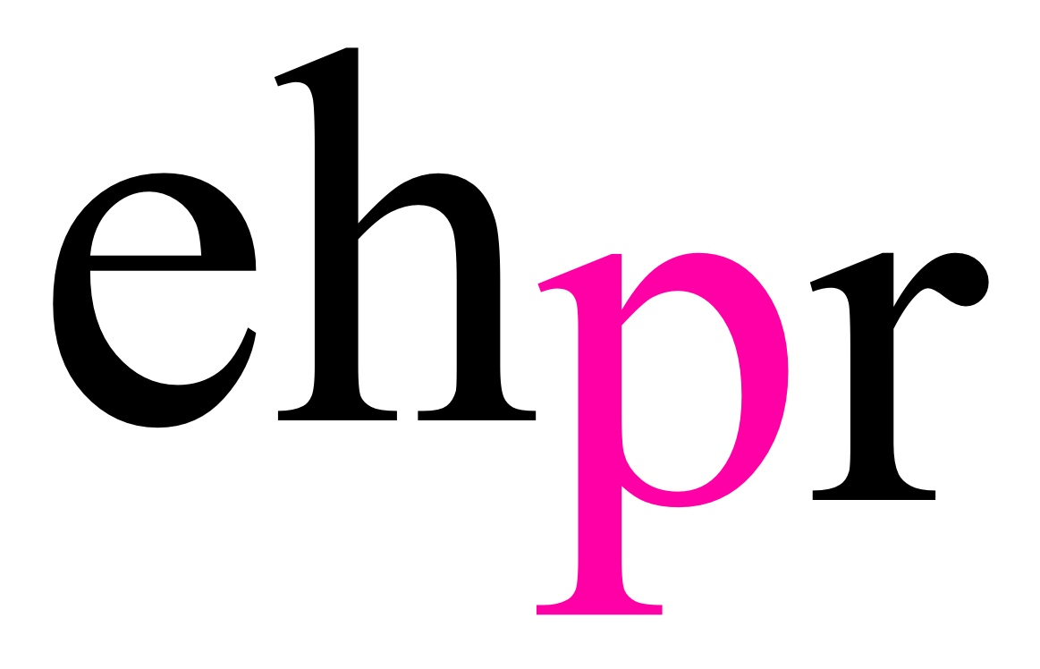

CRITICALLY ACCLAIMED ACTRESS ANITA DOBSON
LEADS THE CAST IN STAGE TRAFFIC PRODUCTIONS’
WORLD PREMIERE OF

3WOMEN

WRITTEN BY RENOWNED COMEDIAN KATY BRAND
AND DIRECTED BY MICHAEL YALE

RUNNING AT TRAFALGAR STUDIOS FROM 15 MAY – 9 JUNE 2018

3Women, the debut play by the award-winning comedian and writer Katy Brand, will premiere at Trafalgar Studios 2, starring the celebrated screen and stage actress Anita Dobson (Eleanor), alongside Debbie Chazen (Suzanne), Maisie Richardson-Sellers (Laurie), and Oliver Greenall (Waiter). Running from 15 May to 9 June 2018, with press night on 18 May, 3Women explores the relationships between three generations of the same family, brought together in one hotel room, in a darkly comic and pertinent exploration of what it means to be a woman.

Katy Brand said, “3Women is a play I have been hoping to write for several years, but now that feminism and women’s rights are at the very forefront of the global conversation, I wanted to really explore those issues from the point of view of three generations of women, and how they interact and intersect within the same family. These movements are not so straightforward as the media would sometimes have us believe but wrapped up in the chaotic and all-too-human lived experiences of real women, from the Suffragettes to those who currently campaign for trans-gender rights. We are all simply trying our best to be ‘modern women’ (whatever that means), making mistakes, and blundering on as best we can!”

Raise a glass to female family bonding and buried resentment!

From generation to generation, Mother to Daughter, this female-led play explores what it means to be a woman in the 21st Century and the consequences of the generational gap on our attitudes, cultural expectations and family dynamic. From wedding celebrations to relationship disillusionment, 3Women is razor-sharp, funny and caustically irresistible.

This hilariously frank and original debut brings our three women and their own very different identities and opinions into one hotel suite for a single night of redemption. What will be revealed?

3Women is directed by Michael Yale, with designs by Zahra Mansouri, lighting by Nic Farman, and is produced by Stage Traffic Productions.

NOTES TO EDITORS

Anita Dobson (Eleanor) is an Olivier Award nominated and well-loved television, theatre and film actress. Anita’s many stage appearances include Budgie (Cambridge Theatre); Three Sisters (Royal Court); Le Bourgeois Gentilhomme (National Theatre); Kvetch (Garrick Theatre); My Lovely… Shayna Maidel (The Ambassadors Theatre); Charley’s Aunt (Aldwych Theatre); The Pajama Game (Victoria Palace Theatre); The Vagina Monologues (Arts Theatre/UK Tour); The Island Of Slaves (Lyric Hammersmith); Frozen (National Theatre) for which she was nominated for an Olivier Award, Evening Standard and London Critics Circle Award; Chicago (Adelphi Theatre); Thoroughly Modern Millie (Shaftesbury Theatre); Hamlet (New Ambassadors Theatre/UK Tour); Hello Dolly (Theatre Royal Lincoln/ UK Tour); Kurt Weill’s opera The Silver Lake (Wexford Festival); Calendar Girls (Noël Coward Theatre); Two Sisters (Eastbourne and Brighton); Sleeping Beauty (Richmond Theatre); Strictly Come Dancing Live!; Bette and Joan (Arts Theatre); The Merry Wives Of Windsor (RSC), Steven Berkoff's production of Oedipus (Edinburgh Festival at the Pleasance Grand.); Carnival Of The Animals; Crush - A Girl's Own Musical; Follies (Royal Albert Hall); She Stoops To Conquer (Theatre Royal, Bath); Wicked (Apollo Victoria Theatre) and most recently The Shadow Factory (Nuffield Southampton).

As Angie Watts in EastEnders, Anita Dobson was one of the most popular characters on television, winning her the PYE award for Television Personality Of The Year, The Daily Mirror’s Actress Of The Year and the TV Times Actress Of The Year Award, voted by the readers.

Other television includes: Leave Him To Heaven, Nanny, The House Of Lurking Death, Up The Elephant And Round The Castle, Split Ends, The World Of Eddie Weary, Red Dwarf, Rab C Nesbitt, Smokescreen, I'll Be Watching You, Dangerfield, The Famous Five, Highlander, Get Well Soon, Junk, Sunburn, The Stretch, Hearts And Bones, Urban Gothic, NCS Manhunt, Fun At The Funeral Parlour, The Last Detective, Doctors, New Tricks, The Bill, Hotel Babylon, Casualty, Katy Brand's Big Ass Show, 12 O'clock Girls, Green Santa, Little Crackers ‘My First Nativity', Coming Up (Hooked), Sadie J, Moving On, Pompidou, Holby City, Armada, Call The Midwife, The Worst Witch and two series of The Rebel.

Film credits include: Seaview Knights, Beyond Bedlam, The Tichborne Claimant, The Revengers' Comedies, Darkness Falls, Charlie, Solitary, The Rise Of The Krays, The Fall Of The Krays, London Road taken from the acclaimed National Theatre production directed by Rufus Norris, and The Fight.

Debbie Chazen’s (Suzanne) numerous theatre credits include: The Girls (Phoenix Theatre/UK Tour); A Lovely Sunday For Creve Coeur (Coronet Print Room); Listen, We're Family (Wilton's Music Hall); The Duck House (Vaudeville Theatre); A Little Hotel On The Side (Theatre Royal Bath); Open Court: The President Has Come To See You, Mint, Untitled Matriarch Play and In Basildon (Royal Court); Calendar Girls (Noel Coward Theatre/UK Tour); The Girlfriend Experience (Royal Court/Young Vic/Plymouth); Cinderella (Old Vic); The Cherry Orchard (Sheffield Crucible); Dick Whittington (Barbican); Crooked (Bush Theatre); A Prayer For Owen Meaney and Mother Clap's Molly House (National Theatre & West End); A Midsummer Night's Dream (Noël Coward Theatre); and The Rise And Fall Of Little Voice (Salisbury Playhouse).

Her work for television includes: Holby City, The Last Kingdom, Dead Pixels, Agatha Raisin, You, Me And The Apocalypse, Ambassadors, Asylum, Sherlock, Trollied, The Spa, Coronation Street, Doctor Who, Tittybangbang, This Is Jinsy, White Van Man, Doctors (nominated for Villain of the Year - Soap Awards 2010 for 12 episodes as Sissy Juggins), We Are Klang, Psychoville, The Smoking Room, Nicholas Nickleby, Mine All Mine, Murder In Suburbia, Doc Martin, Midsomer Murders, Gimme Gimme Gimme, Lucy Sullivan Is Getting Married, Tess Of The D'urbervilles, A Christmas Carol and The Lakes.

Film credits include: Mike Leigh's Topsy Turvy, Suzie Gold, Tooth, Anton Chekhov's The Duel and most recently Red Joan directed by Trevor Nunn.

Maisie Richardson-Sellers’ (Laurie) theatre credits include: Mephisto (Oxford Playhouse), and They Will Be Red and For Coloured Girls Who Have Considered Suicide (Oxford University). Television credits include: Legends Of Tomorrow (CW), Of Kings And Prophets (ABC), and The Originals (CW). Film credits include: Korr Sella in Star Wars VII and ‬Melody in Melody (Short).‬‬‬‬‬‬‬‬‬‬‬‬‬‬‬‬

Oliver Greenall (Waiter) is an actor, writer and director. He was born in Scotland and trained at PACE Youth Theatre. During his final year of school, he was scouted by the model agency Models 1 and worked on various international campaigns for some of the largest fashion houses in the world. He went on to study at Glasgow University and received a BA in filmmaking and screenwriting at UWS. In 2015, he wrote and directed his first short film Directions, which was screened at festivals all around the world, including the London Short Film Festival in 2017. Television credits include: series regular Jordan Whitehead in ITV’s The Loch, and Armchair Detectives for BBC Television. Oliver will be making his West End debut at the Trafalgar Studios in 3Women.

Katy Brand (Writer) is one of Britain’s leading comics, receiving the British Comedy Award for the Best Female Comedy Breakthrough Artist in 2008. Also a successful actress and writer, Katy is most well-known for Channel 4’s Comedy Lap Slap (2006) and the hilarious ITV hit ‘Katy Brand's Big Ass Show’ (2007), where she won two awards including Best Newcomer at the 2008 British Comedy Awards. She has also starred alongside Emma Thompson in Nanny McPhee and The Big Bang (2010), as well as TV favourites such as Never Mind The Buzzcocks (2010) and Peep Show (2006). Katy’s comedy panache has also transferred into a talent for storytelling, with her novel Brenda Monk is Funny (2014) becoming a firm favourite with audiences and fellow writers alike. Here, her flair for writing, observation and comic ability fuse together in perfect harmony to create her debut play 3Women.

Michael Yale (Director) most recently directed the play Late Company at Trafalgar Studios (Broadway World Award nomination shortlisted for Best New Production of a Play 2017)

Other work as director includes: Late Company (Finborough Theatre – OffWestEnd Award finalist), This Little Life of Mine (Park Theatre – multi-award nominations includes Best Director, Broadway World Awards and Best New Musical, Broadway World and OffWestEnd Awards), Thrice Ninth Kingdom (Soho Theatre and Tristan Bates Theatre), Henry IV: Part One (Rose Playhouse Bankside, and St. James Theatre), Baby Mine (Omnibus Theatre), The Disappeared (Theatre503), Maternity (Riverside Studios), Wicked Will (BAC and Tour), Hell’s Kitchen (Midlands Art Centre), and the award-winning Monsieur D’Eon (Union Theatre).

Michael is co-artistic director and founding member of Stage Traffic Productions. He trained at LAMDA and continues to act and write for theatre and television.

Eilene Davidson (Producer) trained at Guildford School of Acting and worked as an actress performing on stage and screen in her twenties. She then moved to the States and studied playwriting and screenwriting and worked as a freelance writer. Her company Stage Traffic was set up in 2016 to exclusively showcase new writing. She recently produced acclaimed plays including: This Little Life of Mine (Park Theatre, London), and Late Company (Trafalgar Studios, London). Eilene has also produced or co-produced A Life Of The Mind (Southwark Playhouse), Insignificance (Langham Place, NYC), War Paint (Nederland Theatre, NYC), Apologia (Trafalgar Studios, London) and The Grinning Man currently showing in London (Trafalgar Studios). In 2018, Eilene is producing Monogamy (UK Tour/Park Theatre), Paper Dolls (Mosaic Theatre, Washington DC), and this October she will produce the award nominated European premiere of A Guide For The Homesick in a transfer from the USA to London. She is also on the board of the award-winning Huntington Theatre in Boston USA.

Stage Traffic Productions is a dynamic new UK/US theatre production company. Based in London, but looking at inspiration from around the globe, it is committed to creating productions with a strong emphasis on contemporary storytelling that truly resonates with modern audiences. The company’s last production, Late Company (Trafalgar Studios), was met with universal critical acclaim and has made the shortlist for Best New Production of a Play at this year’s Broadway World Awards. The company’s inaugural production was the musical This Little Life of Mine, which ran at the Park Theatre in 2016. The show was nominated for many awards, including Best New Musical Production - OffWestEnd Awards and Best Musical, Best Director and Best Actress - Broadway World Awards. Eilene and Michael first met as actors 18 years ago and since then both have worked additionally in the role of writer, director and producer, both in the States and the UK.

LISTINGS

3WOMEN

TRAFALGAR STUDIOS 2

15 MAY – 9 JUNE 2018

Press Night: Friday 18 May at 7pm

Performances:

Monday - Saturday at 7.45pm

Thursday & Saturday at 3pm

Ticket Prices: £20-£30

Address: Trafalgar Studios 2, 14 Whitehall, Westminster, SW1A 2DY

Box Office: 0844 871 7632

Website: www.stagetraffic.com
www.3womentheplay.co.uk

Facebook/Twitter: @stagetraffic
@3womentheplay

PRESS CONTACT: EMMA HOLLAND PR (EHPR)
W: www.emmahollandpr.com

Emma Holland Georgie Robinson

E: emma@emmahollandpr.com E: georgie@emmahollandpr.com

M: 0791 709 4203 M: 0751 211 2776

Jocasta Marron Natasha Haddad
E: jocasta@emmahollandpr.com E: assistant@emmahollandpr.com
M: 0772 517 1327

