YOU GUYS GIVE UP?
OR ARE YOU THIRSTY FOR MORE?
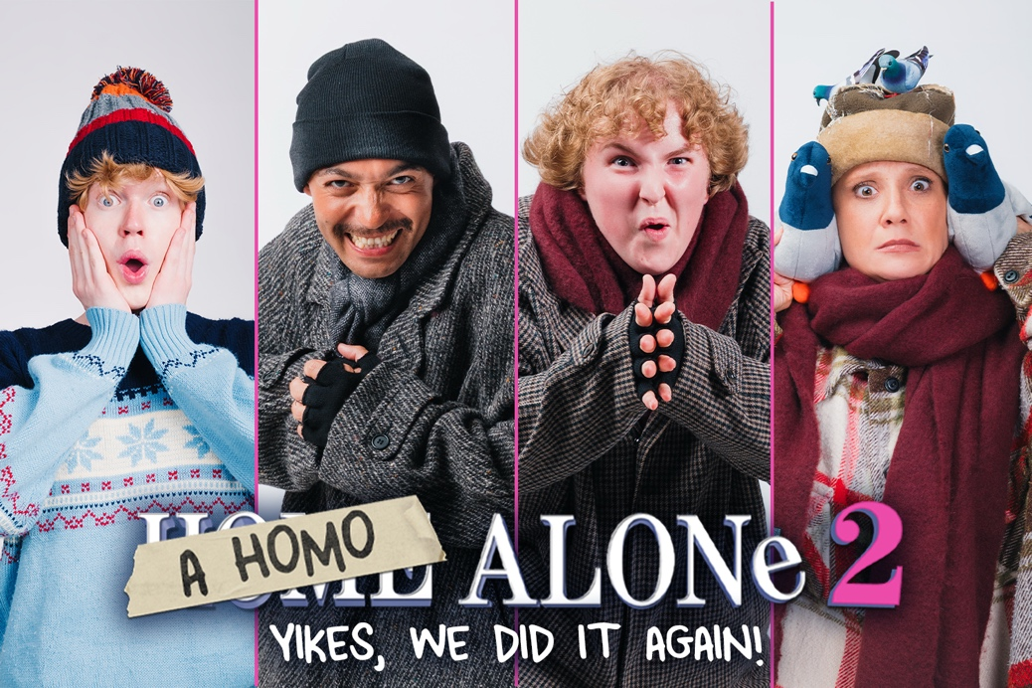

Image by Tyrone Lewis

RUNNING AT THE OTHER PALACE STUDIO
FROM 13 NOVEMBER 2026 – 3 JANUARY 2027

HE’S BACK. HE’S CAMPER, AND STILL NOT BEING SUPERVISED!
MERRY CHRISTMAS YA KINKY ANIMALS!

Remember the sold out hit ‘Homo Alone’ back in 2024? Well good news, Kevin is back for more as he returns to The Other Palace Studio for A Homo Alone 2: Yikes, We Did It Again!

Kevin will be played by Thomas John Stocks with the multi-rolling Jenny Bede (Prince Andrew: The Musical) as Kevin's Mum, Bird Woman, and Cedric the Bell Boy, Jermaine Woods (The Producers) as Kevin’s Dad, Harry, and the Hotel Manager, and Charlotte Dixon as Buzz, Marv and…Trump (someone genuinely had to this time…)

After last year’s Lovers Actually, The Other Palace Studio’s best-selling show ever, Jodie Prenger (Coronation Street, I'd Do Anything) and Neil Hurst (Fat Friends The Musical, Casualty) reunite with Kevin McCallister for the highly anticipated sequel parody of the beloved holiday classic A Homo Alone 2: Yikes, We Did It Again! You might be too old for a lot of things, but you’re never too old for a naughty, festive theatre treat at Christmas!

Camp Kevin. Lost in The Big Apple. With Dad’s credit card in hand, bébé Kevin has arrived, lost and unaware, in New York City, the gayest place on Earth! What could possibly go wrong? Throw in a couple of dodgy burglars, a Rocky Horror-esque hotel manager, and a Trump cameo nobody asked for and you’ve got yourself one hell of a Christmas night out.

Jodie Prenger says:

“Did you say KEVIN?! Well, he’s back and this time, in New York City! He’s older, more mischievous and has been left to his own devices one more time (a bit like the writing team!). And don’t worry if you missed the first instalment, you won’t have to have seen Homo Alone to join the party, but be warned that sweet childhood memories may be at risk! Intrigued? If you are, why not tell Santa that instead of presents this year, you just want tickets to see A Homo Alone 2 – even though you may end up on the naughty list.”

Homo Alone 2 is directed by comedian Laura Checkley (Detectorists), with choreography by Philip Michael Thomas (RAGS The Musical); musical direction and arrangement by Tom Noyes (Love Quirks); design by Reuben Speed (Deep Heat Rivalry); lighting design by Matt Hockley (Redcliffe) and sound design by Tom Jervis (Why Would We Care).

His parents might’ve forgotten him again, but you won’t. Not with this upbeat, filthy-fun musical parody kicking off your crimbo.

NOTES TO EDITORS

JODIE PRENGER (WRITER) SHE/HER
Jodie can be seen on the cobbled streets of Coronation Street as the much-loved series regular, Glenda Shuttleworth.

Recent theatre work includes tours of A Taste of Honey (Tour/West End); Abigail’s Party; Shirley Valentine; Annie; Fat Friends; Tell Me On A Sunday and Calamity Jane. In the West End, she starred in Oliver! at Theatre Royal Drury Lane; One Man Two Guv’nors at Theatre Royal Haymarket; Spamalot at the Playhouse and appeared in Les Misérables for the inaugural production at the Dubai Opera House. Jodie has starred in pantomime at Liverpool Empire and Birmingham Hippodrome.

Television acting work includes Coronation Street; Shakespeare & Hathaway: Private Investigators; The Walk-In; Years and Years; Jamie Johnson; Citizen Khan; Casualty; Wizards Vs Aliens; Candy Cabs and Waterloo Road. Television presenting work includes Let’s Dance for Comic Relief; Top Dog; Over The Rainbow and Let It Shine.

Writing credits includes Tracks; Lockdown Love Story; Cinderella: A Socially Distanced Ball; Raisins; A Government Inspector; A Very Very Bad Cinderella; Homo Alone and Lovers Actually.

NEIL HURST (WRITER) HE/HIM
Neil is a writer whose work includes two pantos for CAST Doncaster and Cinderella, a panto for Towngate Theatre Basildon. With writing partner Jodie Prenger he has scripted A Very Very Bad Cinderella and Cinderella, A Socially Distanced Ball, Homo Alone and Lovers Actually. They also co-wrote the TV pilot Dating For Dogs. Other writing work includes The Choir; Showbiz Stories; and TV Comedy Pilot, Tracks.

Neil is also an established actor whose recent credits include Hairspray (National Tour); The Full Monty (National Tour); Early Doors Live (UK Arena Tour); Fat Friends the Musical (World Première and UK Tour); Evita (Leeds Grand Theatre); Early Doors - One More Chance (The Lowry, Salford); Jungle Book the Musical (Oldham Coliseum). He is also an award-winning pantomime performer who currently headlines an annual panto for X-roads Pantomimes.

As a presenter Neil has also hosted his own US television pilot for Food Network called Hopping the Pond, which saw ‘Brit' Neil travelling the US, eating local dishes, drinking local brews and learning all about small town America from the locals.

Neil’s television credits include two series in a recurring live improvisation role on Michael McIntyre’s Big Show. TV drama guest roles include All Creatures Great and Small; Coronation Street; Home from Home; Casualty; Doctors; The Syndicate and Moving On; Fresh Meat; Andy and the Band; Biff and Chip; The 4 O’ Clock Club; Player Prank; and All-Star Family Fortunes. Feature film roles include The Railway Children Return; Tomorrow Morning and The ABC Murders.

THE OTHER PALACE
The Other Palace is dedicated to discovering, developing, exploring, and celebrating theatre. It’s a lively, friendly, and inventive place where ideas can be shared and explored, and the next generation of theatre-makers are encouraged, supported, and celebrated.

The venue has an extraordinary history dating back to 1766 when it began life as the Charlotte Chapel and was turned into the Westminster Theatre in 1931. In 2021 the venue was acquired by Bill Kenwright Ltd, one of the largest commercial theatre producers in the UK.

The Other Palace Studio is a creative hub for both the aspiring and accomplished within the industry. The intimate space breaks down the barriers between audiences and performers and provides a platform for new musical theatre to be developed and celebrated.

The Other Palace runs multiple schemes to nurture and develop new writing including the Making a Musical podcast, Musical Bites lunchtime readings, and a development grant.

LISTINGS
A HOMO ALONE 2: YIKES, WE DID IT AGAIN!
THE OTHER PALACE STUDIO
13 November 2026 – 3 January 2027
Written by Jodie Prenger and Neil Hurst
Press Night: Wednesday 18 November at 8:00pm

Performance Schedule:
Tue – Fri – 8.00pm
Sat – 4.30 & 8.00pm
Sun – 3.00 & 6.30pm
Performance times vary on holidays. Please check the website.

https://theotherpalace.co.uk/a-homo-alone-2-yikes-we-did-it-again

Run Time: 2 hours (including interval)

Ticket Prices: Previews from £28. Run from £36

Venue: The Other Palace Studio
Address: 12 Palace Street, London, SW1E 5JA
Box Office: 020 7592 0302

Website: www.theotherpalace.co.uk

Cast Assets: Available to download HERE
Artwork: Available to download HERE
The Other Palace Logo: Available to download HERE
PRESS CONTACT: EMMA HOLLAND PR (EHPR)
W: www.emmahollandpr.com

Emma Holland Didi Ralph
E: emma@emmahollandpr.com E: didi@emmahollandpr.com
M: 0791 709 4203 M: 07872 895 081
