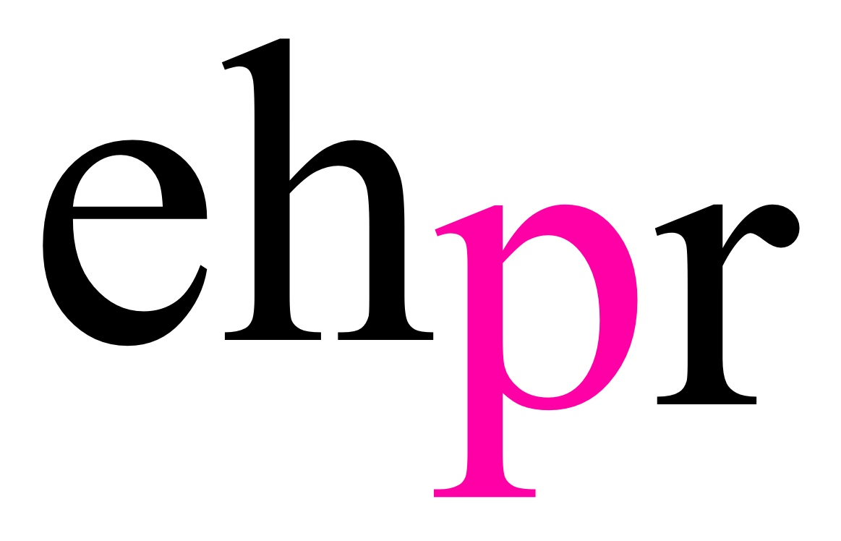

THE GROUNDBREAKING SMASH HIT UK PRODUCTION OF
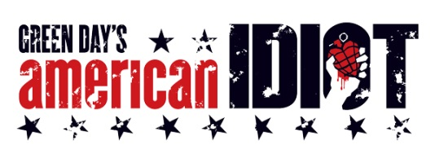
WITH MUSIC BY PUNK POP
& MULTI GRAMMY AWARD-WINNING BAND
GREEN DAY

RETURNS TO THE UK FOR A SPECIAL 10TH ANNIVERSARY TOUR
OPENING 17 JANUARY 2019

★★★★ – The Times, The Independent, Daily Telegraph

“Go for the time of your life!” Evening Standard

Following two critically acclaimed and celebrated West End runs and a sell-out UK Tour, Green Day’s explosive Tony Award winning rock musical, American Idiot, returns to mark the show’s 10th anniversary and the 15th anniversary of the Grammy Award winning album. The special anniversary tour opens from 17 January 2019 at the Grove Theatre, Dunstable, with press night at the Mayflower Theatre, Southampton on Thursday 24 January.

Winner of two Tony Awards and the 2010 Grammy Award winner for Best Musical Show Album, American Idiot is the story of three boyhood friends, each searching for meaning in a post 9/11 world. The show, which premiered in December 2009 at Berkeley Rep Theatre, features the music of Green Day with the lyrics of its lead singer Billie Joe Armstrong and book by Billie Joe Armstrong and Michael Mayer.

This story of youthful disillusion and mistrust of society and government has never been more current; particularly with the modern parallels in the USA where school children have mobilised to form an impressive campaign for gun law reform.

The musical’s hit songs include “Boulevard of Broken Dreams,” “21 Guns,” “Wake Me Up When September Ends,” “Holiday” and the blockbuster title track “American Idiot” from Green Day’s 2004 Grammy Award-winning, multi-platinum album. Also included are several songs from Green Day’s 2009 release “21st Century Breakdown,” and an unreleased love song, “When It’s Time.”

American Idiot The Musical is directed and choreographed by Racky Plews, with musical supervision by Richard Morris, sound by Chris Whybrow and lighting by Tim Deiling. The production is produced by Selladoor Worldwide and presented by arrangement with Music Theatre International (Europe) Limited.

Casting to be announced in due course.

NOTES TO EDITORS

Racky Plews (Director/Choreographer) was the resident director at Trafalgar Studios on Rodgers and Hammerstein’s State Fair and also the choreographer in residence at The Gatehouse where credits include: Guys and Dolls (Best Production nomination - thirteen Off West End nominations); The Drowsy Chaperone (Best Off West End Production nomination What's On Stage); Buddy - The Buddy Holly Story; A Slice of Saturday Night; The Hot Mikado and Into The Woods. Her choreography credits include: the UK Premiere of the musical comedy Cougar (The Belgrade, Coventry); Jekyll and Hyde (UK Tour); the Asian Premiere of Seussical (and director- The Lyric Theatre, Hong Kong, Singapore and Middle East); Guys and Dolls (director- Tring Park); Josephine Baker (The Beckett Theatre, New York); Liza Liza Liza by Richard Harris (Bill Kenwright Tour); Respect La Diva (Garrick Theatre); Momentous Musicals (New Wimbledon Theatre, ATG); Aladdin (Hastings, Qdos); Blockbuster (assistant/resident director, UK Tour); Shitfaced Sondheim (UK Premiere); A Dolls House (UK Tour); Seussical (The Arts Theatre); Wagner’s The Ring Cycle (and co-director- The Scoop Amphitheatre, South Bank); West End Bares 2013 and 2014 (Jerry Mitchell/Darren Carnall); An Evening with Marvin Hamlisch (St. James Theatre, main space); The Jewish Legacy (UK Tour); Oedipus & Antigone (The Scoop Amphitheatre, South Bank); A Tale of Two Cities (Charing Cross Theatre); Lost Boy (Liverpool Playhouse); Billy Elliot's West End Eurovision Entry 2013 and 2014 (Dominion Theatre); Denise Pearson - The Jackson's World Tour (UK Arena Tour/Birmingham Pride/G.A.Y. London); Forever Plaid (UK & International Tour); Sophie Tucker's One Night Stand (UK Tour); the European Premiere of Bare - The Rock Musical (Best Choreography nomination Broadway World); Bernarda Alba; and Once Upon A Mattress (Best Choreography nomination Off West End Awards, The Union Theatre); A Christmas Carol (Kings Head Theatre); Assassins (The Landor); La Traviata and The Marriage of Figaro (and director- Hampstead Garden Opera); Freshers (Edinburgh Festival - Best Musical Whats On Stage Award); Dangerous Daughters (Perfect Pitch); The Wild Party (Mountview); How To Succeed In Business Without Really Trying (CPA); The 48hour Musicals - The Boy Friend (Her Majesty's Theatre); Crazy For You; Me & My Girl (London Palladium); American Idiot (The Arts Theatre); Vanities (Trafalgar Studios); Footloose (Peacock Theatre & UK Tour); Shout! The Mod Musical (UK Tour); and Thoroughly Modern Millie (UK Tour).

Billie Joe Armstrong, is frontman of the rock band Green Day. Green Day’s albums include 1039/Smooth Out Slappy Hours; Kerplunk; 1994’s Dookie, which sold 15 million copies and garnered their first Grammy, Insomniac; Nimrod; Warning; 2004’s landmark American Idiot, which debuted at #1 on the Billboard chart, spawned five hit singles, and earned seven Grammy nominations (winning two, including Best Rock Album); 21st Century Breakdown (Grammy Award, Best Rock Album); and 2012’s consecutively released ¡Uno!, ¡Dos!, and ¡Tré! (as well as the behind the scenes DVD,¡Cuatro!). Last year, Armstrong and Norah Jones released Foreverly, a tribute to the Everly Brothers’ 1958 Songs Our Daddy Taught Us. The Tony and Grammy winning musical American Idiot, featuring lyrics by Armstrong, music by Green Day, and a book written by Armstrong and director Michael Mayer, opened on Broadway in 2010. Throughout its run, he made cameo appearances in the role of St. Jimmy. The recent documentary, Broadway Idiot, chronicles his road to the Great White Way. Armstrong also composed the music for These Paper Bullets staged last year at the Yale Repertory Theatre. His other film and TV credits include This is 40, Nurse Jackie, and the upcoming feature film, Like Sunday, Like Rain.

Green Day – Vocalist/guitarist Billie Joe Armstrong, Bassist Mike Dirnt, and Drummer Tré Cool - were kids from working-class backgrounds who came of age in the underground punk scene in Berkeley. Even though they had released two records prior (1039 / Smoothed Out Slappy Hours and Kerplunk), they announced their arrival with 1994's Dookie, a dynamic blast of exuberant punk-pop that sold 15 million copies and earned the band its first Grammy® Award for Best Alternative Music Performance. Over the years, Green Day continued to top the charts with their subsequent studio albums Insomniac, Nimrod and Warning, while entertaining millions of fans with their frenetic live shows. But it was their landmark 2004 album American Idiot that launched Green Day into the stratosphere. American Idiot debuted at No. 1 on the Billboard chart, spawned five hit singles, earned seven Grammy® nominations (winning two, including Best Rock Album), and raised the bar for modern rock and roll. In 2009, Green Day released 21st Century Breakdown, which won the 2010 Grammy® Award for Best Rock Album. It spawned two hit singles: the gold "Know Your Enemy," which was the first song ever to top Billboard's Rock, Alternative, and Mainstream Rock charts simultaneously, and the doubleplatinum "21 Guns," which earned them three 2009 MTV Video Music Awards including Best Rock Video. Green Day also took home an American Music Award for Favourite Alternative Rock Music Artist. Later that year, Green Day collaborated with Tony Award winning director of Spring Awakening, Michael Mayer, for the stage musical of American Idiot. The play bowed at the Berkeley Repertory Theatre in September 2009 and set attendance records during its limited engagement. The play went on to Broadway and ran for a year at the St. James Theatre and won two Tony Awards Green Day's highly anticipated album trilogy kicked off with the release of Green Day ¡Uno!, (September 25, 2012) followed by Green Day ¡Dos! (November 13th), and Green Day ¡Tré! (December 11th). The band recently completed the Soundwave Festival in Australia. For more info visit www.greenday.com.

Selladoor Worldwide began its life in 2009 as Sell a Door Theatre Company and has gone on to develop rapidly under co-founders David Hutchinson (Executive Creative Producer) and Phillip Rowntree (Executive Commercial Producer). The company has become an integral part of the regional theatre landscape in the UK and Ireland, and increasingly on an international platform, establishing itself as a leading producer of mid and large-scale touring theatre.
From the very outset, the company’s aim has been to make accessible work for our audiences, and their experience is at the heart of the company’s work and artistic planning. Principally aimed at engaging young and adult audiences and first time attendees, our objective is to continue to encourage the next generation of theatregoers. Our education programmes and online presence aim to provide the fullest experience of our productions possible.
Our origins lie in re-imagined classics and new commissions, which we continue to champion to this day. We are able to create a varied and distinctive programme; large-scale commercial touring is complimented by the company’s not-for-profit routes and ongoing investment and development of new work. As a company operating across a range of scales we continue to deliver and invest in our patron base on a regional land international basis, as well as our product.
In 2017, Selladoor Worldwide produced 9 productions, with over 900 performances, across 8 countries, in over 50 venues, reaching over 400,000 audiences with The Quite Remarkable Adventures of the Owl & the Pussycat (Coventry, Belgrade Theatre), The Crucible (UK Tour), Guess How Much I Love You (UAE & Asia Tour, and Greenwich Theatre & Arts Theatre, London), Footloose The Musical (2nd UK Tour), Flashdance The Musical (UK Tour), Spamalot (UK Tour), and Footloose (2nd UK Tour), and Peter Pan A Musical Adventure (Blackpool, Winter Gardens). 2017 also saw the launch of Selladoor Worldwide’s first International Tours, producing the multi-award musicals Jersey Boys and The Producers, along with our first production in the United States, bringing the popular children’s tale of The Very Hungry Caterpillar to New York City.
2018 brings another exhilarating year for Selladoor. In January, we were thrilled to be producing the John Steinbeck classic Of Mice and Men in association with the Marlowe Theatre in Canterbury. February brought our collaboration with the Queen’s Theatre Hornchurch and Les Theatre De La Villa De Luxembourg for a limited run of Diane Samuel’s Kindertransport marking 25 years since its debut at the Cockpit Theatre in London. Flashdance and Spamalot go from strength to strength as they continue their tours into 2018 visiting iconic venues such as the Manchester Palace Theatre, Brighton Theatre Royal, Zurich MAAG and the Dubai Opera House. In the summer, our production schedule really heats up as we journey to the island of Madagascar alongside Alex the lion, Marty the zebra, Melman the giraffe and Gloria the hippo in Madagascar A Musical Adventure! which tours the UK from the July 21st. We’ll also be lighting the sky like a flame with the Fame 30th Anniversary UK tour opening at the Manchester Palace on the 20th July. We finish off the year in the merry old land of Oz as we return to the bright lights of Blackpool at Christmas with family favourite The Wizard of Oz. With our 2019 rostra already starting to take shape, we are thrilled with the variety of work in production, and remain committed to creating daring, diverse and dynamic productions that are accessible to all.
If you’d like anymore information please visit www.selladoor.com

LISTINGS

AMERICAN IDIOT – THE MUSICAL
17 JANUARY – 01 JUNE 2019
UK TOUR

PRESS NIGHT: 24 January 2019 – Southampton Mayflower Theatre

RUNNING TIME: 1hr 40min (no interval)

WEBSITE: www.americanidiotthemusical.co.uk

FACEBOOK: American Idiot UK

TWITTER: @ukamericanidiot

INSTAGRAM: ukamericanidiot

RECOMMENDED AGE: Contains strong language and drug references – Ages 14+

TOUR VENUES

DUNSTABLE GROVE THEATRE
17 – 19 January 2019
grovetheatre.co.uk
01582 602 080

SOUTHAMPTON MAYFLOWER THEATRE
22 – 26 January 2019
mayflower.org.uk
02380 711 811

CARDIF NEW THEATRE
29 January – 02 February 2019
newtheatrecardiff.co.uk
029 2087 8889

EDINBURGH PLAYHOUSE
05 – 09 February 2019
atgtickets.com/edinburgh
0844 871 3014

BLACKPOOL WINTER GARDENS
05 – 09 March 2019
wintergardensblackpool.co.uk
01253 625 252
*On-sale 20 April*

SHEFFIELD LYCEUM
26 – 30 March 2019
sheffieldtheatres.co.uk
0114 249 6000

MANCHESTER PALACE THEATRE
02 – 06 April 2019
atgtickets.com/manchester
0844 871 3019

BIRMINGHAM NEW ALEXANDRA THEATRE
09 – 13 April 2019
atgtickets.com/birmingham
0844 871 6971

BRIGHTON THEATRE ROYAL
16 – 20 April 2019
atgtickets.com/brighton
0844 871 7650

BRIDLINGTON SPA THEATRE
07 – 11 May 2019
bridspa.com
01262 678 258

WIMBLEDON NEW THEATRE
14 -18 May 2019
atgtickets.com/wimbledon
0844 871 7646

GLASGOW KINGS THEATRE
28 May – 01 June
atgtickets.com/glasgow
0844 371 7648

Further dates and venues to be announced in due course.

PRESS CONTACT: EMMA HOLLAND PR (EHPR)
W: www.emmahollandpr.com

Emma Holland Georgie Robinson
E: emma@emmahollandpr.com E: georgie@emmahollandpr.com
M: 0791 709 4203 M: 0751 211 2776

Jocasta Marron Natasha Haddad
E: jocasta@emmahollandpr.com E: assistant@emmahollandpr.com
M: 0772 517 1327 M: 07967 175 221
