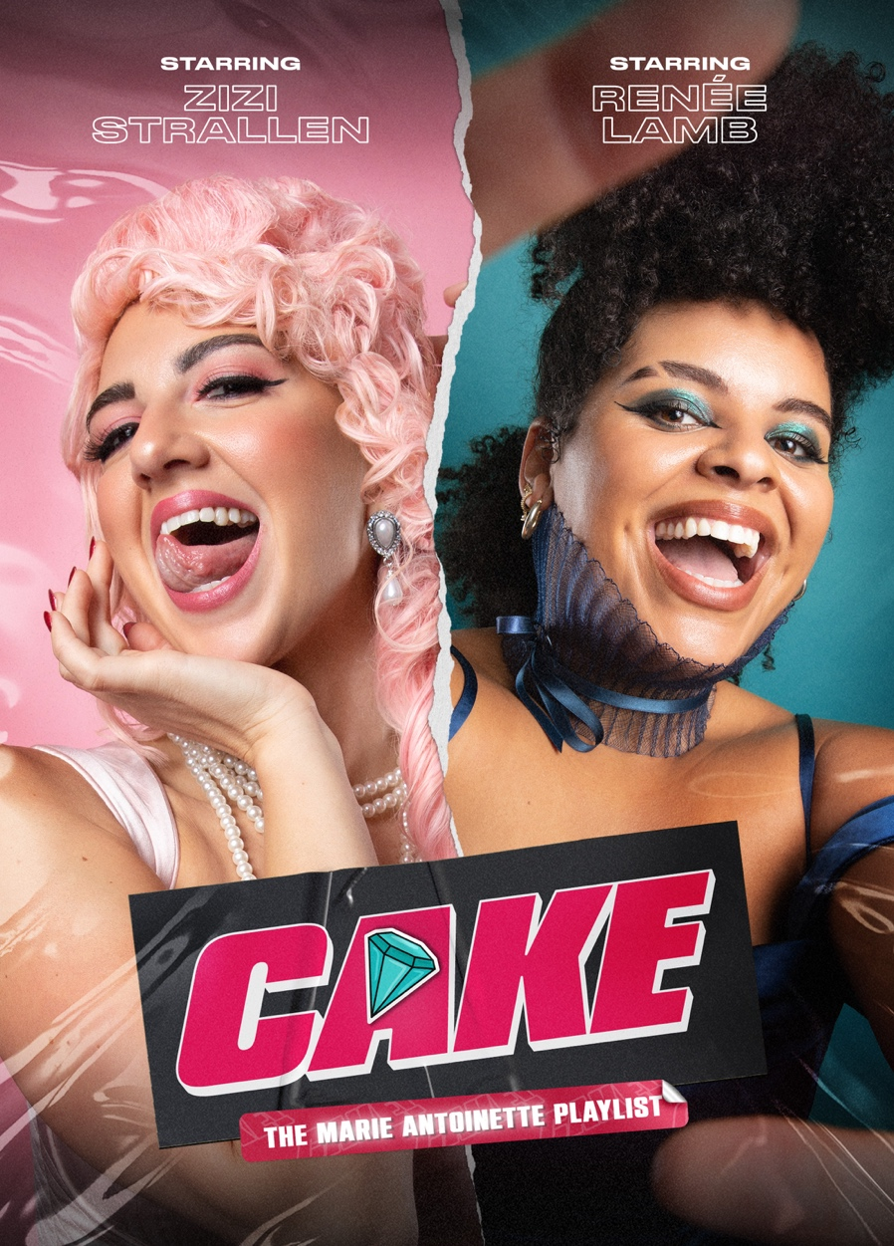
COMING TO THE OTHER PALACE
FROM 13 SEPTEMBER – 10 NOVEMBER
Following electrifying try-out performances at The Lyric Theatre last year, Bill Kenwright Ltd and Paul-Taylor Mills present the brand-new musical, come gig, come ballet, now back for a full reign. This time, one of the most prolific monarchs in history has found her (rightful) home at a palace…The Other Palace, to be exact from 13 September 2024 for a strictly limited season.

From some of the most exciting figures in modern British theatre, Cake: The Marie Antoinette Playlist continues its journey, following a successful UK tour at the start of 2023 and five performances in the West End last September, it now returns for a limited season in London this autumn.

Cake: The Marie Antoinette Playlist has an award-winning creative team, including Morgan Lloyd Malcolm (Emilia – The Globe), Tasha Taylor Johnson (The Cat In The Hat), singer-song writer and Jack McManus with Bronagh Lagan (Cruise) and Christopher Tendai (Closer To Heaven) joining as director and choreographer respectively, as they build on Olivier winner Drew McOnie (In the Heights; Jesus Christ Superstar) original show.
Reprising their roles will be West End star Zizi Strallen (Mary Poppins; Strictly Ballroom) as Marie Antoinette, and the original Catherine of Aragon in the award-winning musical SIX, Renée Lamb (Be More Chill; SIX) as Jeanne with further casting to be announced.
Combining a multi-genre pop score with 18th century France, Cake: The Marie Antoinette Playlist, retells a story that sparked a revolution.
Marie Antoinette’s reign was blighted by gossip and scandal. But when she is implicated in a crime to defraud the crown jewellers of a diamond necklace, it is not just her reputation at stake, but the monarchy and France itself.
Cake was originally commissioned by Paul Taylor-Mills (Heathers; In the Heights) and promises to re-define our expectations of what a musical can be.
Paul Taylor-Mills (Artistic Director of The Other Palace):
“I’m delighted we are bringing CAKE to The Other Palace for a full run, as this brand-new genre busting musical continues to evolve following on from its try-out last year. Completing our 2024 programme of new musicals and developing work, from Cruel Intentions the Musical at the start of the year to Babies currently receiving rave reviews, and Fantastically Great Women Who Changed The World over the summer, the London Premiere of The Lightning Thief, this will literally be the icing on the CAKE!
Cake: The Marie Antoinette Playlist has book by Morgan Lloyd Malcolm and Tasha Taylor Johnson, music and lyrics by Jack McManus and Tasha Taylor-Johnson, directed by Bronagh Lagan based on the original staging by Drew McOnie with additional choreography by Christopher Tendai. Set and costume design by Sami Fendall, lighting design by Joshie Harriette and casting by Will Burton.

LISTINGS
BILL KENWRIGHT LTD & PAUL TAYLOR-MILLS PRESENT
CAKE: THE MARIE ANTIONETTE PLAYLIST
THE OTHER PALACE
13 SEPTEMBER – 10 NOVEMBER 2024

Book by Morgan Lloyd Malcom and Tasha Taylor Johnson
Music and Lyrics by Tasha Taylor Johnson and Jack McManus
Directed by Bronagh Lagan based on the original staging by Drew McOnie
Additional choreography by Christopher Tendai
Based on an idea by Paul Taylor Mills

Press Night: Wednesday 18 September

Performance Schedule: Tuesday – Friday at 7.30pm
Saturday at 2.30pm and 7.30pm
Sunday at 1.30pm and 5.30pm

Run Time: 90 minutes
Age Guidance: 12 years+

Ticket Price: from £26

Venue: The Other Palace
Address: 12 Palace Street, London, SW1E 5JA
Box Office: 020 7592 0302
Website: theotherpalace.co.uk

Assets:
Artwork: Available to download HERE
Past Production Images: Available to download HERE
Music: Available to stream and download HERE

Twitter/X: @cakemusical
Instagram: @cakemusical
Facebook: @cakemusical
TikTok: @cakemusical
#CakeMusical

NOTES TO EDITORS
Zizi Strallen’s theatre credits include: Mary Poppins (Cameron Macintosh Ltd.); The Car Man (New Adventures); Hairspray and Chicago (Leicester Curve); A Tale of Two Cities (Theatre Royal Windsor); The Herbal Bed (Royal Shakespeare Company); The Music Man (Chichester Festival Theatre); Dirty Dancing (Aldwych Theatre); Rock of Ages (Shaftesbury Theatre); Merrily We Roll Along (Menier Chocolate Factory); Follies (Chichester Festival Theatre); Pippin 50th Anniversary Concert and Oklahoma! In Concert (Theatre royal Drury Lane).
Her screen credits include: Cats (Universal Pictures); Cinderella (Walt Disney Productions); Britannia High (Globe productions); The Prince and the Pauper (BBC); Victoria and Albert, Bramwell (ITV); Dinotopia (Hallmark).
Renee Lamb’s theatre credits include: Six (Original London Cast – Arts Theatre); Little Shop of Horrors (Regent’s Park Open Air Theatre); Ain’t Misbehavin’ (Mercury Colchester & Southwark Playhouse); Malory Towers (Original Cast - Wise Children); Be More Chill (The Other Palace); Fantastically Great Women Who Changed the World (Kenny Wax Ltd).
Her screen credits include: This Is The Night Mail (Unquiet Skulls); Still So Awkward (BBC). Recording credits include: Six Original Cast Recording (Historemix Ltd).
Morgan Lloyd Malcom (Book) is a playwright and screenwriter. Morgan was commissioned by The Globe to write Emilia which became a hit show in summer 2018 before transferring to the West End in 2019, winning three Olivier awards. Morgan is adapting three of her plays for film, including Emilia, and her adaptation of her play The Wasp began filming at the end of 2022 starring Naomie Harris and Natalie Dormer, and directed by Guillem Morales.

She is working on a number of TV projects including an adaptation of Damage by Josephine Hart for Moonage, Gaumont and Netflix, starring Richard Armitage and Indira Varma which aired in April 2023 with the title ‘Obsession’.
She has worked extensively with Clean Break, a feminist theatre company working with women with experience of prison. Her commission Typical Girls, a play set in a women’s prison featuring the music of The Slits, ran at the Sheffield Crucible in 2021. Her new play Mum ran at Plymouth Theatre Royal and Soho Theatre autumn of 2022, with another new play for High Tide, When the Long Trick’s Over, which toured last year after a run at the New Wolsey Theatre in Ipswich.
Morgan’s previous plays Belongings and The Wasp were both produced at the Hampstead Theatre and Trafalgar Studios. Belongings was shortlisted for The Charles Wintour Most Promising Playwright Award.

Tasha Johnson Taylor (Book, Music and Lyrics) is a composer, lyricist, writer & performer.
Recent theatre credits include Giraffes Can’t Dance (Curve); Spring Awakening (The Young Vic); Cat in the Hat (UK tour/ Curve); The Wheel (Guildhall); Cotton Fingers (National Theatre Wales); Woman & Scare-crow (RADA); Memoirs of an Asian Casual (Curve); The Crucible (Curve); George’ s Marvellous Medicine (Curve) and To You (National Youth Ballet & Drew McOnie).

She’s worked on multiple projects with the McOnie company including the Good Morning Midnight (Jermyn Street theatre) & Shine (Sadlers Wells).

Tasha has also created original music for ITV, Audible, The Old Vic, and various commercials.

In 2017 she was awarded the prestigious Cameron Mackintosh Resident Composer position at Leicester Curve and is honoured to continue as an Associate Artist there.

Bronagh Lagan (Director) is an award-winning director. She is the director of Olivier nominated play Cruise by Jack Holden which ran for 4 weeks at The Duchess Theatre and was the first new play to open the West End after the pandemic. Cruise returned to the Apollo Theatre, West End for another sell out run. She also directed a film version of the show in Shoreditch Town Hall's Ditch which won an ONCOMM award for Best Recorded Show.
​
Most recently she directed the award-winning London premier of Flowers for Mrs Harris by Richard Taylor and Rachel Wagstaff, starring the Olivier Award-winning and Tony nominated Jenna Russell.

Her production of Rags, the musical by Charles Strouse and Stephen Schwartz at The Park Theatre received nine Off West End Award nominations, including: Best Director and Best Production. Bronagh worked closely with Stephen Schwartz in reimagining the script for an actor-musician production and curated a cast album of her production of Rags which is available on iTunes and Spotify.

Bronagh directed the world premiere of Umm Kulthum the first bilingual English and Arabic musical based on the life of Umm Kulthum. The show was first performed at London Palladium, The National Theatre of Bahrain and then at Dubai Opera House

Passionate about new writing Bronagh recently directed the world premiere of Animal by Jon Bradfield at The Park Theatre. The show has been nominated for 5 Off West End awards including Best New Play and Best Director.

In addition to directing, Bronagh is part of the From Page To Stage Literary department for Aria Entertainment and is also a regular practitioner at top drama schools in London.

Directing Credits for the West End include: Cruise (The Apollo Theatre & Duchess Theatre); RUMI (London Coliseum); Umm Kulthum, the Golden Era (London Palladium); Broken Wings (Theatre Royal Haymarket & Charing Cross Theatre) and Rags, in concert (Lyric Theatre).

Other directing credits: Flowers For Mrs Harris (Riverside Studios); The Rise And Fall of Little Voice (UK Regional Tour); Broken Wings (Charing Cross; Doha Opera House & Beiteddine Festival); Animal; Little Women & Rags, The Musical (The Park Theatre); Jack and The Beanstalk (Becks Theatre); Putting It Together and Little Women (Hope Mill Theatre, Manchester); A-Typical Rainbow (Turbine); Children of Eden (Mackintosh theatre); A Christmas Carol (Ivy Studio); Girlfriends, in concert (Bishopsgate Institute); A Winter’s Tale (Rose Theatre, Kingston) Brexit, the Musical (C Venues, Edinburgh); tick, tick... BOOM! (Park Theatre); Promises, Promises (Southwark Playhouse); As You Like It (Jackson’s Lane); The Rise and Fall of Little Voice (Chipping Norton Theatre); The Pajama Game (Pleasence Theatre); Heart of Winter (Tristan Bates); James and The Giant Peach (UK & International Tour); A Man of No Importance (Pleasance Theatre); The Stationmaster (Tristan Bates); Portia Coughlan (The Old Red Lion Theatre); Girlfriends (Union Theatre); A Day In The Death Of Joe Egg (Greenwich Theatre); The Mistress Cycle (Landor Theatre); Expectations (Arcola Theatre); Blood Wedding (Courtyard Theatre); Newsrevue (Canal Café Theatre); Henry VI Part1 (Rose Theatre); Erris (Theatre 503); Julius Caesar (The Scoop) and The Madness of Sweeney (Lyric Theatre, Belfast).

Associate Director credits: Saving Grace (Riverside Studios); C-O-N-T-A-C-T (London), Pippin (Southwark Playhouse); Becoming Shades (The Vaults); The History Boys (UK Tour) and Nothing Left to Lose (Purcell Rooms).

Christopher Tendai (Additional Choreography) is an up-and-coming Theatre Choreographer, breathing a fresh new life into the imagery of how we see Theatre and Dance productions. Some of his credits include: Closer To Heaven, Bare: A Pop Opera, RENT, Wuthering Heights: A New Musical Workshop, Children of Eden, Scroogelicous, The Wonderful, and The Guap Gala at the Natural History Museum.

Christopher is also the Artistic Director for the Award-Winning Dance Company: CTC Dance Company. The company are known for their thought provoking works such as Wonderland In Alice (Offies Finalist for Best Choreography), IDENTITY (Winning Edinburgh Fringe Teapot Award), and ‘iNk’d’. Their ethos is ’Sparking Important Conversations Through Narrative Movement.'

He is currently the Resident Choreographer for the 50th Anniversary of Drew Mconie’s Olivier Award Winning Jesus Christ Superstar UK Tour 2023/24.
Performance Credits: Cabaret (Playhouse Theatre); Carousel (Regents Open Air Theatre); Dick Whittington (National Theatre); Matilda (Cambridge Theatre); In The Willows (UK Tour); West Side Story (Royal Exchange Theatre); Original Cast of Hamilton (Victoria Palace Theatre); Jesus Christ Superstar (Regents Open Air Theatre); In The Heights (Kings Cross Theatre); Hairspray (UK & Ireland Tour).

A big passion of Tendai’s is to give back to young aspiring performers, especially performers of colour and part of the LGBTQIA+ community, providing help and support to those who do not have access to professional training. He is currently part of the Creative Collective Board at East London Dance.

Paul Taylor Mills (Producer/Idea) is the Artistic Director of both The Turbine Theatre at The Battersea Power Station and The Other Palace Theatre, London. He has worked as Advisory Producer to Andrew Lloyd Webber and The Really Useful Group.

Stage credits include: At the Turbine Theatre - My Son’s A Queer (But what can you do?) (The Garrick, Ambassadors Theatre – Olivier Nominated, Best Entertainment or Comedy Play); Eugenius!; But I’m A Cheerleader, My Night with Reg, MTFestUK 2021, 2022, 2023 and 2024, Cinderella: The Socially Distanced Ball, Hair (part of the Turbine on the Jetty Season), Torch Song, High Fidelity and Cat In The Hat.

Elsewhere, Cruel Intentions at The Other Palace, Heathers the Musical at the Theatre Royal Haymarket, The Other Palace and UK Tour (winner of the WhatsOnStage Best New Musical Award), Murder For Two at the Watermill Theatre and The Other Palace, Cake the UK Tour and Lyric Theatre, Boy Out The City and Bloody Elle at the Lyric Theatre, The Wild Party at The Other Palace, European Premiere of Disney’s Peter and the Starcatcher at the Royal & Derngate, Northampton, Side Show at Southwark Playhouse, The Last Five Years at the St. James Theatre (winner of the WhatsOnStage Award for Best Off-West End Production) End of The Rainbow on UK Tour, In The Heights at Kings Cross Theatre and Southwark Playhouse (winner of three Olivier Awards), Casa Valentina at Southwark Playhouse, Carrie The Musical at Southwark Playhouse (winner of The WhatsOnStage Off West End Award), and Associate Producer on The Importance of Being Earnest starring David Suchet on UK Tour and the Vaudeville Theatre.

Bill Kenwright Ltd (Producer) is one of the largest and most established commercial theatre and entertainment producers with over 5 decades experience of producing more than 500 productions to date – including touring, West End, and international productions. Bill Kenwright Ltd is part of the Bill Kenwright Group of companies, alongside Bill Kenwright Theatres and film and TV production and financing company BK Studios.

Bill Kenwright CBE 4 September 1945 – 23 October 2023
A beloved partner, father, grandfather, friend, and founder of his namesake companies, Bill Kenwright CBE was driven by his passions and devoted his life to them; his deep love of theatre, film, music and his beloved Everton, and the families they created.
In a multi-award-winning career spanning six decades, Bill produced over 500 West End, Broadway, UK touring and international theatre productions, films, and music albums. His impact on the arts industry has been profound. Bill helped to launch the careers of many West End producers, performers, and creatives, and for many years was the biggest employer of actors in live entertainment, estimated to employ more actors in a year than any other employer aside from the BBC. His tireless work across the UK also revitalised the touring network in Britain, with barely a stage in the UK that Bill hadn’t brought a show to.

“Bill was one of the greatest producers this country has ever known” Rufus Norris Artistic Director and CEO of The National Theatre.

West End productions include: Boys from the Blackstuff (Garrick Theatre & National Theatre), Cruel Intentions – The Musical, Ian McKellen & Roger Allam in Frank & Percy (The Other Palace); My Son’s a Queer, (But what can you do?) (Ambassadors Theatre), Saturday Night Fever (The Peacock); Heathers the Musical (Haymarket and The Other Palace); Love Letters (Haymarket); The Best Man (Playhouse); The Exorcist (Phoenix); Evita (Dominion); How the Other Half Loves (Haymarket); The Go-Between (Apollo); Let the Right One In (Apollo); Twelve Angry Men (Garrick); Cabaret (Savoy); Blood Brothers (Phoenix); Written on the Heart (RSC – Duchess); Brief Encounter (Lyric); The Pitmen Painters (Duchess); The Wizard of Oz (The London Palladium); On the Waterfront (Haymarket); Sunset Boulevard (Comedy); Joseph and the Amazing Technicolor Dreamcoat (Adelphi); The Crucible (RSC – Gielgud); Whistle Down the Wind (Palace); A Man for All Seasons (Haymarket); Scrooge (The London Palladium); A Few Good Men (Haymarket); Festen (Lyric); Jessica Lange in Long Day’s Journey into Night (Lyric); The Glass Menagerie (Apollo); Judi Dench in All’s Well That Ends Well (RSC – Gielgud) and ten years of the Peter Hall Company, with credits including Judi Dench in Hay Fever (Haymarket); The Gift of the Gorgon (Wyndham’s); Filumena (Piccadilly); Jessica Lange in A Streetcar Named Desire (Haymarket); Peter Bowles and Eric Sykes in School for Wives (Piccadilly); Elaine Paige in Piaf; Donald Sinden, Michael Pennington, and Stephen Dillane as Hamlet; and An Ideal Husband starring Martin Shaw which played five West End seasons and won awards on Broadway.

On Broadway: Travels With My Aunt (Drama Desk Award); Dancing at Lughnasa (Tony Award); Medea (Tony Award); Ibsen’s A Doll’s House (four Tony Awards); Théâtre de Complicite’s The Chairs (six Tony Award nominations); Cat on a Hot Tin Roof, The Glass Menagerie, Primo, Festen, Passing Strange and Guys and Dolls. Blood Brothers, which ran for 24 years in the West End, also played for three years at Broadway’s Music Box Theatre. Bill Kenwright Ltd were also co-producers of the phenomenally successful arena tour of Elvis – The Concert with Elvis Presley Enterprises.

Film includes: My Sister’s Bones, Frederick Forsyth’s The Shepherd, Sean Mathias’ Hamlet, Patrick Marber’s The Critic, Off the Rails, Another Mother’s Son, The Hope Rooms, The Day After the Fair, Stepping Out, Don’t Go Breaking My Heart, Cheri and Broken, which won Best Film at the British Independent Film Awards. Die Mommie Die! and Burden were both Sundance Festival Award winners in 2003 and 2018 respectively. My Pure Land was Britain’s submission for the Foreign Language Oscar.

PRESS CONTACT: EMMA HOLLAND PR (EHPR)
W: www.emmahollandpr.com

Emma Holland Didi Ralph
E: emma@emmahollandpr.com E: didi@emmahollandpr.com
M: 0791 709 4203 M: 0787 289 5051

