FOR ONE NIGHT ONLY
AT THE GARRICK THEATRE

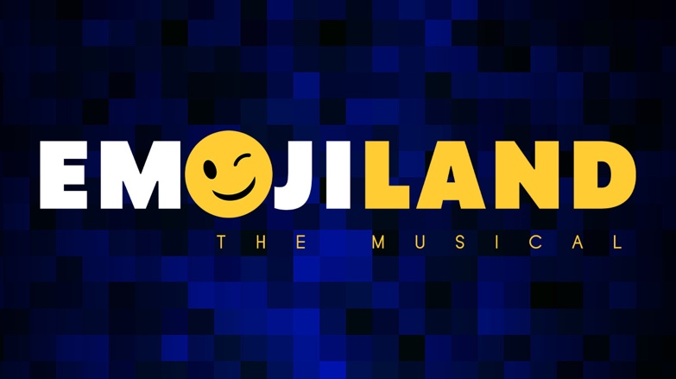

MUSIC BY KEITH HARRISON DWORKIN
BOOK & LYRICS BY KEITH HARRISON DWORKIN & LAURA SCHEIN

MONDAY 31 OCTOBER 2022

“Emojiland is a delectably silly-smart confection”
The New York Times

Having opened off-Broadway in January 2020 where it received a New York Times Critics’ Pick, the award-winning Emojiland, will be hitting the West End on 31 October 2022.

For a one night only concert at The Garrick Theatre some of the leading talent in musical theatre will take on these iconic figures inside our phones. Giving them life, personality, and whole lot of song.

This esteemed cast will include, Blake Patrick Anderson (Be More Chill), Laura Baldwin (Cinderella), Louise Dearman (Wicked), Olly Dobson (Back to the Future), Hiba Elchikhe (Everybody’s Talking About Jamie), Renee Lamb (Six), Hannah Lowther (Heathers), Tim Mahendran (& Juliet), Natalie Paris (Six), Oliver Saville (Rocky Horror Show), Jonny Weldon (101 Dalmations), and Dean John Wilson (Aladdin).

Emojiland is an electric, funny and surprisingly touching piece about a diverse community of archetypes who live in our smart phones. They take one another at face value – but are far more complex: a smiling face dealing with depression; a princess who doesn't want a prince; a skull dying for deletion; a nerd face too smart for their own good; a face with sunglasses who can't see past their own reflection; and a police officer who struggles to break ranks for what’s right.

When a software update and an evil skull emoji threaten to destroy life as they know it, the characters in Emojiland must step out of their iconic roles to fight for survival, for freedom of self-expression and for true love.

Silly, witty, chaotic, and fun - How else would you want to spend Halloween this year?

Emojiland was originally presented by the New York Musical Festival (Dan Markley, Executive Director & Producer). Emojiland was a Grand Jury Selection of the 2018 New York Musical Festival. The original 2020 Off-Broadway production produced by Visceral Entertainment, and directed by Thomas Caruso.

The Original Cast Recording of Emojiland is available at BroadwayRecords.com and wherever digital music is sold.

LISTINGS
EMOJILAND
In Concert
THE GARRICK THEATRE
Monday 31 October 2022
Music by Keith Harrison Dworkin
Book and Lyrics by Keith Harrison Dworkin & Laura Schein

Venue: The Garrick Theatre

Address: 2 Charing Cross Rd, London WC2H 0HH

Date: Monday 31 October

Running Time: 2 hours 30 Minutes, inc. interval

Website: https://nimaxtheatres.com/shows/emojiland/

Tickets: From £25

Socials:
@TurbineTheatre
#PoweringTheImagination

Headshots: Available to download HERE

Artwork: Available to download HERE

PRESS CONTACT: EMMA HOLLAND PR (EHPR)
W: www.emmahollandpr.com

Emma Holland Didi Ralph
E: emma@emmahollandpr.com E: didi@emmahollandpr.com
M: 0791 709 4203 M: 07872 895 051

