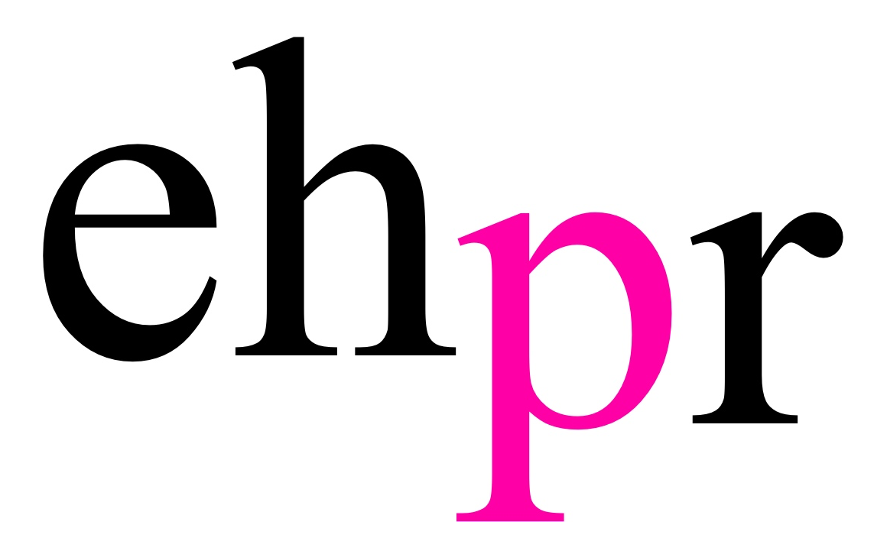
CINEMALIVE PRESENTS

CHARLES DICKENS’ CLASSIC FESTIVE TALE

A CHRISTMAS CAROL

STARRING CELEBRATED BRITISH ACTOR
SIMON CALLOW

A NEW CINEMATIC VERSION
RECONCEIVED FROM THE CRITICALLY ACCLAIMED STAGE SHOW

SCREENING AT CINEMAS NATIONWIDE & IRELAND ON TUESDAY 11 DECEMBER 2018

Beautiful and magical - Daily Telegraph
As rich as figgy pud - The Guardian

Following three critically-acclaimed, sold-out seasons on stage in London’s West End, Simon Callow (Four Weddings and a Funeral, Shakespeare in Love) brings Charles Dickens’ beloved classic A Christmas Carol to the big screen in December 2018. On Tuesday 11 December the stage-to-film adaptation, reimagined especially for cinema, will be released in 444 cinemas across the UK and Ireland by leading event cinema distributors CinemaLive.
Based on Charles Dickens’s own performance adaptation, Simon Callow and director Tom Cairns (Marie and Bruce, Amongst Women) have created a one-man cinematic extravaganza of festive storytelling that is both heart-warming and deeply moving. A Christmas Carol is produced by BBC Films, The Space and Assembly Christmas Carol Ltd.

Simon Callow said: “When Tom Cairns and I started working on our one-man version of A Christmas Carol, we were very excited by the possibilities of putting the audience in direct contact with Dickens, who is even more vividly present in it as a narrator than in his other books, he climbs into your head, he is always by your side, the master conjuror and also the commentator. As we worked on the show, right from the beginning we saw that it might make a wonderful film, quite different from the stage show, drawing the viewer even more closely into contact with the story-teller, using the matchless poetic resources of the camera to summon up the many worlds through which Dickens takes us and the miser, Ebenezer Scrooge. Shot entirely in an abandoned warehouse, it takes the viewer indoors and outdoors, through the seasons and across the haunted city of London. The theatre version is pure theatre, the film, pure cinema, proving how phenomenally rich this favourite of all Christmas stories is.”

LISTINGS

A CHRISTMAS CAROL IN CINEMAS NATIONWIDE & IRELAND ON 11 DECEMBER 2018
STARRING SIMON CALLOW
DIRECTED BY TOM CAIRNS
DISTRIBUTED BY CINEMALIVE
PRODUCED BY BBC FILMS, THE SPACE, ASSEMBLY CHRISTMAS CAROL LTD

Running Time: 90 Minutes

For more information and to find screenings visit www.cinemalive.com

Images and artwork available to download HERE

In addition to the premiere of the film adaption, the critically acclaimed stage production is making a welcome return to the West End at The Arts Theatre from 8 December 2018 – 12 January 2019, produced by Assembly Festival.

Tickets are available from www.artstheatrewestend.co.uk

NOTES TO EDITORS
Simon Callow went to work in the Box Office of Sir Laurence Olivier’s Old Vic Theatre in 1967, subsequently training at the Drama Centre until 1973, when he left for his first acting job as the front end of a horse in Büchner’s Woyzeck at the Edinburgh Festival. He then played in repertory at Lincoln, and with the Young Lyceum and Traverse Theatre Companies in Edinburgh. His first West End appearance was in 1975 opposite Harry Secombe in The Plumber’s Progress; later that year, he worked for Gay Sweatshop. He then joined Joint Stock Theatre Company for two years, played Titus Andronicus at the Bristol Old Vic, Arturo Ui at the Half Moon Theatre and Eddie in Mary Barnes at the Royal Court, before joining the National Theatre to create the part of Mozart in Amadeus and perform all of Shakespeare’s Sonnets.

Callow has since worked at the Royal Court Theatre, National Theatre, Bush Theatre, Southwark Playhouse and in many West End theatres. He has toured extensively, an activity about which he is passionate. In 1988, he played Faust in both parts of Goethe’s play at the Lyric Hammersmith. In 1997, he acted in The Importance of Being Oscar, following this in 2000 with The Mystery of Charles Dickens, which he played for four years in Britain, Ireland, America (New York and Chicago) and Australia (Sydney and Melbourne). In 2005, he acted in The Holy Terror by Simon Gray. Callow has appeared in The Woman in White and, for the RSC, Merry Wives: The Musical. In 2008, he played Captain Hook in Peter Pan in which he made his entrance singing Michael Jackson’s Bad.

In 2009, he played Pozzo in Waiting for Godot with Ian McKellen, Ronald Pickup and Patrick Stewart at the Theatre Royal Haymarket. In Christmas 2009, he played two unknown one-man plays by Charles Dickens, Mr Chops and Dr Marigold at the Riverside Studios, and in 2010 played his one-man show about Shakespeare, The Man from Stratford across the British Isles and in Trieste. In 2011 and 2012, he did highly successful seasons of Being Shakespeare, a revised version of The Man from Stratford, in the West End.

Callow gave the English language première of Emmanuel Darley’s Tuesday at Tesco’s, at the Edinburgh Festival in 2011, which won a Fringe First Award and the Glasgow Herald’s Archangel. Over Christmas in 2011, 2012 and 2016, he gave an acclaimed performance in his one-man version of A Christmas Carol. In 2013, he performed in the world premiere of Matthew Hurt’s play The Man Jesus at the Lyric Theatre Belfast, and performed his own one-man play Inside Wagner's Head in the Linbury Studio at the Royal Opera House, after which he acted with Felicity Kendal in a tour of Chin-Chin. In 2015 he appeared in Tuesday at Tesco’s off-Broadway.

This year, 2018, saw him perform Frank McGuiness’s new dramatization of Oscar Wilde’s De Profundis in Edinburgh, and from December he will be reviving A Christmas Carol for the last time at the Arts Theatre. Early next year, 2019, he will appear in Noël Coward’s last play, A Song at Twilight, at the Theatre Royal Bath.

His films include Amadeus, A Room with A View, Four Weddings and a Funeral, Thunderpants, The Phantom of the Opera, The Viceroy’s House, Mindhorn, and most recently, Victoria and Abdul. His latest films soon to be released are The Blue Iguana, The Matchbox and film version of A Christmas Carol.

His television credits include the 1980’s cult sitcom, A Chance in a Million and, most recently, The Rebel, for UK Gold.

He has directed over thirty plays, musicals and operas, including the original West End production of Shirley Valentine, the première of Single Spies at the National Theatre, Les Enfants du Paradis at the RSC, Carmen Jones at the Old Vic, Die Fledermaus for Scottish Opera, Jus’ Like That at the Garrick Theatre and The Magic Flute at Holland Park Opera, with designs by Tom Phillips. In 2015, he directed the world premiere of Iain Bell’s opera of A Christmas Carol for the Houston Grand Opera; he also wrote the libretto. In 2017, he directed Christophe Hampton’s The Philanthropist at the Trafalgar Studio. He directed the film of The Ballad of the Sad Café, starring Vanessa Redgrave, Keith Carradine and Rod Steiger, in 1990.

He has also written sixteen books, including: Being an Actor, Shooting the Actor and Love is Where it Falls, as well as biographies of Oscar Wilde, Charles Laughton and the first three volumes of a life of Orson Welles; Dickens’s Christmas has recently been reissued. His most recent books are My Life in Pieces, which won the Sheridan Morley Theatre Biography Award, Charles Dickens and the Great Theatre of the World and Being Wagner, which appeared in January 2017.

Callow was appointed C.B.E in 1999 and is an honorary doctor of Queen’s University Belfast, Birmingham University, the Open University, and Kingston University, as well a Fellow of the University of the Arts London. In 2014 he was made a Freeman of the City of London.
Tom Cairns (Director) is a multi award-winning director and works across several disciplines in the UK and worldwide. His work encompasses Film, International Opera and Theatre production. His film and TV credits include: A Christmas Carol (BBC Films, The Space); Marie and Bruce written by Wallace Shawn and Tom Cairns starring Julianne Moore and Matthew Broderick; Amongst Women adapted from the novel by John McGahern (BBC2) BAFTA nomination – Best Television series, Banff Television Festival - Grand Prize; Trouble in Tahiti written by Leonard Bernstein (BBC) Grammy Nomination, Vienna Television Festival – Best Film; The Human Voice after Cocteau (Channel 4); Big Day, written by Jim Broadbent (BBC); Alistair Fish written by Russell Hoban (BBC) Winner - Art Film Festival, Slovakia; The Anniversary written by Jim Broadbent.

His theatre directing credits include: Scenes From an Execution, Aristocrats and The Odyssey (National Theatre), Being Shakespeare (Trafalgar Studios, BAM New York, Chicago), All About My Mother, Cloud Nine (Old Vic), Phaedra (Donmar Warehouse), Aunt Dan and Lemon (Almeida Theatre), Minetti (Edinburgh International Festival), A Christmas Carol (Arts Theatre), The Music Teacher (New York), A Delicate Balance (Nottingham Playhouse), The Lady From the Sea (Citizens Theatre) and Miss Julie (Greenwich Theatre).

Tom’s opera credits include: The Exterminating Angel (Salzburg Festival, Royal Opera House and The Metropolitan Opera) Olivier nomination, La Traviata (Glyndebourne Festival Opera), The Tempest (Royal Opera House, Opéra National du Rhin, Strasbourg, Royal Opera, Copenhagen) Olivier award, La Voix Humaine (Royal Opera House), The Second Mrs Kong (Glyndebourne Festival Opera), La Bohème (Staatsoper, Stuttgart), Un ballo in maschera (Bayerische Staatsoper, Munich), The Makropulos Case (Opera North and Edinburgh International Festival), Jenůfa, Werther (Opera North), Don Giovanni (Scottish Opera), and King Priam (ENO, Opera North and Flanders Opera).

CinemaLive is one of the world’s leading producers and distributors of premium events for cinemas and big screen venues worldwide. With offices in the UK and Australia, the CinemaLive subsidiary has quickly become one of the fastest growing theatrical distributors since establishing in 2008. It delivers the very best music, cultural and family entertainment via satellite and DCP around the world. www.cinemalive.com

PRESS CONTACT: EMMA HOLLAND PR (EHPR)
W: www.emmahollandpr.com

Emma Holland Georgie Robinson
E: emma@emmahollandpr.com E: georgie@emmahollandpr.com
M: 0791 709 4203 M: 0751 211 2776

Jocasta Marron Natasha Haddad
E: jocasta@emmahollandpr.com E: natasha@emmahollandpr.com
M: 0772 517 1327 M: 07967 175 221

