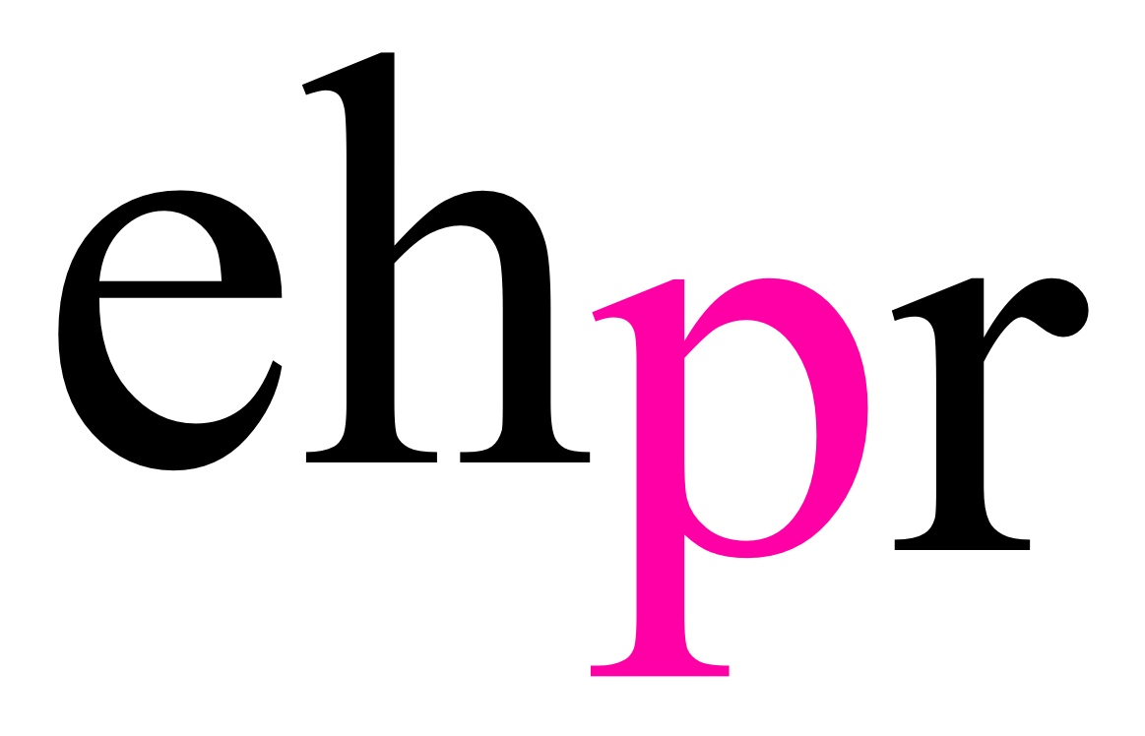

FOLLOWING A CRITICALLY ACCLAIMED WEST END RUN
DAVID MAMET’S OLIVIER & PULITZER PRIZE-WINNING CLASSIC

GLENGARRY GLEN ROSS

STARRING MARK BENTON & NIGEL HARMAN

WILL TOUR THE UK FROM 14 FEBRUARY 2019
OPENING AT WOKING’S NEW VICTORIA THEATRE

‘An extraordinary experience… Go see it!’ BBC Radio 4

‘Bitterly funny and acutely savage’ Daily Telegraph

⬇⬇⬇⬇
The Guardian, The Times, Daily Mail, Evening Standard, Mail On Sunday, Time Out, Financial Times, The Independent, The Observer

After ‘sealing the deal’ with critics and audiences alike during its smash hit West End run, Sam Yates’ unmissable production of one of David Mamet’s greatest and most lauded plays, Glengarry Glen Ross will embark on a nationwide tour from 14 February 2019 opening at the New Victoria Theatre, Woking. The hard-nosed sales team in this darkly funny classic will then visit Birmingham, Manchester, Milton Keynes, Glasgow, Richmond, Brighton and Cardiff with further tour dates to be announced shortly.

Taking on the memorable roles of salesmen Shelley ‘The Machine’ Levene and the ruthless Ricky Roma are Mark Benton (Waterloo Road, As You Like It, Dirty Rotten Scoundrels, Hobson’s Choice) and Olivier award-winning Nigel Harman (EastEnders, A Chorus of Disapproval, Shrek the Musical) respectively, with further casting to be announced in due course.

Lies. Greed. Corruption. It’s business as usual.

Set in an office of cut-throat Chicago salesmen. Pitched in a high-stakes competition against each other, four increasingly desperate employees will do anything, legal or otherwise, to sell the most real estate. As time and luck start to run out, the mantra is simple: close the deal and you've won a Cadillac; blow the lead and you're f****d.

The production of this trailblazing modern classic has designs by Chiara Stephenson, lighting by Richard Howell and is produced by ATG Productions, Act Productions and Glass Half Full Productions.

Mark Benton’s (Shelley Levene) theatre credits include As You Like It, Invisible Friends, Accidental Death and Devil's Disciple all at the National Theatre, Dirty Rotten Scoundrels and Hairspray on UK Tour, Hobson's Choice at Regent's Park Open Air Theatre, Railway Children at Waterloo Station, The Wind in the Willows for Northern Stage, As You Like It for Cheek By Jowl on World Tour, Richard III for the RSC, End of the Food Chain at the Stephen Joseph Theatre, Cock and Bull at Riverside Studios, Hurly Burly at the Old Vic, The Front Page at the Donmar Warehouse, Kosher Harry at the Royal Court, Comedians at the Lyric Hammersmith and A Day in the Death of Joe Egg at Nottingham Playhouse. His television credits include Shakespeare and Hathaway, Midsomer Murders, Ratburger, The Halcyon, Outnumbered Christmas Special, Drunk History, The Tracey Ullman Show, Damned, Inside No. 9, Summer Here, Father Brown, Strictly Come Dancing, Psychobitches, The Job Lot, White Van Man, George Gently, Waterloo Road, Land Girls, The Fixe, Silent Witness, Coming Up - 'I Don't Care', Hustle, Desperate Romantics, Britannia High, Personal Affairs, Blue Murder, City Lights, Most Sincerely, Clash of the Santas, Soapington, The Street II, I'm With Stupid, Northern Lights, If I Had you, Booze Cruise, Afterlife, Inspector Lynley, Planespotting, Doctor Who, Early Doors, Quite Ugly One Morning, Christmas Lights, Catterick, Born and Bred, Clocking Off, Second Coming, Murphy's Law, Out Of Control, Crime and Punishment, Preston Front, Micawber, Anderson, Eureka Street, Nature Boy, Gimme Gimme Gimme, Letting Go, Ballykisangel, Randall & Hopkirk Deceased, This is Personal, Barbara, The Jump, The Governor, Finney and Panto! His film credits include The Medusa, Danny and the Human Zoo, Eddie the Eagle, Career Girls, Sea Change, Topsy Turvy, The Lost Son, Never Better, Morality Play, Mister In-Between, Redemption Road, Lighthouse Hill, Breaking and Entering, Flick, Condementia, Beyond the Pole and Imanginarium of Dr Parnassus.

Nigel Harman’s (Ricky Roma) stage credits include A Chorus of Disapproval, I Can’t Sing at the Palladium, The School for Scandal for Theatre Royal Bath, Shrek The Musical at Theatre Royal Drury Lane, Celebration at the Gate Theatre, Dublin, True West at Sheffield Crucible, Public Property at Trafalgar Studios, Three Days of Rain at the Apollo Theatre, The Common Pursuit at the Menier Chocolate Factory, The Caretaker at the Tricycle Theatre/Sheffield Theatre/UK Tour, Guys and Dolls at the Piccadilly Theatre, Privates on Parade at the Donmar Warehouse, Three Sisters and My One and Only at Chichester Festival Theatre, Lady in the Van at Birmingham Rep, Much Ado About Nothing & Pirates of Penzance, at Regent’s Park Open Air Theatre, Mamma Mia at the Prince Edward Theatre, Damn Yankees at the Adelphi Theatre and Tommy at the Shaftesbury Theatre. Television credits include Cuckoo 4, Mount Pleasant, Downton Abbey, City of Vice, EastEnders, Hotel Babylon, Lark Rise to Candleford, Miss Marple The Mirror Crack’d, Red Cap and The Outsiders. Nigel’s film work includes Patience, Telstar and Blood Diamond.

Sam Yates’ (Director) directing credits include The Phlebotomist at Hampstead Theatre, Desire Under the Elms at the Sheffield Cruicible, Murder Ballad at the Arts Theatre, Cymbeline with Pauline McLynn & Joseph Marcell at the Sam Wanamaker Playhouse, East is East with Jane Horrocks & Ayub Khan Din at Trafalgar Studios followed by two national tours, The El. Train with Ruth Wilson at Hoxton Hall, Billy Liar at the Royal Exchange, Cornelius at the Finborough Theatre and 59E59 New York and Mixed Marriage at the Finborough Theatre.

Sam’s screen credits include The Hope Rooms with Ciarán Hinds & Andrew Scott (Rather Good Films, Bill Kenwright Films, winner Grand Prize Future Filmmaker Award, RIIFF 2016); Cymbeline with Hayley Atwell, All’s Well That Ends Well with Lindsay Duncan & Ruth Wilson, and Love’s Labour’s Lost with Gemma Arterton & David Dawson (The Complete Walk, Shakespeare’s Globe). Yates directed two music videos for Ivor Novello-nominated band Bear’s Den, Emeralds and Auld Wives (MTV’s A-list). For radio he directed Ecco featuring Hayley Atwell (BBC Radio 4).

In 2016 he was voted one of Screen International’s Stars of Tomorrow having previously featured as rising star in theatre in The Observer, and in GQ Magazine’s Men of the Next 25 years for theatre.

David Mamet (Playwright) is the author of the plays November, Boston Marriage, Faustus, Oleanna, Glengarry Glen Ross (1984 Pulitzer Prize and New York Drama Critics Circle Award), American Buffalo, The Old Neighborhood, Life in the Theatre, Speed-the-Plow, Edmond, Lakeboat, The Water Engine, The Woods, Sexual Perversity in Chicago, Reunion and The Cryptogram (1995 Obie Award). His translations and adaptations include Faustus, Red River by Pierre Laville and The Cherry Orchard, Three Sisters and Uncle Vanya by Anton Chekov. His films include The Postman Always Rings Twice, The Verdict, The Untouchables, House of Games (writer/director), Oleanna (writer/director), Homicide (writer/director), The Spanish Prisoner (writer/director), Heist (writer/director), Spartan (writer/director) and Redbelt (writer/director). Mamet is also the author of Warm and Cold, a book for children with drawings by Donald Sultan, and two other children’s books, Passover and The Duck and the Goat. His most recent books include True and False, Three Uses of the Knife, The Wicked Son, and Bambi Vs. Godzilla.

LISTINGS

GLENGARRY GLEN ROSS
BY DAVID MAMET
DIRECTED BY SAM YATES
14 FEBRUARY – 4 MAY 2019
UK TOUR

Website: atgtickets.com

DATES AND VENUES

WOKING New Victoria Theatre atgtickets.com/woking
Thurs 14 – Sat 16 February 2019 0844 871 7645

BIRMINGHAM New Alexandra atgtickets.com/birmingham
Mon 18 – Sat 23 February 2019 0844 871 3011
On sale Monday 25 June

MANCHESTER Opera House atgtickets.com/manchester
Mon 25 – Sat 30 March 2019 0844 871 3018
On sale Monday 25 June

MILTON KEYNES Theatre atgtickets.com/miltonkeynes
Mon 1 – Sat 6 April 2019 0844 871 7652
On sale Monday 25 June

GLASGOW Theatre Royal atgtickets.com/glasgow
Mon 8 – Sat 13 April 2019 0844 871 7647

RICHMOND Theatre atgtickets.com/richmond
Mon 15 – Sat 20 April 2019 0844 871 7651
One sale Monday 25 June

BRIGHTON Theatre Royal atgtickets.com/brighton
Mon 22 – Sat 27 April 2019 0844 871 7650
On sale Monday 25 June

CARDIFF New Theatre newtheatrecardiff.co.uk
Mon 29 April – Sat 4 May 2019 029 2087 8889
On sale Friday 7 September

NOTES TO EDITORS

AMBASSADOR THEATRE GROUP PRODUCTIONS

Led by Executive Producer Adam Speers and producers Richard Darbourne and Emily Vaughan-Barratt, ATG Productions have an impressive track record as an international, award-winning production company.

ATG Productions most recent work includes OSLO and Glengarry Glen Ross starring Christian Slater in the West End, BIG FISH the musical starring Kelsey Grammer in London and Sunday in the Park with George starring Jake Gyllenhaal and Annaleigh Ashford at the newly restored Hudson Theatre on Broadway. Upcoming West End productions include Ian McKellen starring in King Lear , Sharon D. Clarke in Caroline, Or Change and a ground-breaking staging of all of Harold Pinter’s one-act plays starring Martin Freeman, Danny Dyer, Tamsin Greig, David Suchet, Jane Horrocks amongst others.

In 2017 ATG productions co-produced Hamlet at the Harold Pinter Theatre, starring Andrew Scott. Other projects have included a series of collaborations with The New Group. Most recently, a production of Sam Shepard’s gothic masterpiece Buried Child, earning Ed Harris a Best Actor Olivier Award nomination. Harris starred alongside real life partner Amy Madigan (Gone Baby Gone), and exciting new faces Jeremy Irvine (War Horse) and Charlotte Hope (Game of Thrones). This production was preceded by acerbic new comedy, The Spoils, written by and starring BAFTA, Golden Globe and Academy Award nominated Jesse Eisenberg, who was joined by a brilliant ensemble cast.

Continuing this commitment to exciting new writing, last year ATG Productions presented internationally acclaimed actor Matthew Perry (Friends, The Odd Couple) as he starred in the World Premiere of his playwriting debut, The End of Longing. The bittersweet new comedy saw Perry reunited with award-winning director, Lindsay Posner (Speed-the-Plow, Other Desert Cities).

ATG Productions also presented the phenomenally successful Jamie Lloyd Company (JLC) series at Trafalgar Studios, which combined pertinent programming and accessible pricing with the aim of enabling the development of a new, more diverse theatrical audience. The radical reworkings of classic works that were central to this season included Doctor Faustus (Duke of York’s) starring Kit Harington; The Maids starring Uzo Aduba, Zawe Ashton and Laura Carmichael; The Homecoming starring John Simm, Gary Kemp and Keith Allen; The Ruling Class and Macbeth starring James McAvoy; East is East starring Jane Horrocks; Richard III starring Martin Freeman; The Pridestarring Hayley Atwell; and The Hothouse starring Simon Russell Beale and John Simm.

Other West End productions have included the stage adaptation of Women on the Verge of a Nervous Breakdown, Pedro Almodóvar’s 1988 film of the same name by David Yazbek and Jeffrey Lane (Playhouse Theatre) and starring Tamsin Greig and Haydn Gwynne. Other co-productions include a collaboration with the Almeida Theatre and Sonia Freidman productions, bringing the critically acclaimed Oresteia to Trafalgar Studios in summer 2015. Directed by Robert Icke (Mr. Burns, 1984), this five star production also featured Lia Williams (Old Times, Earthquakes in London) and Jessica Brown Findlay (Downton Abbey).

In the touring spectrum, ATG Productions also has a commitment to bringing high quality work to the regions. Recent musicals have included Richard O’Brien’s hugely successful rock’n’roll musical The Rocky Horror Show. Other touring musicals include Priscilla Queen of the Desert, Monty Python’sSpamalot, Jersey Boys and Dolly Parton’s 9 to 5 The Musical. ATG Productions has also launched the long awaited UK tour of the multi-Olivier Award-winning musical Sunny Afternoon, with music and lyrics by Ray Davies, book by Joe Penhall and direction by Edward Hall.

In 2018 ATG Productions produced a successful UK tour of Strangers on a Train starring Chris Harper, Jack Ashton and John Middleton. This followed a new touring production of the Victorian thrillerGaslight, which opened in January 2017, starring Kara Tointon, Keith Allen and Rupert Young. Previous touring plays include Noel Coward’s comedy Private Lives, starring Tom Chambers (Top Hat the Musical) and Charlotte Ritchie (Call the Midwife).

ACT PRODUCTIONS

Founded in 1994 by Roger Wingate, Act Productions is a leading theatre producer in the West End, and of national and international tours.

Recent work under producer Ros Povey includes: The Philanthropist (Trafalgar Studios), Guards at the Taj directed by Jamie Lloyd at the newly reopened Bush Theatre, the UK premiere of A Room with a View, directed by Adrian Noble and starring Felicity Kendal (Theatre Royal Bath & UK Tour) and the transfer of the Royal Opera House production of The Wind in the Willows, which won the Olivier Award for Best Family Entertainment in 2014.

Over more than two decades, Act has worked with the most exciting writers, directors and performers - both new and established - to present work of the utmost creative and commercial integrity. Many of Act’s productions have gone on to win Olivier, Tony and Evening Standard nominations and awards.

Highlights include: A Chorus Line (London Palladium); Yes Prime Minister starring David Haig (Chichester, Gielgud, UK Tour, Apollo, Trafalgar Studios); the Olivier award-winning Legally Blonde – The Musical starring Sheridan Smith (Savoy); Being Shakespeare with Simon Callow (Trafalgar Studios, Sky Arts and DVD); Flare Path starring Sienna Miler, James Purefoy and Sheridan Smith (Theatre Royal Haymarket); Krapp’s Last Tape starring Michael Gambon (Duchess); the Oliver award-winning ENRON directed by Rupert Goold (Noel Coward), the Olivier award-winning Spring Awakening (Novello); the Tony award-winning Boeing Boeing, directed by Matthew Warchus and starring Roger Allam, Mark Rylance and Frances De la Tour (Comedy, Broadway & UK Tour); the Tony and Evening Standard award-winning Frost/Nixon starring Frank Langella and Michael Sheen (Gielgud and Broadway); A Voyage Round My Father starring Sir Derek Jacobi (Wyndham's); Matthew Bourne’s Edward Scissorhands (Sadler’s Wells, UK and Far East tour); the Tony and Evening Standard awardwinning Mary Stuart directed by Phyllida Lloyd and starring Harriet Walter & Janet McTeer (Apollo & Broadway) and the Olivier and Evening Standard award-winning Don Carlos starring Sir Derek Jacobi (Gielgud).

GLASS HALF FULL PRODUCTIONS

Glass Half Full Productions is a London-based production company, managed by Gareth Lake and founded by Gareth and Adam Blanshay.

UK credits include: King Lear, Caroline or Change, Daisy Pulls It Off, Oslo, Hamlet, Dreamgirls, Buried Child, Funny Girl, The End of Longing, The Spoils, Doctor Faustus, A Midsummer Night’s Dream, A Christmas Carol, Mack and Mabel, Made in Dagenham, Sunny Afternoon (Winner of four 2015 Olivier Awards, including Best New Musical), The Nether, Shrek UK Tour, Dirty Rotten Scoundrels, I Can’t Sing, Ghost Stories, 1984, Ghosts (Winner of three 2014 Olivier Awards, including Best Revival), Mojo.

Broadway credits include: Groundhog Day, Sunday in the Park with George, Living on Love, The Curious Incident of the Dog in the Night Time (Broadway and National Tour), the Globe transfer of Twelfth Night/Richard III.

International credits include: Matilda and My Fair Lady in Australia and Blue Man Group World Tour.

The GHF team is made up of Clemmie Forfar (Associate Producer), Pam Jahn (Executive Assistant) and Rebecca Vaa (Production Assistant) in London, and Victoria Weinberg (Associate Producer) and Patrick Roberts (Development Associate) in New York.

PRESS CONTACT: EMMA HOLLAND PR (EHPR)
W: www.emmahollandpr.com

Emma Holland Georgie Robinson
E: emma@emmahollandpr.com E: georgie@emmahollandpr.com
M: 0791 709 4203 M: 0751 211 2776

Jocasta Marron Natasha Haddad
E: jocasta@emmahollandpr.com E: assistant@emmahollandpr.com
M: 0772 517 1327 M: 07967 175 221

