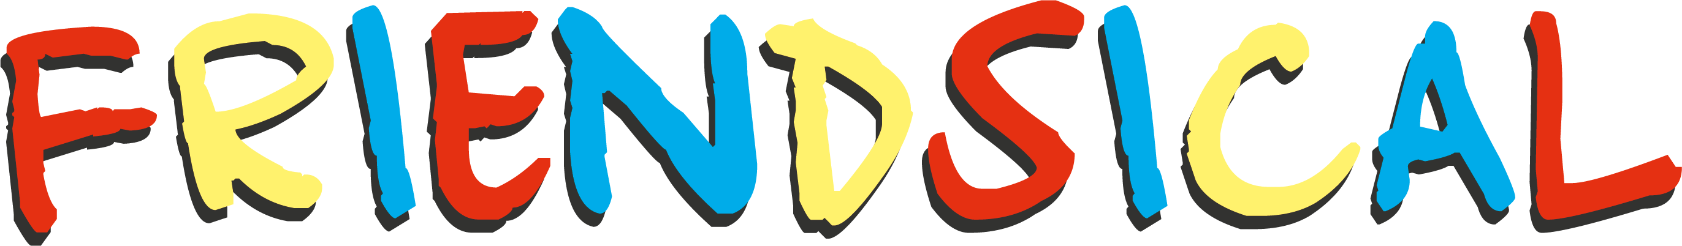

A NEW PARODY MUSICAL ABOUT FRIENDS

INSPIRED BY THE ICONIC TV SHOW FRIENDS
MARKING THE SHOW’S 25TH ANNIVERSARY

WILL TOUR NATIONALLY FROM 15 JULY 2019

WITH A FULL RUN AT THE EDINBURGH FESTIVAL FRINGE
FROM 1 – 25 AUGUST AS PART OF THE ASSEMBLY FESTIVAL PROGRAMME AT THE ASSEMBLY ROOMS

The UK tour of the hilarious parody musical Friendsical written by Miranda Larson, opens at the Everyman Theatre in Cheltenham on 15 July 2019 followed by a nationwide tour visiting: Darlington, Derry, Newcastle, Kingston, Malvern, Blackpool, Chelmsford, Southampton and Croydon. Friendsical will have a full run at the Edinburgh Festival from 1 – 25 August as part of the Assembly Festival programme in the Music Hall of The Assembly Rooms.

When Ross’ wife leaves him for another woman, he fears he will never find love again. But then Rachel runs back into his life... will he end up with his one true love?

Featuring original songs such as ‘(He’s her) Lobster!’, ‘Richard’s Moustache’ and ‘You’re Over Me? When Were You Under Me?’, the gang take on naked Thursdays, a power cut, and a dinosaur convention.

What could possibly go wrong?

This is a loving parody not to be confused with the Warner Bros Entertainment Inc. series Friends.

Miranda Larson is a highly experienced writer-director for TV and theatre. A huge fan of the TV Show, Friends, Miranda was inspired to write her own friends-based comedy, The Box Upstairs and it was her first commissioned play in 2004.

Her most recent credits include the adaptation of Tom Fletcher’s Christmasaurus for the Hammersmith Apollo, and the writing and directing of Peter Harris and Deborah Allwright’s The Night Pirates, which opened at the Rose Theatre Kingston and toured the UK. In addition are Cartoon Network Live and Trolls Live currently touring overseas. Other live show credits include the comedies SpongeBob Live & The Amazing World Of Gumball.

TV credits include Life Bites and Bienvenue Bienvenida Welcome for the Disney Channel. Hubble, Bubble & Squeak for Nickelodeon, Chip and Potato for Darrall Mcqueen & Netflix.

Miranda is currently developing Sleepy Hollow for the stage.

Friendsical is produced by Birdbrooke Entertainment ltd. Full casting and creatives will be announced in due course.

LISTINGS

FRIENDSICAL
WRITTEN BY MIRANDA LARSON
15 JULY – 2 NOVEMBER 2019
UK TOUR

Twitter/Instagram: @Friendsical
Production Artwork: Available to download HERE

TOUR DATES

CHELTENHAM Everyman Theatre Everymantheatre.org.uk
15 – 20 July 2019 01242 572 573

DARLINGTON Hippodrome Darlingtonhippodrome.co.uk
22 – 27 July 2019 01325 405405

EDINBURGH Assembly Rooms assemblyfestival.com
01 – 25 August 2019 01316233030

DERRY Millennium Forum Millenniumforum.co.uk
26 – 31 August 2019 028 7126 4455

NEWCASTLE Northern Stage Northernstage.co.uk
2 – 7 September 2019 0191 230 5151

KINGSTON Rose Theatre Rosetheatrekingston.org
9 – 14 September 2019 020 8174 0090

MALVERN Festival Theatre Malvern-theatres.co.uk
16 – 21 September 2019 01684 892277

BLACKPOOL Grand Theatre Blackpoolgrand.co.uk
23 – 28 September 2019 01253 290 190

CHELMSFORD Civic Theatre Chelmsford.gov.uk/theatres
14 – 19 October 2019 01245 606 505

SOUTHAMPTON Nuffield Theatre Nstheatres.co.uk
21 – 26 October 2019 0238067 1771

CROYDON Ashcroft Theatre Fairfield.co.uk
28 October – 2 November 2019 0203 292 0001

PRESS CONTACT: EMMA HOLLAND PR (EHPR)
W: www.emmahollandpr.com

Emma Holland Georgie Robinson
E: emma@emmahollandpr.com E: georgie@emmahollandpr.com
M: 0791 709 4203 M: 0751 211 2776

Jocasta Marron Natasha Haddad
E: jocasta@emmahollandpr.com E: assistant@emmahollandpr.com
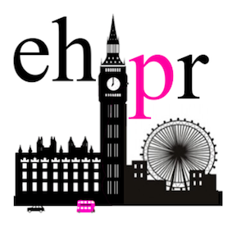
M: 0772 517 1327 M: 07967 175 221

