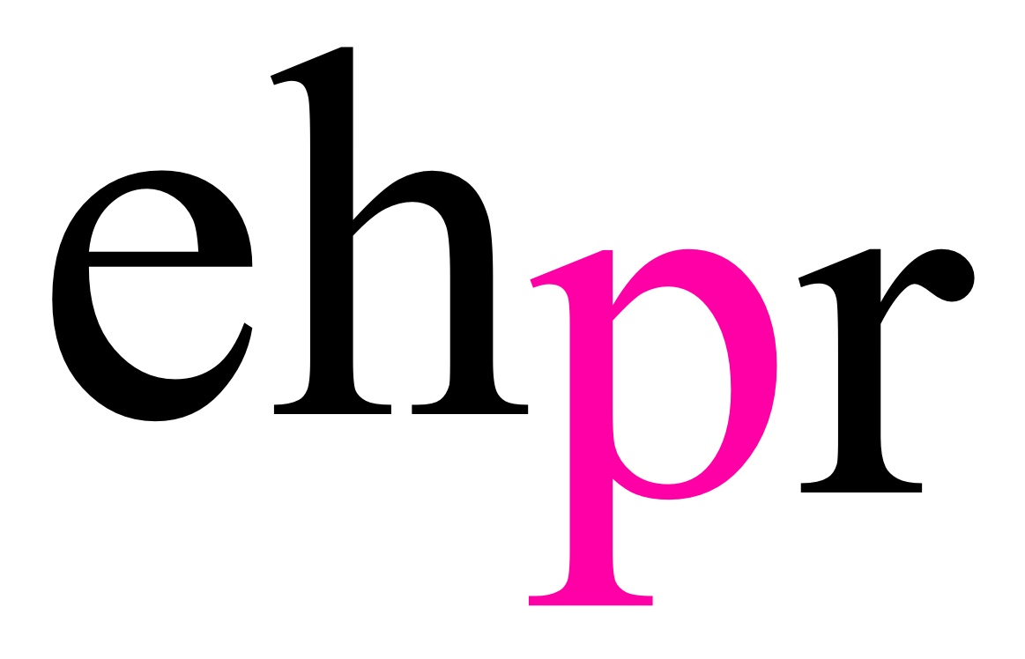

SUBMISSIONS NOW OPEN FOR ARIA ENTERTAINMENT’S 2018
FROM PAGE TO STAGE
FESTIVAL OF NEW MUSICAL THEATRE
RETURNING FOR A 6TH SUCCESSFUL YEAR
FROM 10 SEPTEMBER AT SOUTHWARK PLAYHOUSE

ALONGSIDE A NORTHERN EXPANSION
INCLUDING A FULL MUSICAL COMMISSION WITH
FROM PAGE TO STAGE NORTH WEST
IN PARTNERSHIP WITH THE HOPE MILL THEATRE

Aria Entertainment’s thriving new musical theatre festival, From Page To Stage returns for its 6th year, with submissions now open. This year’s festival will take place in September at Southwark Playhouse, and follows the hugely successful 2017 festival, which took place at The Other Palace, and received over 300 submissions from across the UK and internationally.

From Page To Stage 2018 will showcase each step of how an original musical is developed, from a song-writing showcase, to full staged readings of new musicals. There will also be a showcase evening, which will feature sections of at least four different shows in development with a repertory cast.

Alongside the 2018 Festival at Southwark Playhouse, FPTS will launch a new venture, From Page To Stage North West in partnership with Aria Entertainment’s northern home, the Hope Mill Theatre, which was founded by Joseph Houston and William Whelton. From Page To Stage North West is an exciting and unique opportunity offering one writing team a full writing commission of an original musical.

The writing team selected at the end of this process will be fully commissioned and receive a workshop of the new musical in 2019, with the intention to stage the piece fully in 2020 at the Hope Mill Theatre. The team will be selected through a series of pitching days.

Producer Katy Lipson from Aria Entertainment says: "I have always believed that the future of musical theatre in this country can only be brought about by investing regularly in new musicals and new writers and so I am proud to be presenting the 6th year of the From Page To Stage Festival of new musicals. In just 6 years we have given a platform to over 100 new musicals from over 15 countries with some shows going on to have full productions, more development workshops and even publishing deals. Contrary to other showcases, we invite both industry and the public in to take part in the early stage development of these works, which is important in helping to mould audiences’ expectations of what the genre can actually deliver. We are delighted to be presenting work at London’s Southwark Playhouse this year and know their incredible record as a receiving house for Musical Theatre means they have a large receptive audience ready to receive this exciting new work.

Our expansion into From Page To Stage North West further cements our commitment to developing, commissioning and staging new musicals in the UK. We couldn’t be more thrilled to be partnering with Joe and Will at the Hope Mill Theatre to find new musicals for us to actually bring from page to stage by 2020.”

Joseph Houston, co-artistic director of the Hope Mill Theatre adds: “We are so thrilled to announce our musical commission as part of Katy’s From Page To Stage season. When Will, Katy and I formed our collaboration it was always our aim to champion new musical theatre and to date we have been so fortunate to be able to stage many premieres, but creating new work was always our ambition and this commission is hopefully the first of many grass roots projects to come from Hope Mill Theatre. It is such an exciting time for Manchester to have From Page To Stage branch out to the North West and we cannot wait to see how we can continue to champion and develop new musicals regionally.”

Young producer and founder of Aria Entertainment, Katy Lipson launched the From Page To Stage Festival in 2013. The festival has gone from strength to strength, and Katy has now produced five seasons, which have showcased over 8 new musicals each year. The project was supported by Grant For The Arts in 2014, ‘15, ‘16, and ‘17, and the 2017 season took place at Andrew Lloyd-Webber’s recently acquired theatre, The Other Palace.

So far, Aria Entertainment and the Hope Mill Theatre have had 2 years working together, making it into The Stage’s 100 Most Influential Figures 2018, and producing over 8 in-house productions and this has developed to 3 London transfers. Many of these shows were UK, Northern or World premieres of new musicals.

Entrants for the From Page To Stage 2018 Festival need to include their show title, lyricist/composer/book writer, a short synopsis and three record tracks and scenes from the show. Each submission of a new musical will be fully assessed by the From Page To Stage expert literary team. In July 2018, it will be announced which musicals have been selected for this years festival.

Writing teams interested in From Page To Stage North West will need to sign up on the From Page To Stage website and register their interest. Writing teams will then be invited to a pitching day in August 2018.

Submissions for FPTS 2018 are open until 25 June 2018.

For full details and more information about submitting a musical, go to the From Page To Stage website: www.frompage2stage.com.

NOTES TO EDITORS

ARIA ENTERTAINMENT

Aria Entertainment was founded in 2012 by Katy Lipson.

In 2017, Katy was awarded the Best Producer award by the Off-West End Awards and is a recipient of the Stage One Bursary and Start Up Award. She made The Stage 100 this year with Joe Houston and William Whelton for their work at Hope Mill Theatre.

Katy has recently finished two hugely successful runs as lead producer on the UK Tour of The Addams Family and the 50th Anniversary production of Hair at the London Vaults, which she originally co-produced with Hope Mill Theatre in 2016, where she is Resident Producer and co-artistic director for in-house productions. Hair won the award for Best Musical Revival at the 2018 Whatsonstage Awards. She has also recently produced the London transfer of new musical The Toxic Avenger at The Arts Theatre, West End following a run at The Edinburgh Festival’s Pleasance Theatre.

Other recent productions include: Spring Awakening and Little Women (Hope Mill Theatre); the London transfers of Pippin (Southwark Playhouse) and Yank! (Charing Cross Theatre); tick, tick...BOOM! (Park Theatre); Pippin, The ToyBoy Diaries, Yank!, Parade and Hair (Hope Mill Theatre); Promises, Promises and The Toxic Avenger (Southwark Playhouse); Vanities The Musical (Trafalgar Studios); See What I Wanna See and The Return Of The Soldier (Jermyn Street Theatre); Bar Mitzvah Boy (Upstairs at the Gatehouse); The Adventures of Pinocchio, Lizzie and The Who’s Tommy (Greenwich Theatre); The House of Mirrors & Hearts, Supported By Grant For The Arts (Arcola Theatre) and Marry Me A Little, Jerry’s Girls and Forever Plaid (St. James Studio).

Other current projects include: It’s Only Life (Union Theatre), Aspects of Love, The Return Of The Soldier & A Christmas Story (Hope Mill Theatre) and Unexpected Joy (York Theatre, Off-Broadway) and (Southwark Playhouse).

www.aria-entertainment.com

HOPE MILL THEATRE

Hope Mill Theatre was the dream of couple Joseph Houston and William Whelton who after a career in Musical Theatre and living in London, became inspired by the highly regarded Off West End theatres and the high-quality work they were creating. With the growing theatre industry blossoming in Manchester and no medium sized venues, they set up and established the independent venue, Hope Mill Theatre in November 2015.

The venue has firmly placed itself on the northern map for its ambitious in-house musical productions. In October 2016 Joseph and William were awarded the Hospital Club Award for contribution to Theatre and Performance. They recently won a Special Achievement Award at the Manchester Theatre Awards and the venue was nominated for Fringe Theatre of the Year 2016.

Joseph and William joined forces with Katy Lipson of Aria Entertainment to collaborate on a season of musicals, including Parade, Hair, Yank!, Little Women, The ToyBoy Diaries and Spring Awakening all receiving critical acclaim.

William Whelton is a recent recipient of the Stage One Young Producers Bursary for emerging producers.

Hope Mill Theatre hosts many emerging Manchester theatre companies, touring productions and offers a varied programme for its audiences. Recently Hope Mill Theatre was nominated for the prestigious Peter Brook Empty Space Award, which celebrates innovation in smaller theatres and earlier this year Hope Mill Theatre was named Fringe Theatre of Theatre 2018 by The Stage. Will and Joseph - alongside Katy - were also named in industry powerlist The Stage 100 for the first time this year.

www.hopemilltheatre.co.uk

LISTINGS

ARIA ENTERTAINMENT’S 2018 FROM PAGE TO STAGE FESTIVAL
SOUTHWARK PLAYHOUSE
FROM 10 – 25 SEPTEMBER 2018

Events & Readings: 10, 11, 17, 18, 24 & 25 September

Address: Southwark Playhouse, 77-85 Newington Causeway, London, SE1 6BD

Website:
www.frompage2stage.com
www.aria-entertainment.com
www.hopemilltheatre.co.uk

Twitter:
@FromPage2Stage
@AriaEnts
@HopeMillTheatr1

Facebook:
@FromPageToStageMusicals
@AriaEntertainment
@HopeMillTheatre

PRESS CONTACT: EMMA HOLLAND PR (EHPR)
W: www.emmahollandpr.com

Emma Holland Georgie Robinson
E: emma@emmahollandpr.com E: georgie@emmahollandpr.com
M: 0791 709 4203 M: 0751 211 2776

Jocasta Marron Natasha Haddad
E: jocasta@emmahollandpr.com E: assistant@emmahollandpr.com
M: 0772 517 1327 M: 07967 175 221

