KAREN RUIMY PRESENTS
HOUSE OF FLAMENKA
CREATED AND DIRECTED BY ARLENE PHILLIPS
WITH CHOREOGRAPHY BY JAMES COUSINS AND
FLAMENCO CHOREOGRAPHY BY FRANCISCO HIDALGO
RUNNING AT THE PEACOCK THEATRE
FROM 17 - 28 OCTOBER 2023
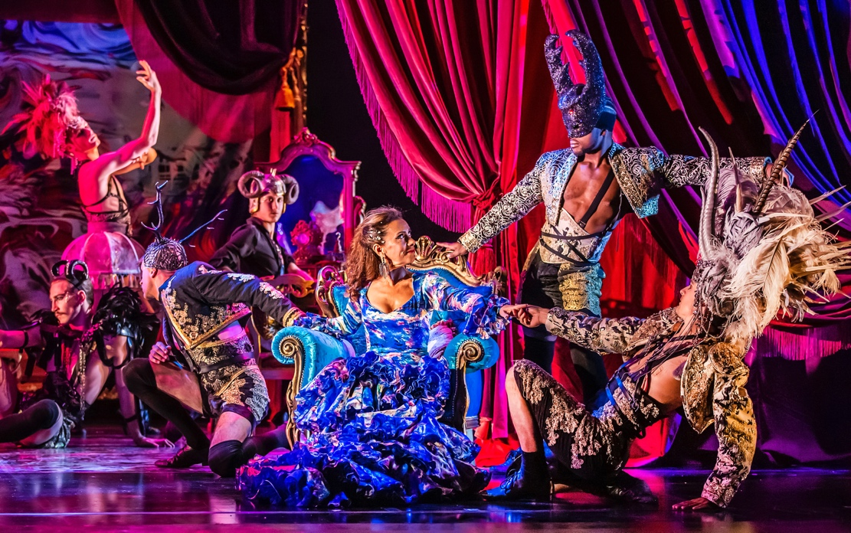
★★★★★
A world of pure decadence and fantasy,
a show that constantly dazzles
Love London Love Culture
★★★★★
A heady concoction of energy, attitude and talent
Queerguru
Bigger, bolder, and sexier than ever, House of Flamenka returns to the Peacock due to phenomenal demand. Created and directed by dance royalty Arlene Phillips (Grease, Guys and Dolls, Strictly Come Dancing), and starring renowned flamenco dancer Karen Ruimy (When Jazz Meets Flamenco), this fusion of contemporary dance, flamenco, passion, and high drama is the best night out this autumn!

Featuring an ensemble of internationally acclaimed male dancers, with an intoxicating mix of contemporary pop, Latin and flamenco music, this show will leave you dancing all the way home.

Arlene Philips has said “I am delighted to announce House Of Flamenka is returning to the Peacock Theatre with more sass, more sex, more style and smashing the fourth wall with our dazzling and dynamic flamenco and contemporary dancers, sensational choreographers James and Francisco and of course, our star Karen Ruimy”

Karen Ruimy has said “I am so delighted that the Peacock Theatre have chosen to invite House Of Flamenka back after last year’s season. So much work and passionate vision went into creating what we believe is a fantastic show and to have the chance to share it again with the London and international audiences is amazing! Creatively for me it has been an incredible journey of creating a fusion of flamenco and contemporary dance, mixing in pop and classical flamenco music. I look forward to continuing that journey when we return in October. I’d also like to say working with Arlene has been an absolute pleasure and I learn everyday from her. I am looking forward to revisiting that creative process again in the rehearsal room and expressing this high energy, one-of-a-kind choreography and artistic creation on the Peacock stage!”

With a glittering set, lavish costumes, red-hot choreography and a soundtrack bursting with drama and emotion, House of Flamenka is the ultimate night of theatre. Award-winning choreographer James Cousins and flamenco master Francisco Hidalgo come together to choreograph this sexy and spicy spectacular.

You are invited to the House of Flamenka, where hypermasculinity and high camp collide in the sexiest, steamiest evening in London.
Created and directed by Arlene Phillips with co-creator and producer Karen Ruimy. Choreography by James Cousins with flamenco choreography by Francisco Hidalgo.
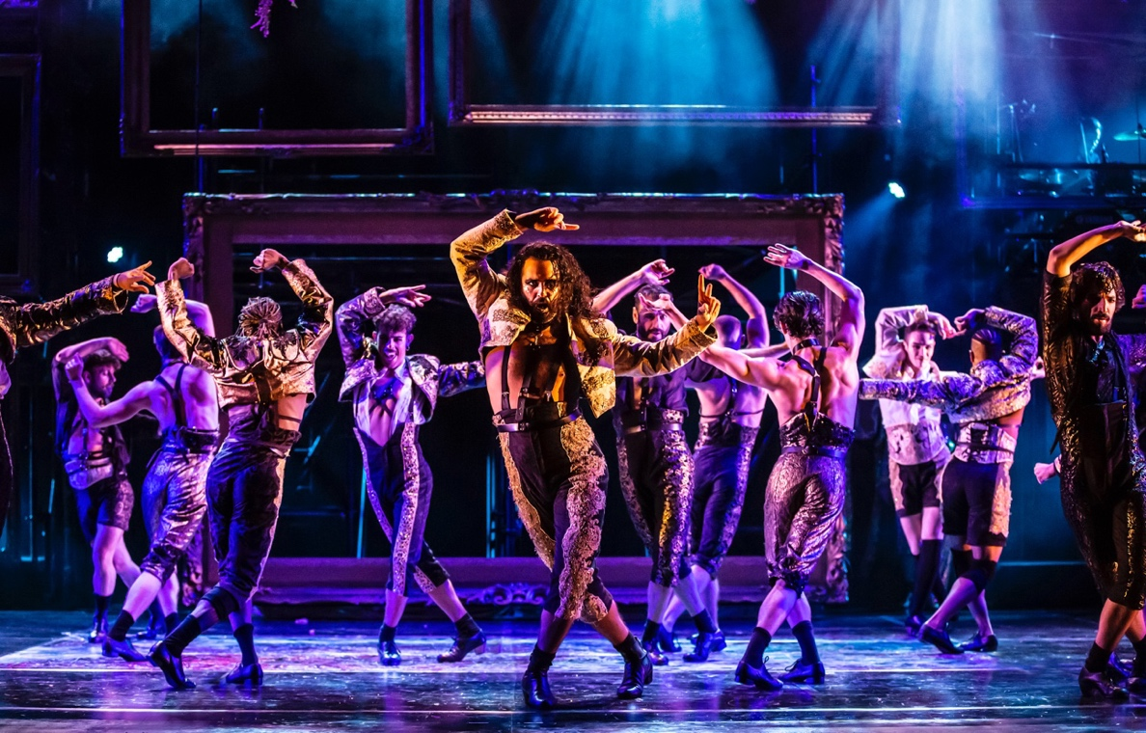

The Cast of House of Flamenka - Photo Credit: Pamela Raith Photography - Past Production (2022)
NOTES TO EDITORS
KAREN RUIMY (PRODUCED, CO-CREATED AND STARS IN HOUSE OF FLAMENKA)
An accomplished flamenco dancer, Karen Ruimy is the definition of multifaceted being a dancer, creative director and singer-songwriter. Her most recent show, ‘When Jazz Meets Flamenco’, a fusion of music, expression, dance & culture, premiered in a sold-out run at Lilian Baylis Studio. She previously performed and produced ‘Flamen’ka’ at Casino de Paris, ‘Flamen’ka Nueva’ at Folies Bergeres, ‘Cabaret Flamen’ka’ at La Cigale, Sangre and Riverside Studios which was directed and choreographed by Redha Benterifour (Roman Polanski, Rick Rosenthal, Alvin Ailey, San Francisco Ballet, Ballet Nacional de Cuba), ‘Zik’r’, which sold out a week-long run at the Peacock Theatre, whose musical director was Youth (founding member and bassist of the rock band Killing Joke, producer The Verve’s Urban Hymns and other member of The Fireman alongside Paul McCartney) at the World Sufi Spirit Festival in Jodphur, India which also toured for three years. She recently released ‘Black Coffee’, a 10-track album of songs that featured the last produced material from the eminent producer Phil Ramone (Ray Charles, Bob Dylan, Paul Simon, Marilyn Monroe, Frank Sinatra, Stevie Wonder, Dusty Springfield, Barbra Streisand) made before he passed away. Youth and Tim Bran (London Grammar, Bloc Party) added additional production. The result was a decadent selection of covers that more than stand on their own, covering The Mamas & the Papas to Radiohead and some French classics in between. Ruimy was originally an international banker but she left that career to pursue creative and spiritual ventures. Alongside broadcaster Mariella Frostrup and human rights lawyer Jason McCue, Ruimy went on to establish GREAT (Gender Rights Quality Action Trust) Initiative to ensure that all genders are given equal and fair opportunities. Beyond her humanitarian work, Ruimy is known for her spiritual work, podcast, webinars and writing across a series of best-selling books, founding and serving as creative director of sought-after lifestyle brand KALMAR and contributing regularly to publications including UK Psychologies Magazine and The Huffington Post.

ARLENE PHILIPS (DIRECTOR)
Arlene’s prolific career credits include: Director: The Cher Show, Lord of the Dance, Saturday Night Fever, The Music of Andrew Lloyd Webber, Strictly Come Dancing Live Tour, Hair at the London Palladium, EFX at the MGM Grand. Choreographer (Musical Theatre): Guys and Dolls (upcoming), Grease, Starlight Express, We Will Rock You, Saturday Night Fever, The Sound of Music, Wizard of Oz, Flashdance, Jackie The Musical, What’s New Pussycat?, Joseph (USA), Jesus Christ Superstar (USA). Choreographer (Plays): A Midsummer Night’s Dream and Alan Bennett’s Allelujah (Bridge Theatre, directed by Sir Nicholas Hytner). Choreographer (Film): Annie (John Huston), Legend (Ridley Scott), Monty Python’s Meaning of Life (Terry Jones), Wind in the Willows (Terry Jones), Can’t Stop The Music (Nancy Walker). Choreographer (Television): A Midsummer Night’s Dream (Russell T, Davies), Kenny Everett Video Show, BBC2: The Entire Universe, Olivier Awards, An Evening with Michael Ball, BRIT Awards, The Royal Variety Show, Children in Need, Party in the Park, Party at the Palace. Choreographer (Music Videos): Whitney Houston, Elton John, Queen, Freddie Mercury, Diana Ross, Tina Turner, AC/DC, Bee Gees, Duran Duran, Aretha Franklin, Culture Club, KISS, George Michael, Cliff Richard, Robbie Williams, Joan Jett, Olivia Newton John. Choreographer (Arenas and Concerts): Monty Python Live at the O2, Manchester XVII Commonwealth Games, 1992 Barcelona Olympic Games Official Theme, Donna Summer Live at Universal Amphitheatre, Candoco Dance Company: You and I Know, Whelan/Watson: Other Stories. TV Judge: Dancing on Ice, Strictly Come Dancing, So You Think You Can Dance, Over The Rainbow, Strictly Dance Fever, DanceX, Let’s Dance for Comic Relief (BBC). Arlene is also an Associate Artist at Curve Theatre, Leicester.
JAMES COUSINS (CHOREOGRAPHY)
James is a choreographer, director and artistic director of his eponymous dance company, James Cousins Company, which has toured nationally and internationally to critical acclaim since 2013. In 2020 the company took over Battersea Arts Centre with ‘We Are As Gods’, the company’s first large scale immersive event and in 2019 was nominated for Best Independent Company at the National Dance Awards. As a freelance choreographer James has been commissioned to create work for companies around the world including National Ballet of Chile, Royal Ballet of Flanders and Scottish Ballet as well as music videos for MUSE and pop sensation Anne-Marie and working commercially for brands including Impulse and Jigsaw. In theatre James was co-director and movement director on The Book of Dust (Bridge Theatre); associate director on The Cher Show (UK Tour, dir. Arlene Phillips) and Bach and Sons (Bridge Theatre, dir. Nick Hytner); and associate movement director on A Midsummer Night’s Dream (Bridge Theatre, dir. Nick Hytner). In 2023 James will be associate director and choreographer on a new production of Guys and Dolls at the Bridge Theatre. James was the inaugural winner of the New Adventures Choreographer Award, selected by Matthew Bourne for his ‘refreshing desire to entertain’ and the resulting production Within Her Eyes is currently on the GCSE Dance syllabus in England.
FRANCISCO HIDALGO (FLAMENCO CHOREOGRAPHY)
Hidalgo was born in Algodonales, Cádiz, in 1985 and he was trained in both Seville and Jerez by masters such as Manolo Marín and Pilar Ortega. This is how he developed a unique and personal language that meets his own need for expression. In addition, he was inspired by great artists of the flamenco scene, such as La Paquera de Jerez: In 2008, he was awarded the Premio Nacional Anilla la Gitana de Ronda and, in 2010 he won Second Prize at the Festival Internacional del Cante de las Minas de la Unión. Thanks to his career and recognition, Francisco Hidalgo works in the most prestigious tablaos in Spain, such as El Cordobés in Barcelona, Los Gallos and El Arenal in Seville, Casa Patas and Corral de la Morería in Madrid. He also collaborates with Miguel Poveda in several recitals by the artist and in the American premiere of the film Los Abrazos Rotos by Pedro Almodóvar in the Lincoln Center Theatre in New York. Among his best-known productions are Los Silencios del Baile (2016) and Binomio (2017).

LISTINGS
HOUSE OF FLAMENKA
17 – 28 October 2023
The Peacock Theatre
Co-created and directed by Arlene Phillips
Co-created, produced and starring Karen Ruimy
Choreography by James Cousins
Flamenco choreography by Francisco Hidalgo
Press night: Wednesday 18 October 2023
Performance Schedule: Monday - Saturday at 7.30pm
Wednesday & Saturday at 2.30pm
Tickets from: £18*
Address: Peacock Theatre Portugal St, London WC2A 2HT
Box Office: 020 7863 8000 (12pm - 6pm)
Website: www.sadlerswells.com
Link to tickets: https://www.sadlerswells.com/whats-on/house-of-flamenka-2023/
* There is a transaction charge of £3.50 added to telephone and online ticket bookings and reservations. Only one charge is made per booking, and it does not apply to group bookings. There’s no charge when you book in person.
Social Media:
House of Flamenka
Instagram: @houseofflamenkaldn
Facebook: @houseofflamenka
Twitter: @houseofflamenka
Sadler’s Wells
Facebook: Sadler’s Wells
Instagram: sadlers_wells
Twitter: @Sadlers_Wells
Previous Production Images: Available to download HERE
Link to Trailer: www.youtube.com/watch?v=p6CprgXJvD4
PRESS CONTACT: EMMA HOLLAND PR (EHPR)
www.emmahollandpr.com

Emma Holland Didi Ralph emma@emmahollandpr.com didi@emmahollandpr.com
M: 0791 709 4203 M: 0787 289 5051

