FULL CAST ANNOUNCED FOR THE UK PREMIERE OF
JANE EYRE

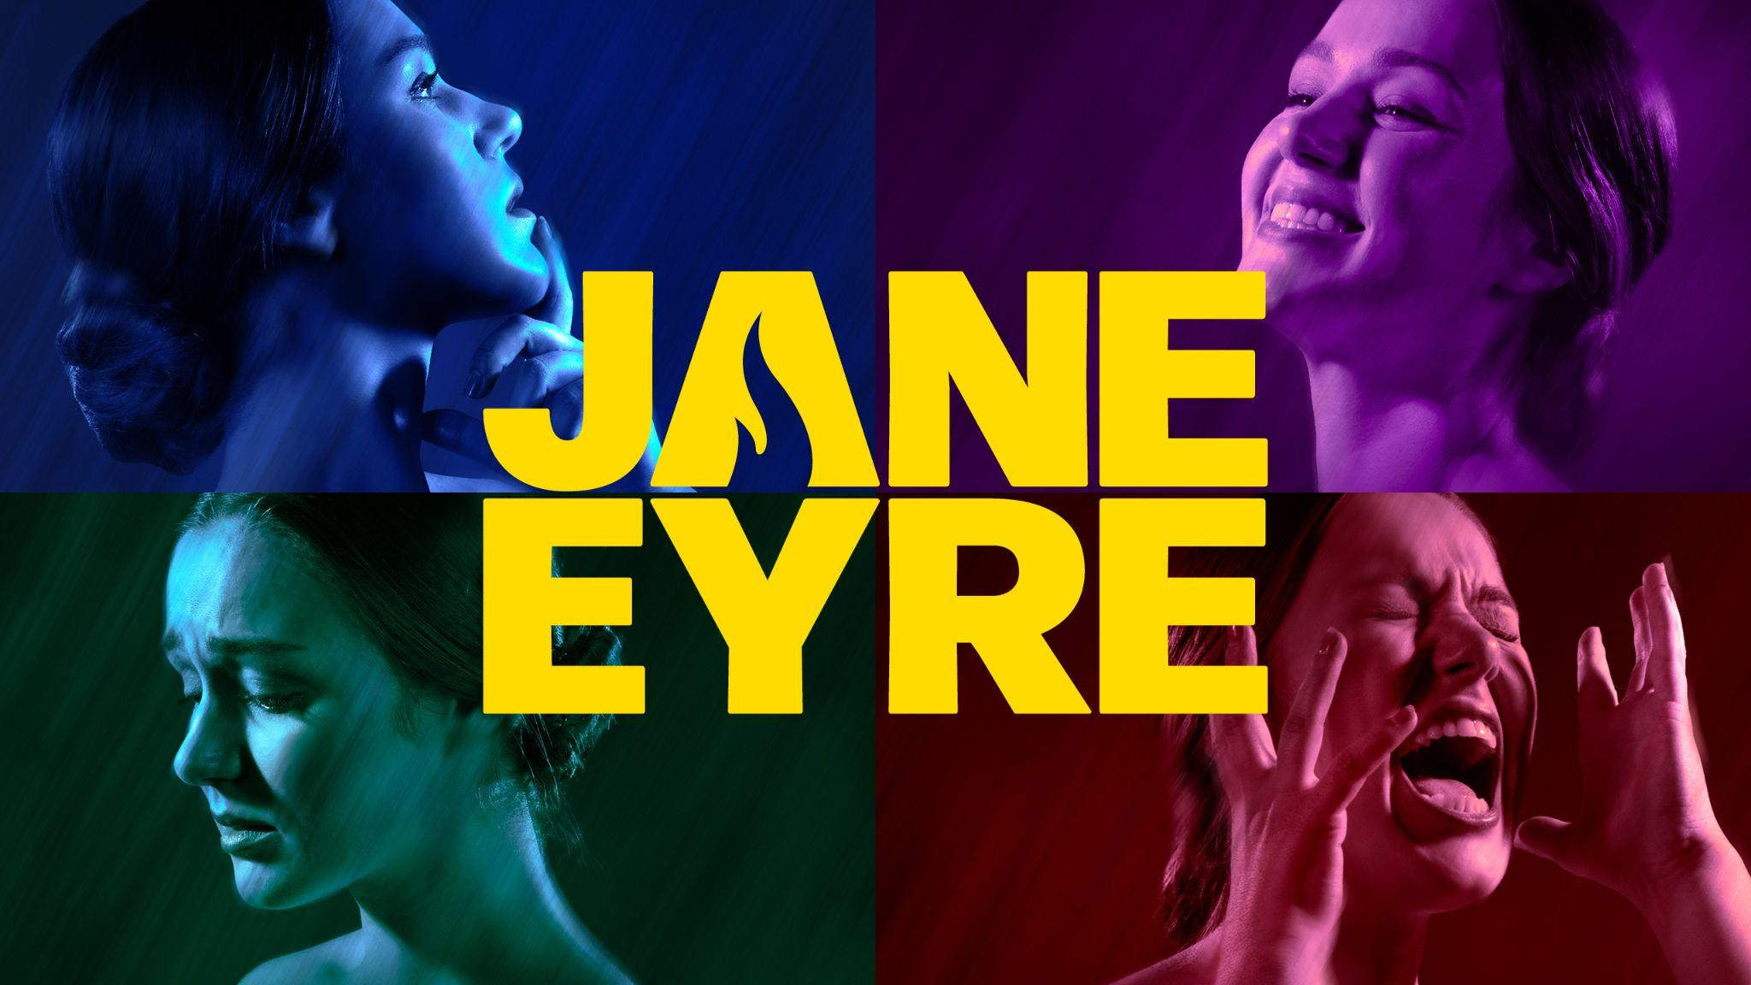

A MUSICAL BY JOHN CAIRD & PAUL GORDON
Based on the novel by
CHARLOTTE BRONTË

AT SOUTHWARK PLAYHOUSE ELEPHANT FROM AUGUST 2026

Full casting has today been announced for Jane Eyre, a musical by John Caird and Paul Gordon based on the novel by Charlotte Brontë, ahead of its UK Premiere at Southwark Playhouse Elephant from 28 August – 24 October 2026.

Joining the previously announced West End stars Charlie Burn (Jane) and Ashley Gilmour (Rochester) are Claire Greenway (Abbot/Grace Poole), Melad Hamidi (St John/Lord Ingram), Connor Wood (John Reed/Vicar), Jonathan Andrew Hume (Brocklehurst/Mason), Izzi Levine (Agnes/Leah/Jane's Mother/Mary Ingram), Hannah Lindsey (Scatcherd/Bertha Mason), Isabelle Methven (Helen Burns/Bessie), Gemma Page (Reed/Fairfax) Eve Shanu-Wilson (Blanche/Sophie) with Poppy Jason (Young Jane/Adele) and Emily-Rose Samuel (Young Jane/Adele).

Jane Eyre will be co-directed by RSC and National Theatre director John Caird, who previously adapted and co-directed the original production of Les Misérables in the West End, on Broadway and across the world. Most recently he directed the hugely successful and critically acclaimed stage adaptation of Spirited Away at the London Coliseum. Broadway’s Megan McGinnis, star of Beauty and the Beast, Little Women and Beetlejuice, will co-direct alongside John Caird.

The full creative team includes Georgina Lamb - Choreographer, Morgan Large - Set & Costume Designer, Andrew Johnson - Sound Designer, James Whiteside - Lighting Designer, Ben Kubiak - Musical Director/Supervisor and Sarah-Jane Price - Casting Director.

This five-time Tony nominated musical retelling of Charlotte Brontë’s revolutionary novel makes its UK premiere. A story of ambition and independence, gothic mystery and great, passionate love, Jane Eyre has enchanted generations and is brought into the 21st century with this new production. Accompanied by an epic sweeping score, prepare to see Jane, the first feminist literary icon, like you never have before.
Jane Eyre originally premiered in Toronto in 1996 and was subsequently produced on Broadway in 2000, being nominated for five Tony Awards. Adam Blanshay Productions is partnering with the original Canadian producers, David and Hannah Mirvish, for the 30th Anniversary year of the show.

NOTES TO EDITORS

Southwark Playhouse
Southwark Playhouse is a registered charity that delivers a year-round programme of entertaining and enriching work. Southwark Playhouse operates two separate venues ‘Southwark Playhouse Borough’ and its newest theatre ‘Southwark Playhouse Elephant’ which opened in January 2023. Southwark Playhouse has always prided itself in telling stories and inspiring the next generation of storytellers and theatre makers, where support for the community has been rooted at the core of the organisation.

Website: southwarkplayhouse.co.uk
BlueSky:@swkplay.bsky.social
Facebook: SouthwarkPlayhouse
Instagram: @swkplay
TikTok: swkplay
YouTube: southwarkplayhouse

LISTINGS
A musical by John Caird & Paul Gordon
Based on the novel by Charlotte Brontë
28 August – 24 October 2026

Performance schedule:
Monday – Wednesday: 7pm
Thursday: 2.30pm & 7pm
Friday: 7pm
Saturday: 2.30pm & 7pm

Press performance: Tuesday 8 September 2026

Ticket Prices: £20 - £47.50
£10 Pioneers’ Preview (28 Aug) / £16 Previews

Address: Southwark Playhouse Elephant, 1 Dante Place, London, SE11 4RX
https://southwarkplayhouse.co.uk/productions/jane-eyre
020 7407 0234

Website: JaneEyreonStage.com

Socials:
Facebook @JaneEyreMusical
Instagram @JaneEyreMusical
TikTok @JaneEyreMusical
#JaneEyreMusical

Assets:
Artwork: Available to download HERE
Headshots: Available to download HERE

PRESS CONTACT: EMMA HOLLAND PR (EHPR)
W: www.emmahollandpr.com

Emma Holland Didi Ralph
E: emma@emmahollandpr.com E: didi@emmahollandpr.com
M: 0791 709 4203 M: 0787 289 5051



