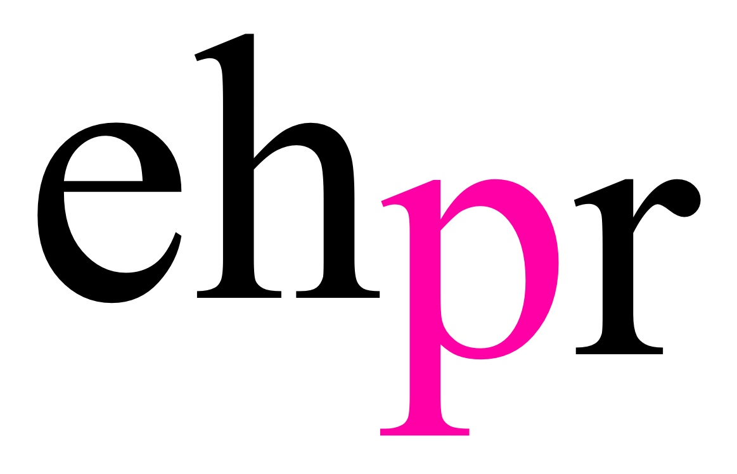
Joseph and the Amazing Technicolor Dreamcoat

Union J star JAYMI HENSLEY dons the DREAMCOAT in his first ever major musical

Bill Kenwright’s ‘Amazing’, ’Superb’, ‘Wonderful’ and ‘Brilliant’ production of Tim Rice and Andrew Lloyd Webber’s sparkling family musical embarks on a national tour with a new Joseph, from February 20th at Theatre Royal Windsor.

Jaymi Hensley, a member of 2013’s BBC ‘British Breakthrough Band’ of the year, will don the Technicolor Dreamcoat and lead the company in his first role in a major musical. Having risen to fame on The X Factor, Union J went on to have a top ten album and a major UK tour and Jaymi later appeared on a number of hit TV shows, including Celebrity Masterchef (BBC One).

Jaymi Hensley: “I cannot describe how excited and honoured I am to be stepping into the prestigious coloured coat! When I think of iconic roles in musical theatre Joseph was always one that I dreamt of playing growing up! And to finally say that I am going to play it is a “dream” come true! I cannot wait to meet all of the loyal Joseph Fans and bring you my take of this amazing dream role.”

Retelling the Biblical story of Joseph, his eleven brothers and the coat of many colours, Joseph and the Amazing Technicolor Dreamcoat is the first of Tim Rice and Andrew Lloyd Webber’s musicals to be performed publicly. Seen by an estimated 26 million people, and counting, Joseph continues to enthral audiences around the world.

Full of life and colour, the magical musical features unforgettable and timeless songs including Go, Go, Go Joseph, Any Dream Will Do, Jacob and Sons and Close Every Door To Me.

Joining Jaymi to complete the cast are Lewis Asquith, George Beet, Arthur Boan, Callum Connolly, Andrew Geater, Alex Hetherington, Trina Hill, Mikey Jay-Heath, Matt Jolly, Jamie Jukes, Amber Kennedy, Henry Metcalfe, Corey Mitchell, Eve Norris, Gemma Pipe, Joshua Robinson and Ed Tunningley.

NOTES TO EDITORS

Bill Kenwright (Director/Producer) recent West End productions include: Heathers (Haymarket); The Best Man (Playhouse), The Exorcist (Phoenix), How the Other Half Loves (Haymarket); The Go-Between (Apollo); The War of The Worlds (Dominion); Evita (Dominion); Let the Right One In (Apollo); Twelve Angry Men (Garrick); Cabaret (Savoy); Blood Brothers (Phoenix); Dreamboats and Petticoats (Wyndhams); Volcano (Vaudeville); Written on the Heart (RSC - Duchess); Three Days in May (Trafalgar); The Pitmen Painters (Duchess); The Wizard of Oz (Palladium); The Country Girl (Apollo); Bedroom Farce (Duke of York's); A Daughter's a Daughter (Trafalgar); On the Waterfront (Haymarket); Woman in Mind (Haymarket); Plague Over England (Duchess); Sunset Boulevard (Comedy); Absurd Person Singular (Garrick); Joseph and the Amazing Technicolor Dreamcoat (Adelphi); The Letter (Wyndhams); Treats (Garrick); Cabaret (Lyric); The Canterbury Tales (RSC - Gielgud); The Crucible (RSC - Gielgud); Whistle Down the Wind (Palace); A Man for All Seasons (Haymarket); The Night of the Iguana (Lyric); Scrooge (Palladium); A Few Good Men (Haymarket); The Big Life (Apollo); Elmina's Kitchen (Garrick); Festen (Lyric); Judi Dench in All's Well That Ends Well (RSC - Gielgud); Hay Fever (Haymarket); Filumena (Piccadilly); and The Gift of the Gorgon (Wyndhams); Jessica Lange in A Streetcar Named Desire (Haymarket); Long Day's Journey into Night (Lyric) and The Glass Menagerie (Apollo); The Taming of the Shrew and The Tamer Tamed (RSC - Queens); The Secret Rapture (Lyric); the RSC Jacobean season (Gielgud); Via Dolorosa (Duchess); Sleuth (Apollo); The Constant Wife (Lyric); Cat on a Hot Tin Roof (Lyric); Ghosts (Comedy); Fallen Angels (Apollo); Brief Encounter (Lyric); Miss Julie (Haymarket); Stepping Out (Albery); Hurlyburly (Queens); Lady Windermere's Fan (Haymarket); Passion (Queens); Company (Albery); The Miracle Worker (Wyndhams); No Man's Land and Moonlight (Comedy). And others directed by Peter Hall: Mind Millie for Me; The Master Builder; On Approval; Piaf; The Vortex; The School for Wives; Hamlet; An Absolute Turkey; Lysistrata; Separate Tables; She Stoops to Conquer; Waiting for Godot; The Misanthrope; Major Barbara and Kafka's Dick.

On Broadway: Travels With My Aunt (Drama Desk Award); Dancing At Lughnasa (Tony Award); Medea (Tony Award); Ibsen's A Doll's House (four Tony Awards); Theatre de Complicite's The Chairs (six Tony nominations); Cat on a Hot Tin Roof; The Glass Menagerie; Primo; Festen; Passing Strange; and Guys and Dolls. Blood Brothers, which ran for 24 years in the West End, also played for three years at Broadway's Music Box Theatre.

As a Director his productions include: Evita, Whistle Down the Wind, Joseph and the Amazing Technicolor Dreamcoat, Jesus Christ Superstar and Blood Brothers. He was nominated for a London Theatre Critics' Award for West Side Story at the Shaftesbury and a Tony Award for Blood Brothers in New York.

His films include: Another Mother’s Son, My Pure Land, The Hope Rooms, The Day After the Fair, Stepping Out, Don't Go Breaking My Heart, Cheri and Broken, which won Best Film at the British Independent Film Awards.

He co-produced the phenomenally successful arena tour of Elvis - The Concert with Elvis Presley Enterprises.

He has received an Honorary Doctorate from both Liverpool University and Nottingham Trent University, an Honorary Fellowship from Liverpool's John Moores University and an Honorary Professorship from Thames Valley University in London. In 2002, he received the Variety Club Bernard Delfont Award for his contribution to the entertainment industry, and a CBE in the same year. In 2008, he received a Lifetime Achievement Award from the Theatrical Management Association.

He is Chairman of Everton Football Club. And a fan.

Andrew Lloyd Webber When Sunset Boulevard joined School of Rock, Cats and The Phantom of the Opera on Broadway in February 2017, Andrew Lloyd Webber became the only person to equal the record set in 1953 by Rodgers and Hammerstein with four Broadway shows running concurrently. Other musicals he has composed include: Aspects of Love, Joseph and the Amazing Technicolor Dreamcoat, Jesus Christ Superstar, Evita and Love Never Dies.

His production of School of Rock is the first British musical to have world premiered on Broadway. He has co-produced his own shows including Cats and The Phantom of the Opera and as a solo producer he presented the groundbreaking Bombay Dreams which introduced the double Oscar winning Bollywood composer AR Rahman to the Western stage.

Other productions include the Olivier Award winning Daisy Pulls It Off and La Bête, the record breaking Palladium production of The Sound of Music and The Wizard of Oz.

He owns seven West End theatres including the Theatre Royal Drury Lane, the Palladium and most recently the St James which reopened this year as The Other Palace and provide a unique London home for new musicals in development.

He is passionate about the importance of music in education and the Andrew Lloyd Webber Foundation has become one of Britain’s leading charities supporting the arts and music.

His awards, both as composer and producer, include seven Tonys, seven Oliviers, a Golden Globe, an Oscar, the Praemium Imperiale, the Richard Rodgers Award for Excellence in Musical Theatre, a BASCA Fellowship, the Kennedy Center Honor and a Grammy for Best Contemporary Classical Composition for Requiem, his setting of the Latin Requiem mass which contains one of his best known compositions, ‘Pie Jesu’.

He was knighted by Her Majesty The Queen in 1992 and created an honorary member of the House of Lords in 1997.

Tim Rice began songwriting in 1965, in which year the first song he wrote, ‘That’s My Story’ (tune as well as words), was recorded by a group called the Nightshift whose career never recovered. That same year, he met fellow budding songwriter Andrew Lloyd Webber, whose musical ambitions were in theatre rather than rock or pop. They teamed up and wrote four musicals together from 1965 to 1978. The first, The Likes of Us (1965–66), was performed for the first time in 2005 and became available on CD a mere 40 years after its creation. The other three, Joseph and the Amazing Technicolor Dreamcoat (1968), Jesus Christ Superstar (1969–71) and Evita (1976–78) were more immediate successes.

Feeling certain that they could never top this lot, the pair went their separate ways in the early 1980s, whereupon ALW immediately topped that lot with Cats. TR then wrote Blondel (1983), a mediaeval romp, with Stephen Oliver, which ran for a year in London. In 1984, Tim wrote Chess, in collaboration with ABBA’s Björn Ulvaeus and Benny Andersson. Chess had a healthy run in the West End from 1986 but an unimproved version flopped on Broadway in 1988. There have been countless productions worldwide since then, with wide variations of quality and indeed storyline. New productions are scheduled for both the London Coliseum and the Kennedy Center, Washington DC, in 2018.

In 1989, Tim translated the famous French musical Starmania (by Michel Berger and Luc Plamondon) into English, which merely resulted in a hit album - in France. In the 1990s, he worked primarily and happily with the Disney empire, contributing lyrics to the movies Aladdin (music by Alan Menken) and The Lion King (music by Elton John and Hans Zimmer) and to the stage shows Beauty and the Beast and King David (both Alan Menken), The Lion King and Aida (both Sir Elton). Between Disney commitments, he wrote the words for Sir Cliff Richard’s theatrical blockbuster Heathcliff (music by John Farrar), which toured the UK in 1995–96. For DreamWorks, he and Sir Elton joined forces yet again to write the score for the 2000 animated film The Road to El Dorado. Tim’s last new West End show (2013/14) was From Here to Eternity, with music written by Stuart Brayson. In 2017, the new Beauty and the Beast movie featured three new songs he wrote with Alan Menken.

He is a regular broadcaster on BBC Radio 2. He has won a variety of awards, mainly for the wrong things, or for simply turning up. These include a star on Hollywood’s Walk of Fame, three Oscars, four Tonys, five or six Grammys and 13 Ivor Novellos. He is a former president of the MCC and chairman of the UK charitable Foundation for Sport and the Arts. In 2017, he was appointed president of the London Library. Sir Tim’s cricket team has being going strong since 1973 and by the summer of 2017 had played almost 700 matches.

The first volume of his autobiography, Oh What a Circus, was published in September 1999. If his publishers ask, he is currently working on part two, due out 10 years ago.

Jaymi Hensley member of Union J who finished 4th on The X Factor in 2012. Union J are an
English four-piece boy band who are based in London, United Kingdom. The group were formed through the ninth series of British television singing competition The X Factor in 2012. They subsequently signed a recording contract with Sony Music’s division RCA Records and released their first studio album, Union J, on October 28th, 2013. In April 2014 they left RCA Records and signed with Epic Records, they recorded their second album ‘You Got It All’ which was released in December 2014. Jaymi has recently appeared on a number of UK shows from Release The
Hounds (ITV2), The Great Magician (ITV1), Big Brothers Bit On The Side (Channel 5), Celebrity
Masterchef (BBC One), Sex Pod (Channel 5) and When Celebrity Goes Horribly Wrong (Channel
5). In 2018 Jaymi appeared on Wedding Day Winners (BBC One), Partner’s In Rhyme (BBC One)
and also co-hosted CBBC’S hit show Got What It Takes alongside Lauren Platt.

Jaymi is joined by Trina Hill as Narrator, Andrew Geater as Pharoah, alongside Henry Metcalfe, Amber Kennedy, Matt Jolly, Joshua Robinson, Callum Connolly, Alex Hetherington, Arthur Boan, Mikey Jay-Heath, George Beet, Lewis Asquith, Ed Tunningley, Corey Mitchell, Eve Norris, Gemma Pipe and Jamie Jukes.

LISTINGS
JOSEPH AND THE AMAZING TECHNICOLOR DREAMCOAT – BY TIM RICE & ANDREW LLOYD WEBBER – 20 FEBRUARY – 20 JULY 2019
Theatre Royal, Windsor
Wed 20th Feb – Sat 2nd Mar
theatreroyalwindsor.co.uk
01753 853 888

atgtickets.com
01303 228600

parkwoodtheatres.co.uk
01293 553636

atgtickets.com
0844 871 3014

Leas Cliff Hall, Folkestone
Tues 5th – Sat 9th Mar

The Hawth, Crawley
Tues 12th – Sat 16th Mar

Playhouse, Edinburgh
Tues 19th – Sat 23rd Mar
rhylpavilion.co.uk
01745 33 00 00

theatreroyal.co.uk
08448 11 21 21
atgtickets.com
0800 912 6971
storyhouse.com
01244 409 113
wmc.org.uk
029 2063 6464
darlingtonhippodrome.co.uk
01325 405405
wintergardensblackpool.co.uk
0844 856 1111
leedsgrandtheatre.com
0844 848 2700

derbytheatre.co.uk
01332 59 39 39
apps.ipswich.gov.uk
01473 433100
birminghamhippodrome.com
0844 871 3012
atgtickets.com
0844 871 3020

Pavilion, Rhyl
Tues 26th – Sat 30th Mar

Theatre Royal, Newcastle upon Tyne
Tues 2nd – Sat 6th Apr

Theatre, Milton Keynes
Tues 9th – Sat 13th Apr

Storyhouse, Chester
Tues 16th – Sat 20th April

Wales Millennium Centre, Cardiff
Tues 14th – Sat 18th May

Hippodrome, Darlington
Tues 21st – Sat 25th May

Opera House, Blackpool
Tues 28th May – Sat 1st June

Grand Theatre, Leeds
Tues 4th – Sat 15th June

Theatre, Derby
Tues 18th – Sat 22nd June

Regent Theatre, Ipswich
Tues 25th – Sat 29th June

Hippodrome, Birmingham
Tues 2nd – Sat 13th July

New Theatre, Oxford
Tues 16th – Sat 20th July

PRESS CONTACT: EMMA HOLLAND PR (EHPR)
W: www.emmahollandpr.com
Emma Holland Georgie Robinson
E: emma@emmahollandpr.com E: georgie@emmahollandpr.com
M: 0791 709 4203 M: 0751 211 2776
Jocasta Marron Natasha Haddad
E: jocasta@emmahollandpr.com E: natasha@emmahollandpr.com
M: 0772 517 1327 M: 07967 175 221

