MY SON’S A QUEER (BUT WHAT CAN YOU DO?)
IS BACK. IN ALL ITS SEQUINED GLORY

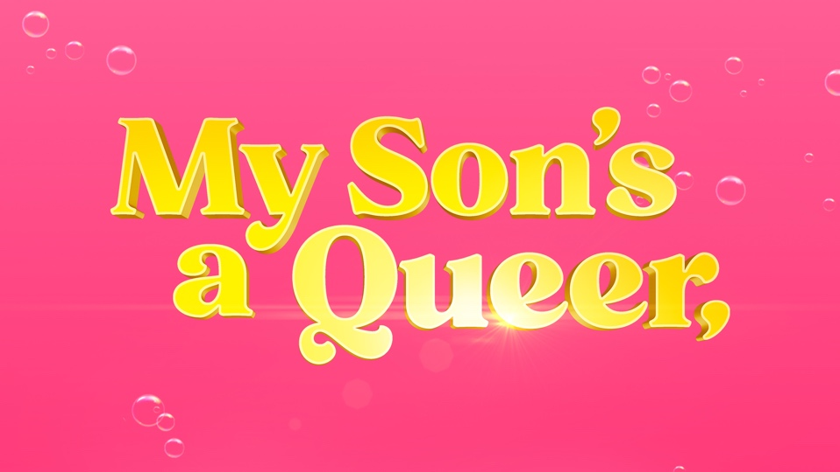
ON A UK TOUR FROM
8 JULY TO 25 AUGUST 2024
WITH A RUN AT EDINBURGH FRINGE
FROM 1 TO 16 AUGUST 2024
AT MCEWAN HALL

Celebrating the joy and chaos of raising a queer child, My Son’s A Queer, (But What Can You Do?) is testament to the power of unconditional familial love. Written and performed by Rob Madge, and directed by Luke Sheppard, the award-winning, beloved show is back, due to public demand, and is set to embark on a brand new UK tour for 2024.

Announcement video available to download HERE

When Rob was 12, they attempted to stage a full-blown Disney parade in their house for their Grandma. As Rob donned a wig and played Mary Poppins, Ariel, Mickey Mouse and Belle, their Dad doubled as Stage Manager, Sound Technician and Goofy.

Unfortunately, Dad missed all his cues and pushed all the floats in the wrong direction. Mum mistook Aladdin for Ursula. The costumes went awry, and Ariel's bubble gun didn't work properly. Grandma had a nice time though.

Originating at the Turbine Theatre in 2021, what followed was a sold-out season at the Edinburgh Festival in 2022, a national tour and then two West End runs. Now, three years on, with a WhatsOnStage Award and Olivier nomination to its name, join social-media sensation Rob Madge as they set out to recreate that parade - and this time, nobody, no, NOBODY is gonna rain on it!

My Son’s a Queer, (But what can you do?) is written and performed by Rob Madge (Oliver!, Les Misérables), directed by Luke Sheppard (& Juliet, In the Heights) with songs by Pippa Cleary (The Great British Bake Off Musical, The Secret Diary of Adrian Mole Age 13 ¾). It has set and costume design by Ryan Dawson Laight, video design by George Reeve, lighting design by Jai Morjaria, sound design by Tingying Dong, and orchestrations by Simon Nathan. The show is produced by Bill Kenwright LTD and Paul Taylor-Mills.

NOTES TO EDITORS

Rob Madge (Writer and Performer) is a theatre maker, writer and actor. They began working professionally in theatre at the age of 9, having spent the majority of their childhood forcing their family to help them put on shows in the living room, most of which are now documented on Rob’s social media channels. Rob is best known for their show My Son’s A Queer (But What Can You Do?) which was nominated for Best Entertainment or Comedy Play at the 2023 Olivier Awards. Following this ongoing success, Rob won Best Creative Debut at The Stage Debut Awards, 2023 and the Attitude Award for Best Theatre Production, 2023.
Theatre credits as a performer include: Peter Pan (London Palladium); My Son’s A Queer (Writer/Performer: Turbine Theatre, Edinburgh, West End); Jack and the Beanstalk (London Palladium); Mary Poppins (Prince Edward Theatre); Macbeth (Gielgud Theatre); Oliver! (Theatre Royal, Drury Lane); Les Misérables (25th Anniversary International Tour and Concert); Matilda the Musical (Courtyard Theatre, RSC); Bedknobs & Broomsticks (UK Tour/World Premiere); Timpson the Musical, Held Momentarily, Leave A Light On, Roles We’ll Never Play.
TV credits include: The Sarah Jane Adventures, That Mitchell and Webb Look, The Armstrong and Miller Show, Kröd Mändoon and the Flaming Sword of Fire, Poirot: Appointment with Death
Rob writes and performs their own skits on their social media channels which, as a result, have amassed a following of over 300,000 collectively, with over 11.3 million likes.
Luke Sheppard (Director)’s theatre credits include: The Little Big Things (@soho Place); Just For One Day (The Old Vic); My Son’s A Queer (But What Can You Do?) (Turbine Theatre, West End, Edinburgh Fringe); Startlight Express (West End); Paddington (London); In Dreams (Toranto, Leeds Playhouse); Rent (Hope Mill Theatre); & Juliet (West End); The Secret Diary of Adrian Mole Aged 13 ¾: The Musical (West End, Menier Chocolate Factory & Leicester Curve); Billionaire Boy (Nuffield Theatre, Southampton & UK Tour); Newsies (Arts Ed); Murder For Two (Watermill Theatre, The Other Palace & UK Tour); Spring Awakening (Hope Mill, Manchester); In the Heights (Kings Cross Theatre & Southwark Playhouse); Peter and the Starcatcher (Royal & Derngate); Night Must Fall (Salisbury Playhouse & UK Tour); Stig Of The Dump (UK Tour); Oliver! (Watermill Theatre); Working; Casa Valentina; Next Fall (Southwark Playhouse); A Christmas Carol; The Adventures of Pinocchio; The Hundred and One Dalmatians (Castle Theatre); Bed and Sofa (Finborough); The Great British Soap Opera (Jermyn Street & Edinburgh) and Jet Set Go! (Jermyn Street & Theatre 503).
His production of In the Heights won three Olivier Awards and a nomination for Best New Musical. The show also won the Broadway World Award for Best New Production of a Musical and received nine WhatsOnStage Award nominations, including Best Director. His production of Spring Awakening was awarded the WhatsOnStage Award for Best Regional Production. The Secret Diary of Adrian Mole Aged 13 ¾ received nominations for the Evening Standard Award for Best New Musical and the UK Theatre Award for Best Show for Children and Young People. Luke was also nominated for the Off-West End Award for Best Director for Casa Valentina.
Pippa Cleary (Songs by) is a musical theatre composer, songwriter, lyricist, and singer based in London. Recent work includes: The Great British Bake Off: The Musical (Cheltenham Everyman, West End 2023); My Son’s a Queer, (But what can you do?) (Turbine Theatre, Edinburgh Fringe, West End); The Secret Diary of Adrian Mole Aged 13¾ (West End Ambassadors Theatre, Menier Chocolate Factory, Leicester Curve Theatre); In the Willows (UK Tour, Metta Theatre) and A Midsummer Night's Dream - The Musical (BBC Teach).
Further composition credits include: The Iron Woman (Workshop, St James’ Theatre); The Ascension of Mrs Leech (Workshop, Laura Evans Productions); Prodigy (St James’ Theatre, London); Chicken Little and Treasure Island (Singapore Repertory Theatre); The Snow Gorilla (Rose Theatre Kingston, Steve Bor Productions); Red Riding Hood (Singapore Repertory Theatre, Pleasance Theatre London, Middle East Tour); Tess of the D’Urbervilles (St James’ Theatre London, South Hill Park); Alice in Wonderland (Polka Theatre, London); Jet Set Go! (Theatre 503, Jermyn Street Theatre, Edinburgh Fringe Festival, Turbine Theatre); The Great British Soap Opera (Jermyn Street Theatre, Edinburgh Fringe Festival); The Night Before Christmas (The Humble Theatre Company, Letchworth); Katy's Road Show (CBeebies); The Wonderful World of Dissocia (Wickham Theatre, Bristol); A Song Cycle for Soho (Soho Theatre). Pippa is the winner of: The Arts Foundation Fellowship for Composition for Musical Theatre Award (2012), The Times Christmas Carol Competition (2011) and the MTM Judges Discretionary Award for Composition (2008) for Jet Set Go! And she has been mentored by Claude-Michel Schonberg.

LISTINGS
MY SON’S A QUEER, (BUT WHAT CAN YOU DO?)
2024 UK Tour
Written by Rob Madge
Directed by Luke Shepard
Songs by Pippa Cleary

Artwork: Available to download HERE
Past Production Images: Available to download HERE

Run time: 75 minutes (no interval)

Age guidance: 12+
*Contains some swearing, a fair bit of precociousness and scenes of utter joy. May cause happiness!

Social Media:
Instagram/Tiktok/YouTube/Facebook/X: @mysonsaqueer

TOUR DATES
Curve Theatre, Leicester curveonline.co.uk
8 – 10 July 2024 0116 242 3595

Hippodrome, Birmingham birminghamhippodrome.com
11 – 13 July 2024 0844 338 5000
Belgrade Theatre, Coventry belgrade.co.uk
15 – 17 July 2024 024 7655 3055
Everyman and Playhouse, Liverpool everymanplayhouse.com
18 – 20 July 2024 0151 709 4776

Derby Theatre derbytheatre.co.uk
22 – 24 July 2024 01332 59 39 39

McEwan Hall, Edinburgh underbellyedinburgh.co.uk
1 – 16 August 2024

HOME, Manchester homemcr.org/theatre/
19 – 25 August 2024 0161 200 1500

PRESS CONTACT: EMMA HOLLAND PR (EHPR)
W: www.emmahollandpr.com

Emma Holland Didi Ralph
E: emma@emmahollandpr.com E: didi@emmahollandpr.com
M: 0791 709 4203 M: 07872 895051

