‘DEAR DIARY, DID YOU HEAR?’

LAUNCHING SPRING 2020
INITIAL TOUR DATES ANNOUNCED FOR
THE RECORD-BREAKING SMASH HIT

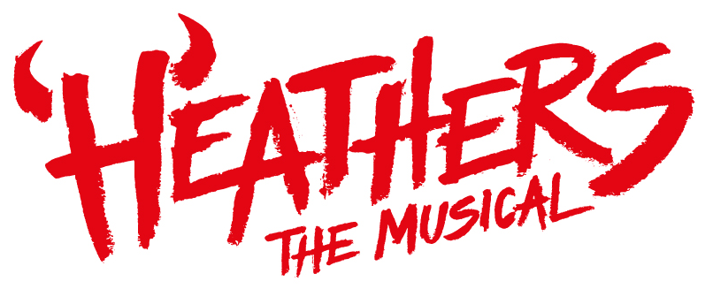

BY LAURENCE O’KEEFE & KEVIN MURPHY

BEST NEW MUSICAL - WHATSONSTAGE AWARDS 2019

Daily Telegraph, The Independent, Metro, Daily Express,
The Stage, Attitude, The Arts Desk, Broadway World

In the immortal words of Heather Chandler, ‘Honey whatcha waitin’ for?’… The first venues have been announced for the highly anticipated 2020 UK tour of Heathers the Musical (WhatsOnStage 2019 award for BEST NEW MUSICAL).

Following two record-breaking seasons at London’s The Other Palace and West End transfer to the Theatre Royal Haymarket in 2018, Heathers the Musical, the sassiest show around, will be touring to Brighton, Liverpool, Cardiff, Sheffield, Edinburgh, Milton Keynes, Sunderland, Bristol and Wimbledon, with further dates and venues to be announced in due course.

Produced by Bill Kenwright and Paul Taylor-Mills, this high-octane, black comedy, rock musical based on one of the greatest cult teen films of all time, starring Winona Ryder and Christian Slater, is back with a bang!

Greetings and salutations!

Westerberg High’s Veronica Sawyer is just another nobody dreaming of a better day. But when she joins the beautiful and impossibly cruel Heathers, her dreams of popularity may finally come true. Mysterious teen rebel JD teaches her that it might kill to be a nobody but it is murder being a somebody.

The award-winning writing team, Laurence O’Keefe and Kevin Murphy’s hit musical adaptation has enjoyed successful runs in Los Angeles and New York, and its West End premiere saw it become the highest grossing show at The Other Palace. It subsequently had spectacular success on transferring to the Theatre Royal Haymarket.

The musical is directed by acclaimed American screen and stage director Andy Fickman, with choreography by Thriller Live’s Gary Lloyd, design by David Shields, lighting by Ben Cracknell and sound by Dan Samson.

The 2020 Class of Westerberg High will be announced shortly…

LISTINGS

BILL KENWRIGHT & PAUL TAYLOR-MILLS PRESENT
HEATHERS THE MUSICAL
2020 UK TOUR
By Laurence O’Keefe & Kevin Murphy
Directed by Andy Fickman
Choreography by Gary Lloyd
Design by David Shields
Lighting by Ben Cracknell
Sound by Dan Samson

Running Time: Approx. 2 hours 30 minutes including interval

Calling all #CornNuts – Be the first to hear the latest Heathers the Musical gossip and further details on dates, venues and on-sales by following us on the following:

Website: www.kenwright.com

Facebook/Twitter/Instagram:
@BKL_Productions
@HeathersMusical
#HowVery

DATES & VENUES

Windsor Theatre Royal www.theatreroyalwindsor.co.uk
Wednesday 13 May – Saturday 23 May 01753 853 888

Brighton Theatre Royal www.atgtickets.com/brighton
Tuesday 26 May – Saturday 30 May 0844 871 7650

Guildford G Live www.glive.co.uk
Tuesday 2 June – Saturday 6 June 0148 336 9350

Liverpool Empire Theatre www.atgtickets.com/liverpool
Tuesday 9 June – Saturday 13 June 0844 871 3017

Cardiff Wales Millennium Centre www.wmc.org.uk
Tuesday 16 June – Saturday 20 June 029 2063 6464

Sheffield Lyceum Theatre www.sheffieldtheatres.co.uk
Tuesday 23 June – Saturday 27 June 0114 249 6000

Nottingham Theatre Royal www.trch.co.uk
Tuesday 30 June – Saturday 6 July 0115 989 5555

Edinburgh Playhouse www.atgtickets.com/edinburgh
Tuesday 7 July – Saturday 11 July 0844 871 3014

Milton Keynes Theatre www.atgtickets.com/milton-keynes
Tuesday 14 July – Saturday 18 July 0844 871 7652

Sunderland Empire www.atgtickets.com/sunderland
Tuesday 21 July – Saturday 25 July 0844 871 3022

Bristol Hippodrome www.atgtickets.com/bristol
Tuesday 28 July – Saturday 1 August 0844 871 3012

Wimbledon New Theatre www.atgtickets.com/wimbledon
Tuesday 22 September – Saturday 26 September 0844 871 7646

York Grand Opera House www.atgtickets.com/york
Tuesday 29 September – Saturday 3 October 0844 871 3024

Manchester Palace Theatre www.atgtickets.com/manchester
Tuesday 6 October– Saturday 10 October 0844 871 3019

Aylesbury Waterside Theatre www.atgtickets.com/aylesbury
Tuesday 13 October – Saturday 17 October 0844 871 7607

Dublin Bord Gáis Energy Theatre www.bordgaisenergytheatre.ie
Tuesday 20 October– Saturday 24 October +353 (1) 677 7999

Eastbourne Congress Theatre www.eastbournetheatres.co.uk
Tuesday 27 October – Saturday 31 October 01323 412 000

Birmingham Alexandra Theatre www.atgtickets.com/birmingham
Tuesday 3 November – Saturday 7 November 0844 871 3011

Further dates and venues to be announced in due course.

PRESS CONTACT: EMMA HOLLAND PR (EHPR)
W: www.emmahollandpr.com

Emma Holland Georgie Robinson
E: emma@emmahollandpr.com E: georgie@emmahollandpr.com
M: 0791 709 4203 M: 0751 211 2776

Natasha Haddad Madeleine Ralph
E: natasha@emmahollandpr.com E: madeleine@emmahollandpr.com
M: 07967 175 221 M: 07872 895 051

