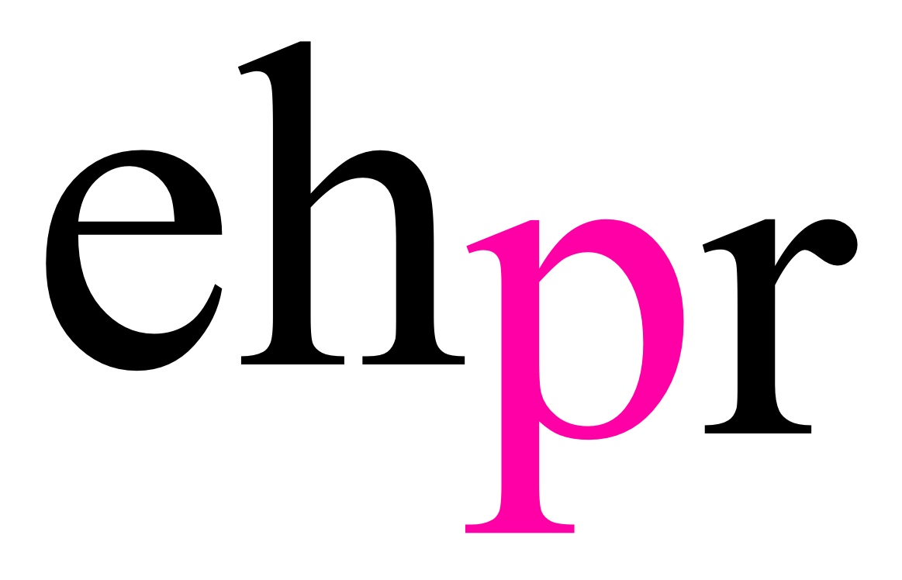
 

ON THE 74TH ANNIVERSARY OF D-DAY
INTENSE WORLD WAR II THRILLER

PRESSURE

WRITTEN BY AND STARRING THE OLIVIER AWARD WINNING ACTOR
DAVID HAIG

WILL TRANSFER TO THE AMBASSADORS THEATRE
FOR A LIMITED SEASON FROM 6 JUNE – 1 SEPTEMBER 2018

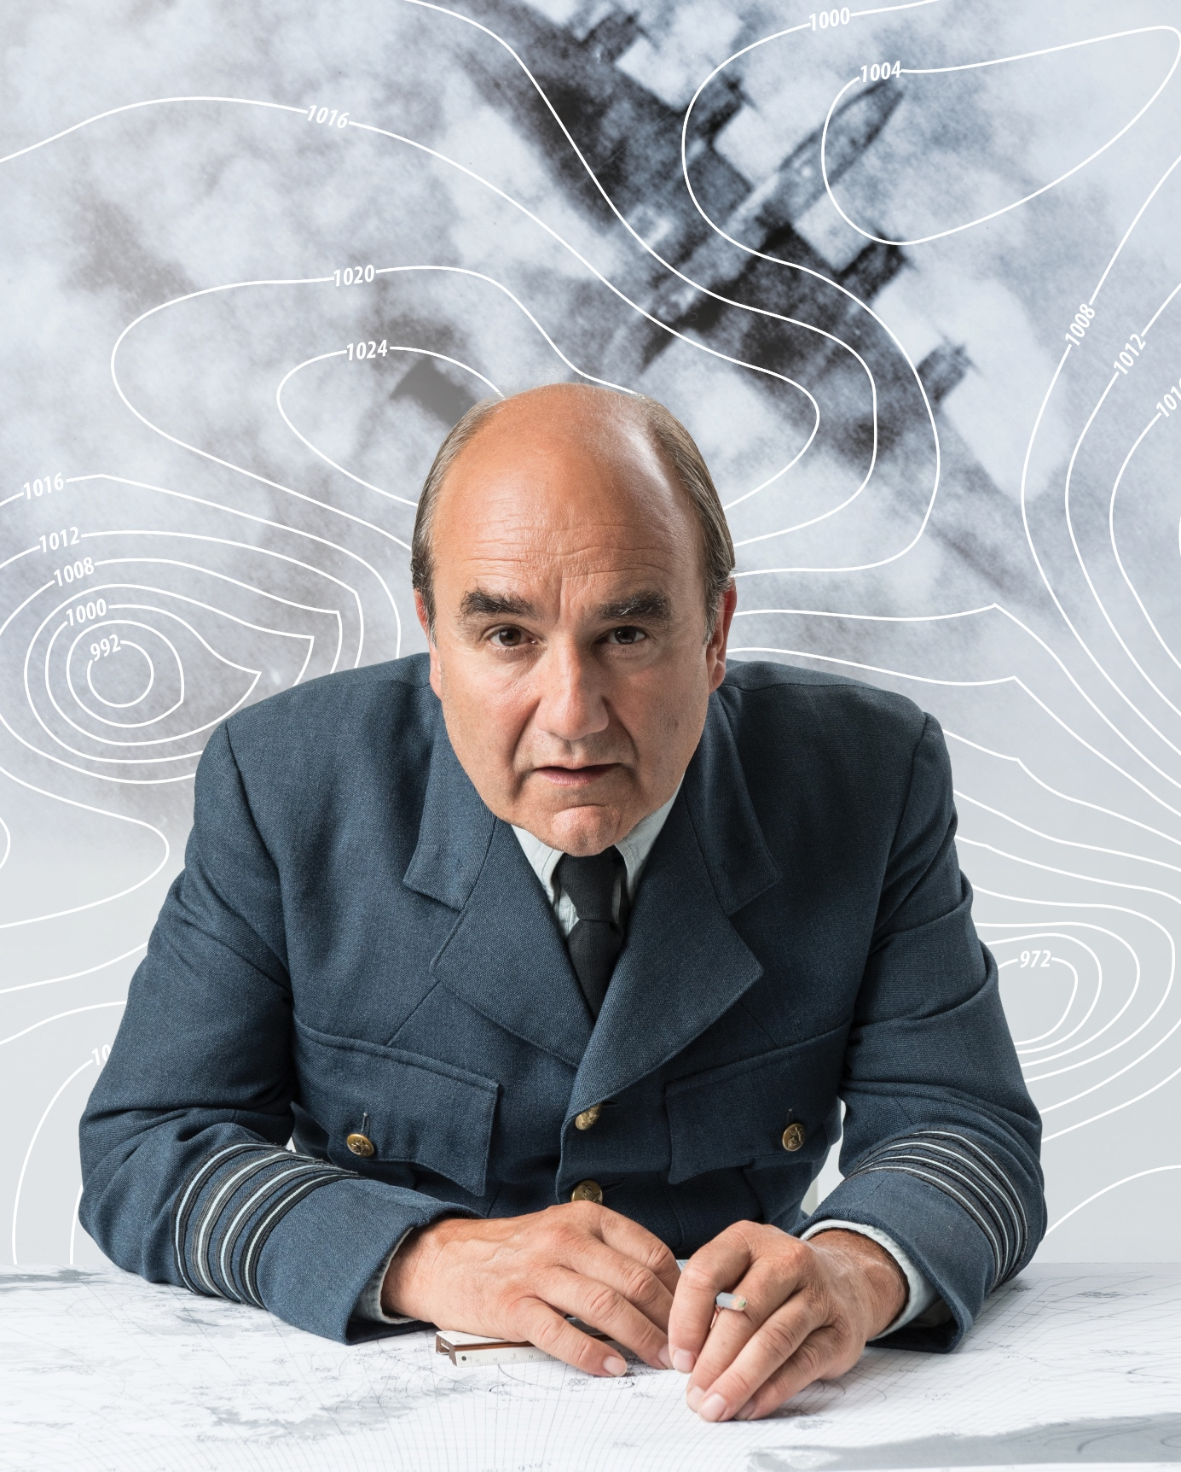

IT’S THE EVE OF D-DAY 1944 AND 350,000 LIVES DEPEND ON ONE OF THE MOST IMPORTANT WEATHER FORECASTS OF ALL TIME.

Based on the remarkable true story of two warring Allied meteorologists tasked with predicting the weather conditions for the D-Day landings, David Haig’s critically acclaimed play Pressure will transfer to the West Ends’ Ambassador’s Theatre for a limited season from 6 June to 1 September 2018. The transfer follows a celebrated run at Chichester Festival Theatre (5 stars from the; Daily Telegraph, Observer & Evening Standard), a national tour (in association with Cambridge Arts Theatre and Touring Consortium Company) and a sold out run at the Park Theatre.

David Haig reprises his role as Group Captain James Stagg, alongside Malcolm Sinclair as General Eisenhower and Laura Rogers as Kay Summersby, with further casting to be announced in due course.

David Haig said “"I am absolutely thrilled that Pressure is transferring to the West End on 6 June. What sublime timing that my play about the weather forecaster for D-Day, will open on the 74th anniversary of the D-Day invasions. The play has been profoundly fulfilling to write and perform. It's about one of the great unsung heroes of the 20th century and I'm so proud that his story will now be available to a West End audience. I couldn't be more excited."

Pressure is directed by John Dove, with design by Colin Richmond, lighting by Tim Mitchell, sound by Philip Pinsky, video by Andrzej Goulding and casting by Lisa Makin.

72 hours prior to the D Day landings, Scottish meteorologist, Group Captain James Stagg, advises General Eisenhower on the weather conditions likely to prevail when 350,000 troops are to be sent across the Channel in Operation Overlord. With Stagg predicting severe storms and Irving P. Krick – Hollywood’s meteorological movie consultant – predicting beautiful weather, the future of Britain, Europe and the United States rests on one single forecast.

Pressure was originally commissioned by the Royal Lyceum Theatre Edinburgh as a co-production with Chichester Festival Theatre. The production premiered at the Royal Lyceum Theatre Edinburgh in 2014, followed by a run at Chichester Festival Theatre.

David Haig is a five-time nominee and Olivier Award-winning actor best known for his roles in the film Four Weddings and a Funeral, TV series The Thin Blue Line and stage production of The Madness of King George III (Tour and West End). He is also an award-winning playwright. He wrote and starred alongside Daniel Radcliffe in My Boy Jack – which was made into a TV drama for ITV in 2007.

Malcolm Sinclair will reprise his role as General Eisenhower. Sinclair has performed extensively in leading roles with theatre companies such as the National Theatre and the RSC. He has performed widely, both in Britain and internationally. In 2001 he won the Clarence Derwent Award for his role as Gavin Ryng-Maine in the National Theatre’s production of House/Garden and was also nominated for an Olivier Award for best supporting actor for his performance as Major Miles Flack in Privates on Parade.

Laura Rogers will reprise the role of Kay Summersby. Her theatre credits include: An Ideal Husband, Masterpieces (Royal Court), Blue Remembered Hills (Chichester Festival Theatre), The Comedy of Errors (USA Tour and Shakespeare’s Globe), The 39 Steps (West End), Hay Fever (Chichester Festival Theatre), Macbeth, A Midsummer Night’s Dream, The Taming of the Shrew and Richard III (Shakespeare’s Globe) and Bad Girls – The Musical (Garrick Theatre and West Yorkshire Playhouse). Her television credits include: EastEnders, New Tricks, Dates, Twelfth Night, Doctor Who and Bad Girls.

Pressure at the Ambassadors Theatre is produced by Jonathan Church Productions, Jenny King & Oliver Mackwood Ltd.

______________________________________________________________________________________________________

NOTES TO EDITORS

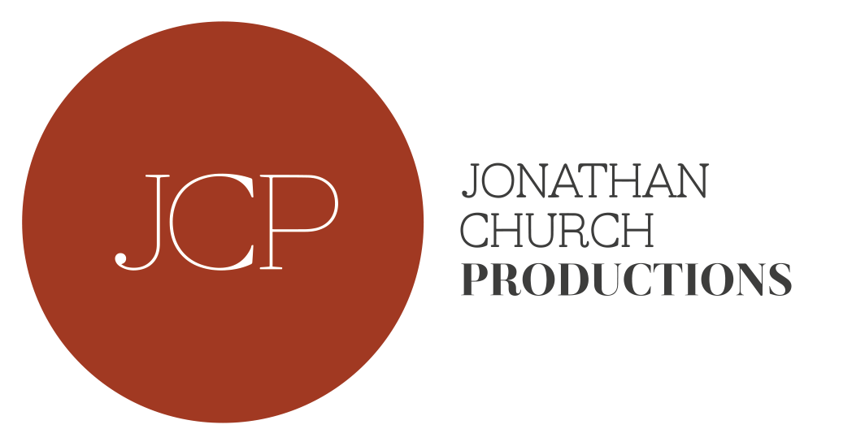

Jonathan Church Productions was formed in 2015, in association with Delfont Mackintosh Theatres, to produce and general manage high quality theatre in the West End, on tour and internationally. Recent productions include Frozen at Theatre Royal Haymarket, This House on a UK tour, Loves Labours Lost/Much Ado About Nothing at Theatre Royal Haymarket and The Dresser at the Duke of York’s Theatre. Jonathan Church is currently Artistic Director of Bath Theatre Royal’s Summer Season. He was Artistic Director of Chichester Festival Theatre (2006-2016), Artistic Director of Birmingham Repertory Theatre (2001-2006), Associate Director of Hampstead Theatre (1999-2001), Artistic Director of Salisbury Playhouse (1995-1999), Associate Director of Derby Playhouse (1994-1995) and Assistant Director of Nottingham Playhouse (1992- 1994).

J K PRODS Ltd
Jenny King started producing in 1995 since which time she has produced and co-produced over thirty five productions in the West End and on tour; including ‘The Father’ directed by Stuart Burge, starring Edward Fox and Stephanie Beacham, ‘Women on Verge of HRT’ at the Vaudeville and on tour, ‘Auntie & Me’ starring Alan Davies at Wyndham’s Theatre, ‘Of Mice and Men’ directed by Jonathan Church and starring Matthew Kelly (who won an Olivier Award for Best Actor), ‘Elmina’s Kitchen’ by and starring Kwame Kwei-Armah at the Garrick Theatre. ‘Honour’ starring Diana Rigg at Wyndhams. ‘The Railway Children’ at Waterloo and Toronto. ‘Slava’s Snowshow’ on tour and at the Royal Festival Hall (2011-2015). From 2011-2018 Jenny has produced eleven large scale tours for the Touring Consortium on tour in the UK. These include ‘Regeneration’ adapted by Nick Wright, ‘A Tale of Two Cities’ adapted by Mike Poulton, ‘Anita & Me’ adapted by Tanika Gupta, ‘Dr Jekyll & Mr Hyde’ adapted by David Edgar, ‘Pressure’ by David Haig and in the Autumn a new adaptation of ‘Dracula’. In 2018 Jenny is stepping down from running the Touring Consortium to develop her own commercial productions for West End and Tour. This includes ‘Man in the White Suit’ adapted by Sean Foley and a new comedy by Colin Swash.
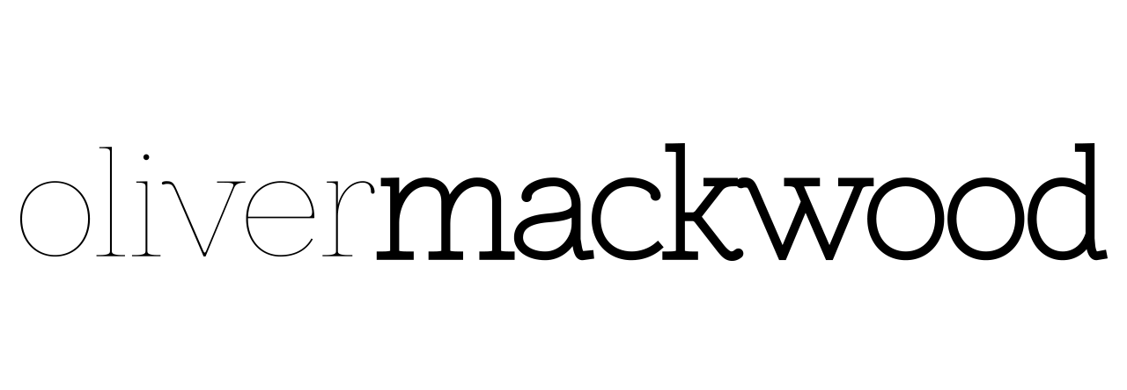
Oliver Mackwood Ltd was created to develop and manage high quality live entertainment in the UK and Internationally. The company was established in 2013 and is based out of the Noel Coward Theatre in the West End of London. Previous Productions include: Sand in the Sandwiches (Theatre Royal Haymarket), What Shadows, (UK Tour, Park Theatre), Vixen (in collaboration with English National Opera, touring internationally), Mack and Mabel (Chichester Festival Theatre), The Rehearsal, Pitcairn, Frankie & Johnny and Pressure (Minerva Theatre), Madame Rubinstein, Dinner with Friends (Park Theatre), Holes (Arcola Theatre) and Giovanni (Beijing).

LISTINGS

PRESSURE
AMBASSADORS THEATRE
6 JUNE – 1 SEPTEMBER 2018

*TICKETS ON SALE FROM WEDNESDAY 4TH APRIL*

Press Night: TBC

Performances:
Monday – Saturday at 7.30pm
Thursday & Saturday at 3.00pm

Ticket Prices: £15 to £55 (not including premiums)

Address: Ambassadors Theatre, West St, London WC2H 9ND

Box Office: 020 7395 5405

Website: www.pressureplay.co.uk

Facebook: @pressuretheplay

Twitter: @pressuretheplay

Instagram: @pressuretheplay

PRESS CONTACT: EMMA HOLLAND PR (EHPR)
W: www.emmahollandpr.com

Emma Holland Georgie Robinson
E: emma@emmahollandpr.com E: georgie@emmahollandpr.com
M: 0791 709 4203 M: 0751 211 2776

Jocasta Marron Natasha Haddad
E: jocasta@emmahollandpr.com E: assistant@emmahollandpr.com
M: 0772 517 1327

