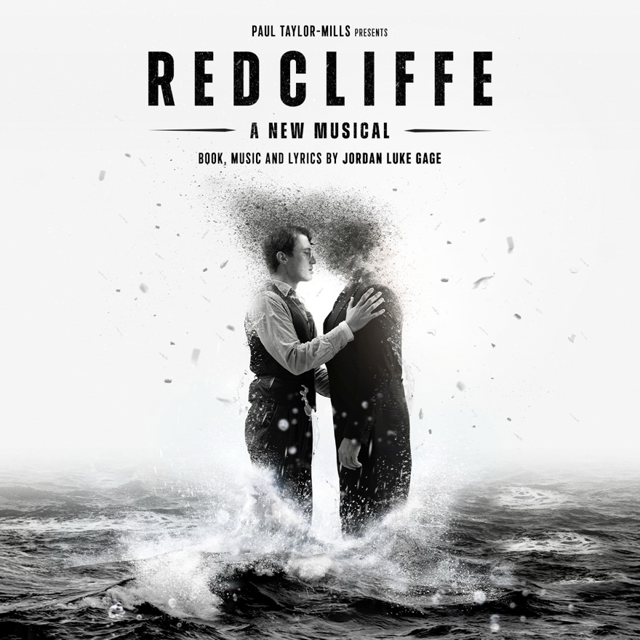
COMES TO SOUTHWARK PLAYHOUSE BOROUGH
FOR A STRICTLY LIMITED RUN
FROM 22 MAY – 4 JULY 2026

WITH BOOK, MUSIC AND LYRICS BY
JORDAN LUKE GAGE

Following eight sold out workshop performances at The Other Palace in 2024, new musical Redcliffe, written by Jordan Luke Gage (Bonnie & Clyde, Heathers, &Juliet) will run for a limited time, fully staged, at Southwark Playhouse Borough from May 2026.

Also reprising his lead role as William, which previously captivated audiences during the workshop performances, Gage has said, “it has been my greatest fulfilment creating Redcliffe and exploring the world of 18th century Bristol, a time that was beyond terrifying for men like me to exist in. To be able to tell this story, one which has never been told on the public stage, and to be able to hopefully move, uplift and change people, is beyond thrilling for me as both writer and actor.”

Set against the backdrop of 18th Century England, the new musical is based on the haunting true story of William Critchard and Richard Arnold in Redcliffe, Bristol and is an epic tale of forbidden love during the persecution people faced for hundreds of years.

William, a man from humble beginnings, is swept up in a hurricane of passion and danger when he meets Richard, a sailor visiting the town. This meeting forces both men to question everything they knew about the world and themselves.

With book, music, lyrics and starring Jordan Luke Gage, Redcliffe has been supported and developed by MTFestUK, The Other Palace and Bill Kenwright Limited. Further casting to be announced in due course.

NOTES TO EDITORS

JORDAN LUKE GAGE (BOOK, MUSIC, LYRICS AND STARRING AS WILLIAM CRITCHARD)
Jordan is most known for originated the role of Clyde Barrow in Bonnie and Clyde (Arts/Garrick) and originating the role of Romeo in the Olivier Award winning &Juliet (Shaftesbury theatre). He was nominated for both roles as Best Lead Actor (What’sOnStage Awards).

His other West End credits include originating Cal in Titanique, Strat in Bat Out Of Hell (The Dominion Theatre) and JD in Heathers (Theatre Royal Haymarket).

He played the role of Phillip in Alexi Kaye Campbells play The Pride at the Fortune theatre, West End, Fabrizio in the Light in the Piazza at Alexandra Palace and the title role in Bat Boy at the London Palladium

His solo show sold out the Outernet live music venue in London twice over and raised hundreds for the charity Stonewall Housing, who are proud sponsors of Redcliffe. Jordan was nominated for ‘Positive role model for the LGBT community’ at the National diversity awards.

His screen credits include Gilbert in Lincoln in the Bardo (Feature film), Prince James in The Royal Kill List (Sky), Adrian Barber in Cilla (ITV), and Luc in Cucumber (Channel 4) and voicing the role of Lucas in Midsummer Night (Netflix).

Redcliffe is Jordan’s writing debut, which he has been working on for three years.

PAUL TAYLOR-MILLS – PRODUCER

Paul is the Artistic Director at The Other Palace Theatre, London, and previously of The Turbine Theatre at The Battersea Power Station. He has also worked as Advisory Producer to Andrew Lloyd Webber and The Really Useful Group.

Stage credits include: At the Turbine Theatre - My Son’s A Queer (But what can you do?) (The Garrick, Ambassadors Theatre – Olivier Nominated, Best Entertainment or Comedy Play); Eugenius!; But I’m A Cheerleader, My Night with Reg, MTFestUK 2021, 2022, 2023 and 2024, Cinderella: The Socially Distanced Ball, Hair (part of the Turbine on the Jetty Season), Torch Song, High Fidelity and Cat In The Hat.

Elsewhere, Heathers the Musical at the Theatre Royal Haymarket, The Other Palace, UK Tour, New World Stages (New York) (winner of the WhatsOnStage Best New Musical Award), Freaky Friday at HOME Manchester, I Wish You Well at the Criterion Theatre, The Lightening Thief at The Other Palace and UK Tour, Cruel Intentions at The Other Palace and UK Tour, Murder For Two at the Watermill Theatre and The Other Palace, Cake the UK Tour, Lyric Theatre and The Other Palace, Boy Out The City and Bloody Elle at the Lyric Theatre, The Wild Party at The Other Palace, European Premiere of Disney’s Peter and the Starcatcher at the Royal & Derngate, Northampton, Side Show at Southwark Playhouse, The Last Five Years at the St. James Theatre (winner of the WhatsOnStage Award for Best Off-West End Production) End of The Rainbow on UK Tour, In The Heights at Kings Cross Theatre and Southwark Playhouse (winner of three Olivier Awards), Casa Valentina at Southwark Playhouse, Carrie The Musical at Southwark Playhouse (winner of The WhatsOnStage Off West End Award), and Associate Producer on The Importance of Being Earnest starring David Suchet on UK Tour and the Vaudeville Theatre.

SOUTHWARK PLAYHOUSE BOROUGH
Southwark Playhouse is a registered charity that delivers a year-round programme of
entertaining and enriching work. Southwark Playhouse operates two separate venues ‘Southwark Playhouse Borough’ and its newest theatre ‘Southwark Playhouse Elephant’ which opened in January 2023. Southwark Playhouse has always prided itself in telling stories and inspiring the next generation of storytellers and theatre makers, where support for the community has been rooted at the core of the organisation.

Website: southwarkplayhouse.co.uk
BlueSky: @swkplay.bsky.social
Facebook: SouthwarkPlayhouse
Instagram: @swkplay
TikTok: swkplay
YouTube: southwarkplayhouse

LISTINGS
REDCLIFFE
22 MAY – 4 JULY 2026
Book, music and lyrics by Jordan Luke Gage
Musical direction and orchestrations by Ben Tomalin
Artwork by Harry Neal Creative
Photography by Mark Senior

Press Night: Wednesday 27 May

Performance Schedule: Monday – Saturday at 7pm
Tuesday and Saturday at 2.30pm

Ticket Prices: £10 Pioneers’ Preview, £16 Previews, £28 Standard Tickets, £22.50 Concessions

Running Time: 2 hours 20 minutes (including interval)
Age Guidance: 14+

Address: Southwark Playhouse Borough, 77-85 Newington Causeway, London SE1 6BD
The nearest stations are Elephant & Castle and Borough
Box Office: 020 7407 0234

Website: https://southwarkplayhouse.co.uk/productions/redcliffe
Social:
Instagram: @redcliffemusical

Production Artwork: Available to download HERE
Artwork by Harry Neal Creative with photography by Mark Senior
Headshot: Available to download HERE

____________________________________________________________________

PRESS CONTACT: EMMA HOLLAND PR (EHPR)
W: www.emmahollandpr.com

Emma Holland Didi Ralph
E: emma@emmahollandpr.com E: didi@emmahollandpr.com
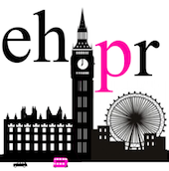
M: 07917094203 M: 07872895051

