SATURDAY NIGHT FEVER
TOURING THE UK THIS AUTUMN
DIRECT FROM ITS TRIUMPHANT WEST END RUN
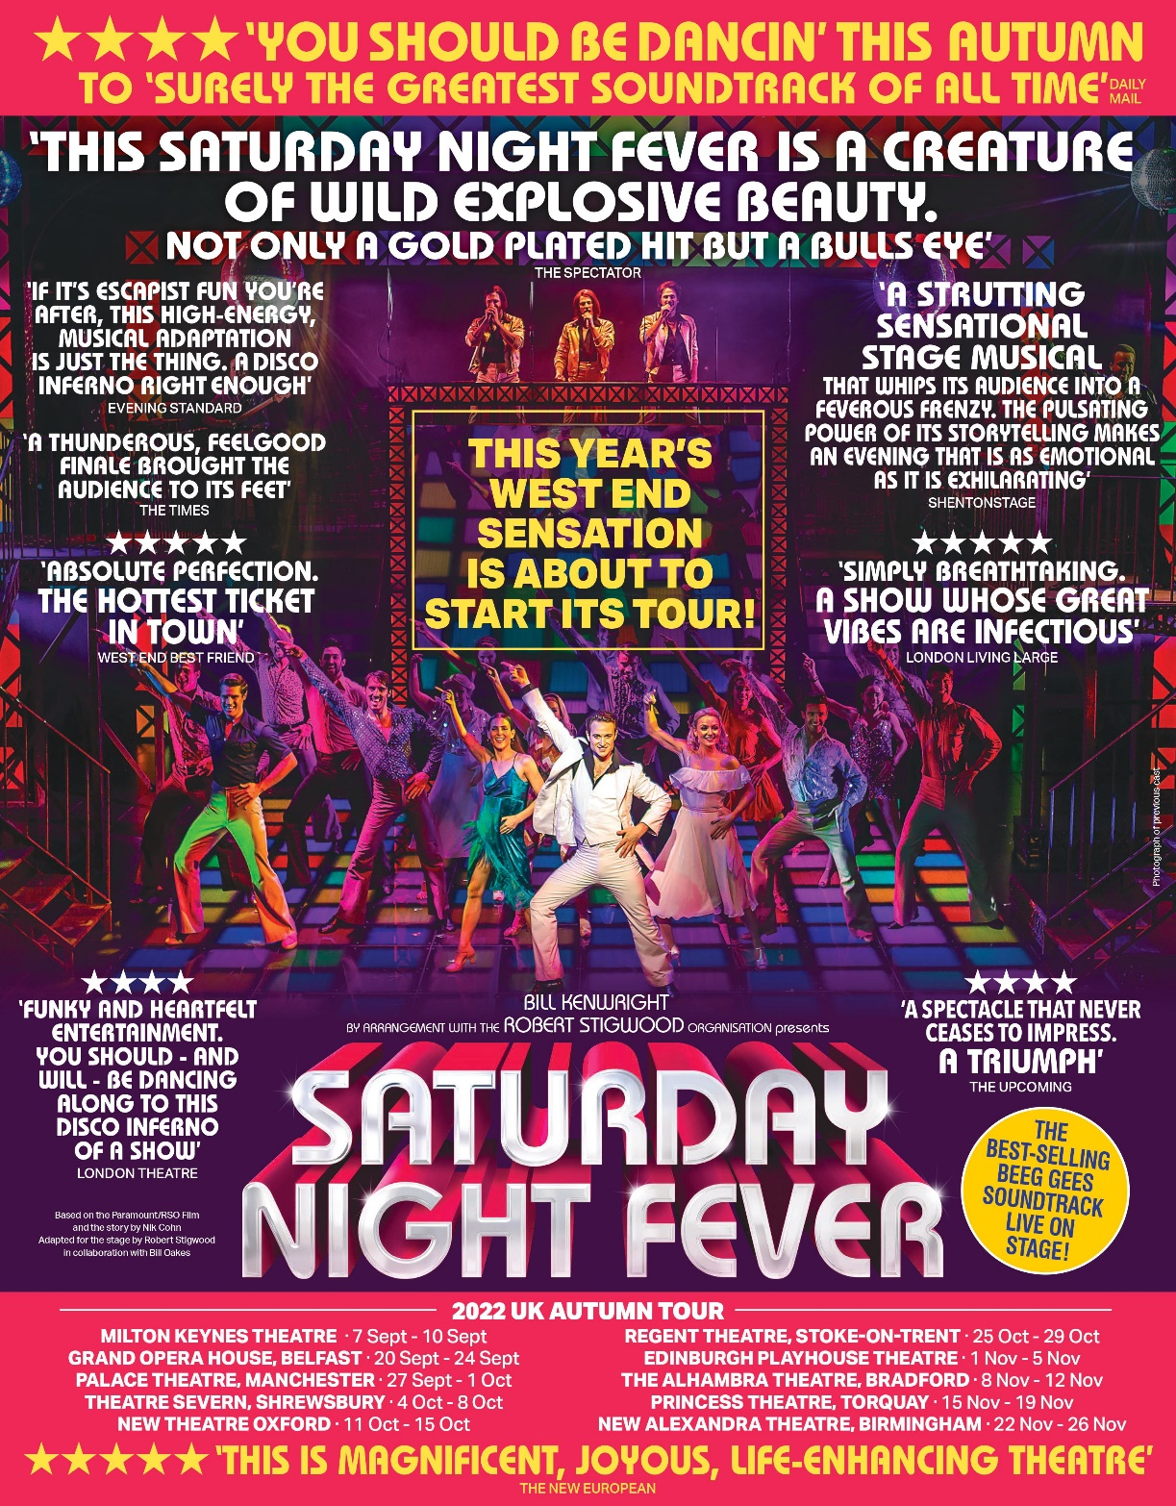

“This Saturday Night Fever is a creature of wild explosive beauty. Not only a gold plated hit but a bulls eye”
The Spectator

“This is magnificent, joyous, life-enhancing theatre”
The New European

“You should be dancin’. Surely the greatest soundtrack of all time”
Daily Mail

“Absolute perfection. The hottest ticket in town”
West End Best Friend

“A thunderous, feelgood finale brough the audience to its feet”
The Times

Direct from the West End, Bill Kenwright’s production of Saturday Night Fever returns this year, hitting the road this September, allowing audiences up and down the country a chance to experience the best-selling Bee Gees soundtrack live on stage in this spectacularly reimagined musical which promises to have you grabbing your boogie shoes and dancing in the aisles!

Saturday Night Fever follows the story of Tony Manero, as he embarks on a reckless yet thrilling road to dancing success. It’s a homage to the 1977 John Travolta classic with more drama, more music, and hot new choreography and features onstage actor-musicians in the roles of the Bee Gees, singing all your favourite hits!

Jack Wilcox will lead the cast in the role of Tony Manero joined by Rebekah Bryant as his dance partner Stephanie including the onstage presence of the Bee Gees, played by Drew Ferry, Oliver Thomson and AJ Jenks.

Completing the glittering line-up are: Harry Goodson-Bevan (Bobby C); James Brice (Gus); Liam Morris (Double J); Dominic Gore (Joey); Billie Hardy (Annette); Tosca Fischer (Connie); Emily Bolland (Linda); Phillip Aiden (Frank Senior); Marios Nicolaides (Frank Junior); Melody Jones (Flo Manero); Faizal Jaye (DJ Monty); Yiota Theo (ensemble); Ashley Luke Lloyd (ensemble); Anthony Starr (ensemble); Joshua Clayton (ensemble); Helen Gulston (ensemble) and James Cohen (ensemble).

Featuring songs from the one of the bestselling movie soundtracks of all time, including the 70s disco classics, Stayin’ Alive, How Deep Is Your Love, Night Fever, Tragedy, and many more, Saturday Night Fever promises to be a night to remember!

Saturday Night Fever is produced and directed by Bill Kenwright, with choreography by Bill Deamer, design by Gary McCann, lighting by Nick Richings, and sound by Dan Samson. The stage adaptation is by Robert Stigwood in collaboration with Bill Oakes.

NOTES TO EDITORS

Jack Wilcox’s stage credits include: Anything Goes (The Barbican/UK Tour); White Christmas (Dominion Theatre); Joseph and the Amazing Technicolor Dreamcoat (The London Palladium); Kiss Me Kate (London Coliseum, Leeds Grand Theatre); An American in Paris (Dominion Theatre); Sweeney Todd (Mercury/Derby Theatre); Cinderella (QDOS Manchester Opera House); Travels With my Aunt (Chichester Festival Theatre); Titanic (Princess of Wales, Toronto); The Sound of Music (Leicester Curve); West Side Story (UK Tour); Singin’ in the Rain (Palace Theatre); Kiss Me Kate (Theatre Du Chatelet); 42nd Street (Leicester Curve); A Chorus Line (Tel Aviv Opera House); Singin’ in the Rain (Chichester Festival Theatre); Shoes (The Peacock Theatre); Wicked (Victoria Apollo); High School Musical 2 (UK Tour); Apollo Victoria 80th Gala (Apollo Victoria); Kerry Ellis Sings the Great British Songbook (Shaw Theatre); Night of 1000 Voices (Royal Albert Hall); Handel’s Messiah (Royal Albert Hall).
Screen credits include: All Star Musicals (ITV); Ant & Dec’s Saturday Night Takeaway (ITV); Surprise Surprise (ITV); Anything Goes (BBC); An American in Paris (Sky Arts).
Other credits include: Singin’ in the Rain (London Cast recording 2012).

Rebekah Bryant’s (Stephanie) stage credits include: 9 to 5 the Musical (UK Tour); Various Pantomimes (Qdos Entertainment) and Stratagem with Alan Partridge (UK Arena Tour).
Screen credits include: The FA Cup Final (BBC); The Brits (ITV).
Other credits include: Carnival Cruise Lines

Drew Ferry’s (Bee Gee) credits include: Lead Vocalist (AIDA Cruises).
Oliver Thomson’s (Bee Gee) stage credits include: Saturday Night Fever (Peacock Theatre). Into the Wonderland (Four Seasons Theatre); Bye Bye Baby! (Four Seasons Theatre).
Other credits include: Carnival, Fred Olsen and Marella (Cruises);
AJ Jenks’ (Bee Gee) stage credits include: Buddy, The Buddy Holly Musical (UK Tour); Million Dollar Quartet (UK Tour).

Harry Goodson-Bevan’s stage credits include: Stephen Sondheim’s Old Friends A Celebration (Sondheim Theatre).

James Brice’s (Gus) stage credits include: Saturday Night Fever (Peacock Theatre); Peter Pan (The Capital Theatre); Cinderella (The Forum Theatre)

Liam Morris’ (Double J) stage credits include: Sleeping Beauty (QDOS); Cinderella (UK Productions).
Other credits include: Grease the Musical (Royal Caribbean).

Dominic Gore’s (Joey) stage credits include: Sleeping Beauty (Crossroads Pantomimes); Peter Pan (St Helen’s Theatre Royal); Snow White and the Seven Dwarves (New Brighton Floral Pavilion); Lord of the Flies (Liverpool Empire).
Other credits include: Royal Caribbean (Cruise); Costa (Cruise);

Billie Hardy’s(Bobby C) stage credits include: Chicago (UK & International Tour); Bat Out of Hell (UK Tour); Burlesque’d Live (Turbine Theatre); Aladdin (Theatre Royal Windsor); Closer to Heaven (Above the Stag Theatre); Cilla the Musical (UK Tour – BKL Productions); Grease (Royal Caribbean); Grease (Belinda King Productions); Peter Pan (The Stag Theatre Sevenoaks) Joseph and the Amazing Technicolour Dreamcoat (Adelphi Theatre).
Tosca Fischer’s (Connie) stage credits include: Saturday Night Fever (UK & International Tours); Saturday Night Fever (Sadler’s Wells’ Peacock Theatre).
Other credits include: Royal Caribbean (Cruise).
Emily Bolland’s (Linda) is excited to make her professional theatre debut.

Phillip Aiden’s (Frank Senior) stage credits include: Saturday Night Fever (40th Anniversary Tour); Billy Elliot (UK and Ireland Tour); Chicago (West End and Asia); Beautiful and Damned (West End); Beauty and the Beast (R.S.C); My Fair Lady (National Theatre and West End); Anything Goes, La Traviata (Grange Park Opera); Evita (Oslo); Always (West End); Mack and Mabel (Leicester and West End); Follies (Leicester Haymarket); Calamity Jane (Leicester Haymarket); Tommy Steele- What a Show! (UK Tour); Me and My Girl (UK Tour); Hollywood Symphonic (Lille).
Screen credits include: Star for a Night (BBC); Abbamania (LWT); The Brits (BBC); Pebble Mill (BBC); Des O’Connor Tonight (ITV); Royal Variety Performance (LWT).

Marios Nicolaides’ (Frank Junior) stage credits include: Saturday Night Fever (Peacock Theatre and UK Tour); Annie (Piccadilly Theatre and Ed Mirvish Theatre, Toronto); Thoroughly Modern Millie (UK Tour); Ghost (English Theatre, Frankfurt); 42nd Street (UK Tour); White Christmas (Edinburgh Festival Theatre); War of the Worlds (Dominion Theatre); Ghost (Marina Bay Sands, Singapore); Kiss Me Kate (Grand Theatre, Luxembourg); Pacific Overtures (Union Theatre).

Melody Jones’ (Flo Manero) stage credits include: Saturday Night Fever (UK Tour); She Loves You (workshop); Copacabana (Copenhagen); Chitty Chitty Bang Bang (UK Tour); Summer Holiday (UK Tour); Annie (UK Tour); The Rat Pack (UK Tour); Smokey Joe’s Cafe (UK Tour); Sunset Boulevard (Germany).

Faizal Jaye’s (DJ Monty) stage credits include: Saturday Night Fever (UK Tour and Peacock Theatre); Snow White And The Seven Dwarfs (Bridlington Spa); Cinderella (Marina Theatre Lowestoft).
Other credits include: Carnival Cruise Lines; Bad Girls the Musical (CPA Studios);

Yiota Theo’s Theo (ensemble) stage credits include: The Bodyguard (UK tour, Japan).

Anthony Starr’s (ensemble) stage credits include: Guys And Dolls (Crucible Theatre); Aladdin (Theatre Royal Plymouth, Crossroads); Resident Ensemble, The Café 5 (Theatre Channel & theatre cafe); Episode 7 of the Theatre Channel - Rogers and Hammerstein Episode (Regents Park Open Air Theatre); Episode 8 of The Theatre Channel with Stephen Schwartz (Finsbury Park Theatre/Charing Cross Theatre, Stream Theatre); Closer To Heaven - Pet Shop Boys Musical! (The Union Theatre); Jackie The Musical! (UK Tour); Coppélia (EYB); Starlight Express (Germany, Bochum); Thoroughly Modern Millie (Landor Theatre, London); Cats The Musical (Tour); Disaster! The Musical (Charing Cross Theatre); Jack And The Beanstalk (Theatre Royal, Nottingham); Aladdin (Mayflower Theatre); Mountbatten Music Festival (Royal Albert Hall); 42nd Street (Gardyne Theatre).
Screen credits include: The Entire Universe (BBC); Eurovision Song Contest: The Story of Fire Saga (Netflix).

Joshua Clayton’s (ensemble) Screen credits include: Hollyoaks (Channel 4); Coronation Street (ITV)

Helen Gulston’s (ensemble) stage credits include: Saturday Night Fever (UK Tour and Peacock Theatre); You Win Again, The Beegees Story and A Night Of Dirty Dancing (Easy Theatres); Cinderella (Grand Theatre, Swansea); Mother Goose (Wilton's Music Hall); Sleeping Beauty (Moonstone Entertainment LTD); Jack And The Beanstalk and Robin Hood And The Babes In The Wood (The Pantomime Productions).
Screen credits include: All Star Musicals (ITV); Beauty And The Beast (Walt Disney Productions); The Alan Titchmarsh Show (ITV); Britain's Got Talent (ITV)
Other credits include: Cats (Oasis of the Seas, Royal Caribbean Productions); Pacific Pearl (P&O Australia); Broken Strings And Rock City (Celebrity Cruise Line);

James Cohen’s (ensemble) stage credits include: Saturday Night Fever (The Peacock Theatre); Legally Blonde (Kilworth House); Priscilla Queen Of The Desert (U.K Tour and Palace Theatre, London); Naked Boys Singing! (Arts Theatre, London); Studio 54 – The Musical (Edinburgh Fringe Festival); Nunsense A-Men (Arts Theatre, London); The eXtra Factor (U.K Tour); Pistol’s Page, RSC Henry IV Part II (Barbican, London); Peter Pan – The Musical (Cambridge Theatre, London); The Sound Of Music (New Victoria Theatre, Woking); Robin – Prince Of Sherwood (Piccadilly Theatre, London); Beauty and the Beast (Palace Theatre, Newark).
Screen credits include: Doctors (BBC); Over The Rainbow (BBC); Eastenders (BBC); Between The Lines (BBC).

LISTINGS
Bill Kenwright presents

SATURDAY NIGHT FEVER
UK TOUR
Adapted by Robert Stigwood
Directed by Bill Kenwright
Design by Gary McCann
Lighting Design by Nick Richings

Dates: 5 September – 26 November 2022

Milton Keynes Theatre, Milton Keynes atgtickets.com/milton-keynes
5 Sep – 10 Sep 2022 0333 009 6690

Grand Opera House, Belfast goh.co.uk
19 Sep – 24 Sep 2022 028 9024 1919

Palace Theatre, Manchester atgtickets.com/manchester
26 Sep – 1 Oct 2022 020 7206 1174

Theatre Severn, Shrewsbury theatresevern.co.uk
3 Oct – 8 Oct 2022 01743 281281

New Theatre, Oxford atgtickets.com/oxford
10 Oct – 15 Oct 2022 0333 009 6690

Regent Theatre, Stoke-On-Trent atgtickets.com/stoke
24 Oct – 29 Oct 2022 0844 871 7615

The Playhouse, Edinburgh atgtickets.com/edinburgh
31 Oct – 5 Nov 2022 03330 096 690

The Alhambra, Bradford bradford-theatres.co.uk
7 Nov – 12 Nov 2022 01274 432000

Princess Theatre, Torquay atgtickets.com/torguay
14 Nov – 19 Nov 2022 0333 009 6690

The Alexandra, Birmingham atgtickets.com/birmingham
21 Nov – 26 Nov 2022 0844 871 7615

PRODUCTION ASSETS

Past Production Images: Available to download HERE
Headshots: Available to download HERE
Poster Image: Available to download HERE

Website: kenwright.com

Twitter: @BKL_Productions

Instagram: @bklproductions

PRESS CONTACT: EMMA HOLLAND PR (EHPR)
W: www.emmahollandpr.com

Emma Holland Didi Ralph
E: emma@emmahollandpr.com E: didi@emmahollandpr.com
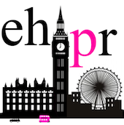
M: 0791 709 4203 M: 07872 895051

