OUT OF THIS WORLD: SPACE DOGS: THE MUSICAL
HAS LIFT-OFF IN LONDON
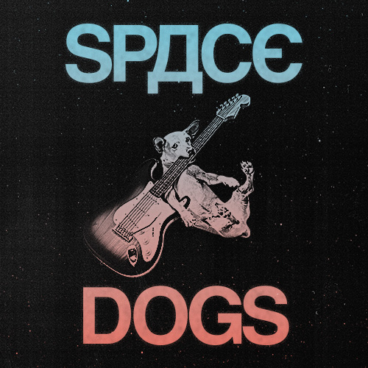
WRITTEN BY NICK BLAEMIRE AND VAN HUGHES

FROM 28 JULY TO 09 AUGUST 2026
AT THE OTHER PALACE STUDIO

London audiences are set for a stellar adventure this summer as Space Dogs: The Musical blasts into The Other Palace Studio for a limited run from 28 July to 09 August.

The epic, mind-bending new musical uncovers the unbelievable-yet-true story of Laika, a stray dog from Moscow, and the mysterious Chief Designer, the top-secret Soviet scientist who sent her into orbit during the Cold War Space Race.

Written and performed by Nick Blaemire and Van Hughes, this unique rock musical docu-comedy is a two-hander unlike any other with Hughes and Blaemire playing and singing every role. From Laika and the Chief Designer to high-ranking politicians, covert scientists, and an entire pack of 40 Russian space dogs, the two actors shift seamlessly between characters in this thrilling, fast-paced theatrical feat.

A sweeping tale of invention, betrayal, political intrigue, and the immortal bond between man and dog, Space Dogs: The Musical takes audiences on a kaleidoscopic journey from the launch pads of earth to the stars above.

Producers Paul Taylor-Mills and Tricia Small shared their excitement: “Bringing SPACE DOGS to London and to The Other Palace - feels like the perfect next chapter for this wildly original show. Nick and Van have created a theatrical universe that is as hilarious as it is heartfelt.”

Space Dogs is written by and starring Nick Blaemire and Van Hughes, directed by Will Blum and produced by Paul Taylor-Mills and Tricia Small.

NOTES TO EDITORS
NICK BLAEMIRE (WRITER AND STAR)
Nick Blaemire is a Brooklyn-based writer and actor. He has written book, music
and/or lyrics for August Rush (with Tom Kitt, Van Hughes and Kathleen
Marshall), Safety Not Guaranteed (Brooklyn Academy of Music and Signature
Theater, with Ryan Miller of the band Guster), Space Dogs (MCC Theater Off-
Broadway, with Van Hughes), Glory Days (Circle in the Square on Broadway,
with James Gardiner), Disney’s Descendants (2500 productions around the
world), Soon (Off Broadway fall '26), A Little More Alive (Williamstown, Barrington
Stage, KC Rep, film option), Edge of the World (with Ethan Slater), Quixote (with
Daniel J. Watts) and Fallout (with Kyle Jarrow). Nick has released three pop
albums, available online. As an actor, he appeared on Broadway in Cry-Baby and
Godspell; the National Tours of Falsettos and Altar Boyz; Off-Broadway in Tick
Tick Boom (Drama Desk nom), Dogfight, Found and The Black Suits. On film,
he recently played Adolph Green in Bradley Cooper's Leonard Bernstein
biopic Maestro for Netflix. A University of Michigan graduate, Nick is repped by
CAA. IG: @blaemire

VAN HUGHES (WRITER AND STAR)
Van Hughes is a multi-instrumentalist, actor, singer, composer, and music
producer. He wrote and starred in SPACE DOGS Off-Broadway with Nick
Blaemire and produced the cast album (2022). He most recently appeared as
John Carter Cash in Des MacAnuff's The Ballad of Johnny and June at La Jolla
Playhouse and the Citadel Theater (Canada). In 2010, Van starred in Green
Day's American Idiot on Broadway opposite Billie Joe Armstrong and led the 1st
National Tour. Other Broadway credits include Almost Famous, Deaf
West’s Spring Awakening, 9 to 5 and Hairspray. On TV and film, he most notably
appeared in both Sex and the City films, Rachel Getting Married and guest-
starred on Law & Order: SVU, Royal Pains, and One Life To Live, as well as
many national commercials and voicing promos for Nickelodeon. As a film score
composer, he scored the indie-horror features Sequence Break, Lonely Man and
the Ghost Machine, and Space Clown. His solo debut art-rock album will be
released this summer. He has a B.A. in Theatre from Fordham University.
@vanhughesmusic

WILL BLUM (DIRECTOR)
Will Blum is thrilled to return to The Other Palace where he directed the UK premiere of Frank Wildhorn’s Bonnie & Clyde in 2017. While in London, he worked with Lonny Price on his productions of Carousel for the English National Opera and Lady Day at Emerson’s Bar & Grill starring Audra McDonald at Wyndham’s Theatre. In New York City, he directed the Off Broadway premieres of Nick Blaemire’s new musical SOON at the East Village Basement, and Pedro Antonio Garcia’s The Witness Room at AMT. BFA from The Boston Conservatory, trained at The Workcenter of Jerzy Grotowski and Thomas Richards in Pontedera, Italy, specializing in Environmental and Immersive Theatre. He has worked extensively as an Actor on Broadway and all around North America. IG: @willblum
THE OTHER PALACE
The Other Palace is dedicated to discovering, developing, exploring, and celebrating theatre. It’s a lively, friendly, and inventive place where ideas can be shared and explored, and the next generation of theatre-makers are encouraged, supported, and celebrated.

The venue has an extraordinary history dating back to 1766 when it began life as the Charlotte Chapel and was turned into the Westminster Theatre in 1931. In 2021 the venue was acquired by Bill Kenwright Ltd, one of the largest commercial theatre producers in the UK.

The Other Palace Studio is a creative hub for both the aspiring and accomplished within the industry. The intimate space breaks down the barriers between audiences and performers and provides a platform for new musical theatre to be developed and celebrated.

The Other Palace runs multiple schemes to nurture and develop new writing including the Making a Musical podcast, Musical Bites lunchtime readings, and a development grant.

LISTINGS
SPACE DOGS
THE OTHER PALACE STUDIO
28 July – 09 August 2026
Written by Nick Blaemire and Van Hughes

Press Night: Thursday 30 July

Performance Schedule: Tuesday to Saturday - 8pm
Saturdays at 3pm
Sundays 2pm and 5pm

Run Time: 1 hour 25 minutes (no interval)

Tickets: from £25
Age Guidance: 10+ years

Socials: @spacedogsmusical
@TheOtherPalace

Venue: The Other Palace, Studio
Address: 12 Palace Street, London, SW1E 5JA
Box Office: 020 7592 0302

Website: https://theotherpalace.co.uk/space-dogs/

Headshots: Available to download HERE
Artwork: Available to download HERE
The Other Palace Logo: Available to download HERE

PRESS CONTACT: EMMA HOLLAND PR (EHPR)
W: www.emmahollandpr.com

Emma Holland Didi Ralph
E: emma@emmahollandpr.com E: didi@emmahollandpr.com
M: 0791 709 4203 M: 07872 895 081



