DEMIGODS UP AND DOWN THE COUNTRY ASSEMBLE!
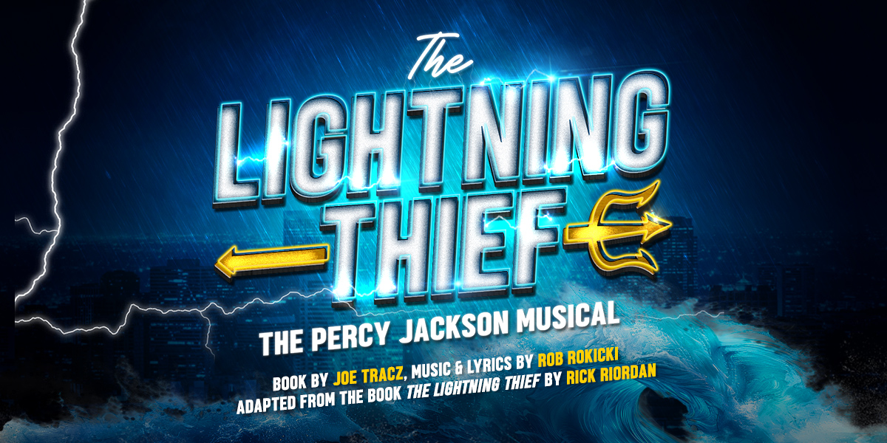
IS SET TO BRING OLYMPIAN ENERGY TO AUDIENCES ACROSS THE UK
THIS AUTUMN AND INTO 2026
“A bolt of stage magic.
A show that whisks you to another dimension.”
The Times

“Catchy songs, original choreography and a quirky spirit brings out the directness and humour of Rick Riordan’s mythical quest.”
The Guardian

Get ready, demigods! The Lightning Thief: The Percy Jackson Musical is set to embark on an electrifying UK tour this autumn, bringing the hit stage adaptation of Rick Riordan’s bestselling novel to audiences across the country. The tour will open at Theatre Royal Windsor from 15 – 23 August 2025 and then play Newcastle, Milton Keynes, Liverpool, Brighton, Stoke-on-Trent, Coventry, Bradford and Wimbledon with many more venues, and casting, to be announced.

Paul Taylor-Mills (Producer) said: “We’re thrilled to bring Percy Jackson’s epic journey to more UK audiences following the success we’ve had in London. This show is full of energy, humour, and heart—whether you're a long-time fan or new to the world of Camp Half-Blood, you’re in for an unforgettable adventure.”

Based on the beloved book series (with over 180 million copies sold worldwide), Percy Jackson’s story has been adapted into both films and a major hit TV series for Disney+. The musical first premiered off-Broadway in 2014 to rave reviews and went on to have two US tours, another off-Broadway run in 2017 and a 16-week limited run on Broadway in 2019. Since November 2024, The Lightning Thief has been making waves with London audiences, receiving critical acclaim and will continue at The Other Palace until 31 August 2025.
When New York City teenager Percy Jackson discovers that he is the half-blood son of the Greek god, Poseidon, his life takes a dramatic turn as he is plunged into a world much bigger than he could possibly have imagined.
With newly discovered powers he is unable to control, an unwanted destiny and a whole textbook’s worth of mythical monsters on his trail, Percy must learn what it means to be a hero.
The future of the world hangs in the balance as Percy and his friends embark on an epic adventure that will have you on the edge of your seat.
This dynamic musical adaptation of Rick Riordan’s bestselling The Lightning Thief has a book by Joe Tracz (Be More Chill), music and lyrics by Rob Rokicki (Monstersongs) and is directed and choreographed by Lizzi Gee (Groundhog Day).

LISTINGS
BILL KENWRIGHT LTD & PAUL TAYLOR-MILLS PRESENT
THE LIGHTNING THIEF
THE PERCY JACKSON MUSICAL
Book by Joe Tracz
Music & Lyrics by Rob Rokicki
Adapted from the book The Lightning Thief by Rick Riordan
Direction and Choreography by Lizzi Gee
Run Time: approximately 2hrs 10 minutes including interval
UK TOUR 2025

15 – 23 Aug Theatre Royal Windsor 01753 853888 On sale 7 Mar
27 – 31 Aug Newcastle Theatre Royal 0191 232 7010 On sale 4 Apr
3 – 6 Sep Milton Keynes Theatre On sale 4 Apr
16 – 20 Sep Liverpool Empire On sale 4 Apr
30 Sep – 4 Oct Brighton Theatre Royal On sale 4 Apr
7 – 11 Oct Regent Theatre Stoke-on-Trent On sale 4 Apr
14 – 18 Oct Coventry Belgrade 024 7655 3055 On sale 1 Apr
21 – 25 Oct Bradford Alhambra Theatre 01274 432000 On sale 14 Apr
28 Oct – 1 Nov New Wimbledon Theatre On sale 4 Apr

Further dates and cast to be announced
Assets:
London Production Images: Available to download HERE
London Trailer: Available to download HERE
Artwork: Available to download HERE
Socials:
Instagram and Tiktok: @percyjacksononstage
Facebook: @peryjacksonlondon
Twitter/X: @PercyOnStage

PRESS CONTACT: EMMA HOLLAND PR (EHPR)
W: www.emmahollandpr.com

Emma Holland Didi Ralph
E: emma@emmahollandpr.com E: didi@emmahollandpr.com
M: 0791 709 4203 M: 0787 289 5051

