RETURNING TO THEATRE ON KEW
THIS SUMMER
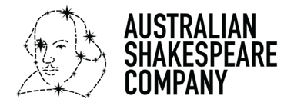

BRING THE SHAKESPEARE COMEDY
TWELFTH NIGHT
AND THE BELOVED STORIES OF
THE WIND AND THE WILLOWS,
JACK AND THE BEANSTALK
TO THE BEAUTIFUL GROUNDS OF KEW GARDENS

FROM 18 JULY 2026

The Australian Shakespeare Company (ASC) is delighted to return to Kew Gardens this summer to bring world-class outdoor theatre to the heart of the Royal Botanic Gardens, Kew. With over 40 years of pioneering theatre at unique venues, the ASC present exciting, accessible, contemporary productions of Shakespeare and children’s classics to audiences of all generations.

This summer they bring an “eventful” evening production of Shakespeare’s Twelfth Night, directed by the ASC’s Artistic Director Glenn Elston, Keneth Grahame’s whimsical The Wind In The Willows, directed by Otis Elston, and completing this year’s line-up and making its UK debut is the magical Jack And The Beanstalk, directed by Dennis Manahan.

Glenn Elston has said, “There is nothing more rewarding than watching families come together to laugh, play, and create lifelong memories through live theatre. At Theatre on Kew this season, we’re inviting audiences of all ages to step into magical worlds—whether that’s climbing sky-high adventures in Jack and the Beanstalk, splashing through mischief and friendship with The Wind in the Willows, or delighting in the romance and comedy of Twelfth Night.

I love seeing young audiences arrive dressed as their favourite characters, ready to sing, laugh and be part of the story, while older children and adults alike discover the joy of immersive, interactive storytelling.

Each of these productions has been crafted to celebrate imagination, humour and the shared experience of theatre, and I can’t wait to see Kew come alive with the energy, creativity and wonder of audiences enjoying these shows together in such a beautiful setting.”

Tickets to all performances include entry into Kew Gardens, so audiences can enjoy an idyllic day exploring Kew’s 320 acres followed by a theatrical production in the sunshine or under the stars.

Alongside the event, families can explore popular attractions around Kew Gardens including the Children’s Garden, Treetop Walkway, the Henry Moore: Monumental Nature Family Trail and Tom Gates EPIC Adventure (the latter running from 18 July to 31 August).
***
TWELFTH NIGHT
25 July – 30 August 2026
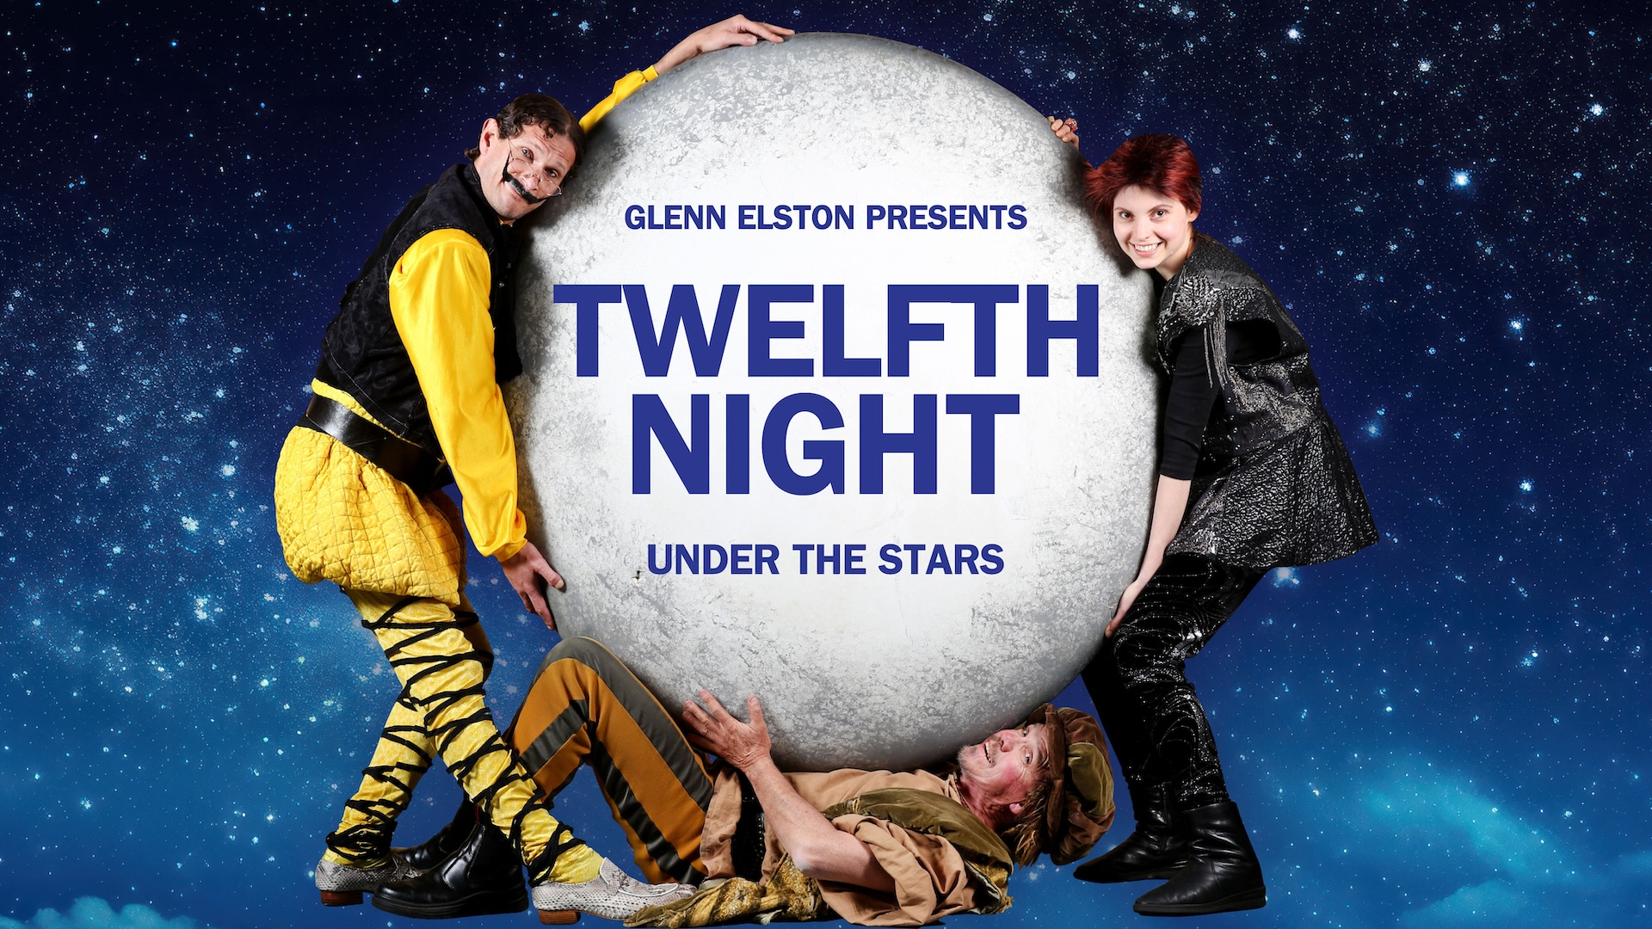

Laugh yourself silly as the Australian Shakespeare Company continues its much-heralded tradition of “Shakespeare Under the Stars at Kew Gardens” to bring one of the bard’s most beloved comedies, Twelfth Night to the grounds this summer.

A “wonderful show, built around an engine of brilliant performances” (Australian Arts Review) this production promises a night of laughter, love and lyrical mayhem for audiences of all ages.

Meet Sir Toby Belch – the man believed to have invented partying; Sir Andrew Aguecheek – dispossessed of any intelligence and naturally silly; Malvolio – a power-hungry puritan who falls from a great moral height when pushed by Sir Toby; and Maria – the housemaid who outwits Malvolio and house-trains Sir Toby. Then there’s Viola, the shipwrecked girl who cross-dresses as a boy to find work, Olivia, the grieving noblewoman who rejects one suitor only to fall for another in disguise, and Orsino, the lovesick Duke whose heart changes course when truth and identity collide.

Age recommendation: 13 years plus.

Directed by Glenn Elston with original music by Paul Norton and choreography by Sue Ellen Shook.

***
THE WIND IN THE WILLOWS
18 July – 23 August

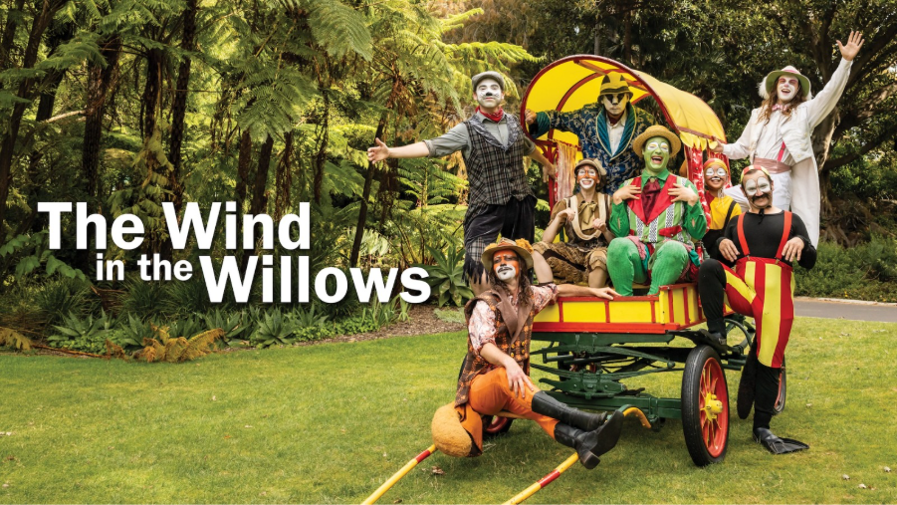

Celebrate the 40th anniversary of Glenn Elston’s critically acclaimed production of Kenneth Grahame’s classic tale of life on the riverbank, The Wind And The Willows. A favourite for all generations, this is interactive theatre at its very best.

A rollicking yet gentle adventure follows best friends Ratty, Mole, Badger, Otter and, of course, the arrogant, vain and hilarious Toad.

Set against the magical backdrop of the lake, this critically acclaimed outdoor production is filled with colourful characters, music, song and laughter.

Young audience members are invited to join the fun as the Head Chief Rabbit transforms them into rabbits with a waggle of the ears and a wiggle of the nose, before they take part in the riverbank adventure, full of laughs and surprises along the way.

Directed by Otis Elston and adapted by Glenn Elston

Suitable for all ages – from 3 to 103 years old!

***
JACK AND THE BEANSTALK
18 July – 23 August
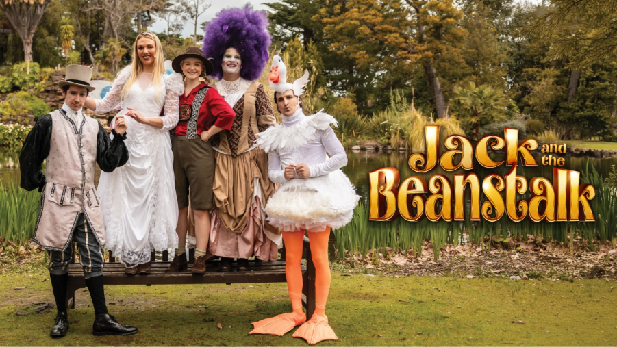

The Australian Shakespeare Company brings the legend of Glenn Elstons adaptation of Jack and the Beanstalk to Kew this summer for its UK premiere.

Presented in a relaxed picnic theatre style with all the charm of a classic pantomime, this delightfully interactive, laugh-out-loud production invites audiences of all ages to join the adventure.

Giggle at the Goose on the Loose, hunt for the Golden Eggs, meet the Fairy Godmother, enjoy the Magic Harp, sing along with Daisy the Cow, and help Jack defeat the Giant once and for all.

Directed by Dennis Manahan, adapted by Glenn Elston OAM, with original music by Paul Norton and choreography by Sue Ellen Shook.

Age recommendation: 2 and up!
___________________________________________________________________________

LISTINGS
TWELFTH NIGHT
From: 25 July – 30 August 2026
Performance Schedule: Tuesday – Sunday, 7.30pm
Press Night: Friday 31 July at 7.30pm
Run Time: 2 hours 45 mins including a 20 minutes interval.

Ticket Price: From £24.90*
*Tickets to all performances include entry into Kew Gardens

Venue: Kew Gardens, London

Assets:
Past Production Images: Available to download HERE
Sizzle Reel: Available to watch HERE

THE WIND IN THE WILLOWS
From: 18 July – 23 August 2026
Performance Schedule: Wednesday – Sunday, 11am
Wednesday, Friday and Saturday, 2.30pm
Press Night: Friday 24 July at 2.30pm
Run Time: 1 hour 30 mins

Ticket Price: From £18.90*
*Tickets to all performances include entry into Kew Gardens

Venue: Kew Gardens, London

Assets:
Past Production Images: Available to download HERE
Sizzle Reel: Available to watch HERE

JACK AND THE BEANSTALK
From: 18 July – 23 August 2026
Performance Schedule: Tuesday – Thursday and Sunday, 10.30am
Friday and Saturday, 10.30am and 2.30pm
Press Performance: Friday 24 July at 10.30am
Run Time: 1 hour 25 minutes

Ticket Price: From £18.90*
*Tickets to all performances include entry into Kew Gardens

Venue: Kew Gardens, London

Assets:
Past Production Images: Available to download HERE
Sizzle Reel: Available to watch HERE

NOTES TO EDITORS

GLENN ELSTON (DIRECTOR – TWELFTH NIGHT)
Glenn Elston OAM is a celebrated Australian theatre director and producer whose career spans more than three decades. With over 250 productions to his name, he is best known for pioneering outdoor picnic theatre in Australia and making Shakespeare and classic stories accessible to audiences of all ages.

Since founding a small performance collective in 1987 – The Australian Shakespeare Company is now grown to be Australia’s largest independent theatre company.
Glenn has created immersive, family-friendly experiences that have become beloved summer traditions. Glenn’s repertoire includes acclaimed outdoor stagings of A Midsummer Night’s Dream, Twelfth Night, Macbeth, Romeo and Juliet, and many more. He has also adapted and directed The Wind in the Willows, Alice in Wonderland, The Jungle Book – The Next Chapter, and Tinkerbell and the Dream Fairies. His productions of classics such as Wuthering Heights, The Crucible, and Lady Chatterley’s Lover further demonstrate his artistic range.

In 1990, he co-produced Hair, later directing its national tour. More than three decades later, he returned to the groundbreaking musical to direct the acclaimed 2025 Australian National Tour, introducing a new generation of audiences to the iconic rock musical.

His 2002 rock musical version of Much Ado About Nothing, created with songwriter Paul Norton, has toured extensively and played sold-out seasons.

Glenn has produced a wide range of international and Australian acts. He has collaborated with Djilpin Arts since 2003 to co-present Walking with Spirits, a major Indigenous cultural festival in the Northern Territory. In 2010, he produced Little Black Bastard which took Indigenous storytelling to the Edinburgh Festival.

Recognized with a Melbourne Award in 2014 and the Order of Australia Medal in 2018, Glenn continues to lead as Artistic Director of the Australian Shakespeare Company.

In 2026, he returns to London’s Royal Botanic Gardens, Kew, for his eighth season with three productions.

DENIS MANAHAN (DIRECTOR – JACK AND THE BEANSTALK)
Dennis Manahan is an Australian actor and director with extensive experience across theatre, film and television. His screen credits include Neighbours, Stingers, Something in the Air, and House Husbands, as well as numerous feature and short films. He starred in the title role of Nathan Loves Ricky Martin, which received an AFI/AACTA nomination for Best Short Film and won Best Film at the Peninsula Film Festival, where Dennis also received the award for Best Actor.
Dennis has been a long-standing collaborator with the Australian Shakespeare Company, performing in productions including Macbeth, Henry IV Part 1 and Alice in Wonderland. He has directed Alice in Wonderland for the company across multiple seasons both in Australia and London. Dennis is passionate about creating accessible, imaginative theatre that delights audiences of all ages.

PAUL NORTON (MUSIC)
Paul Norton began his musical career playing bass in several notable Australian bands, including The Runners, Wendy and the Rocketts, and Steve Hoy and the Hoy Boys. In 1988, he launched a successful solo career, signing with Mushroom Records. His hit single ‘Stuck On You' reached number two on the Australian charts, and a track from his album ‘Under a Southern Sky' was later selected for the Australia Day celebrations at the 2000 Sydney Olympics.

As Musical Director for the Australian Shakespeare Company, Paul has composed original scores for numerous productions, including Much Ado About Nothing, The Jungle Book – The Next Chapter, Romeo and Juliet, A Midsummer Night’s Dream, Hamlet, As You Like It, The Dream Fairies, Alice in Wonderland, Certified Male, and Barassi: The Stage Show.

SUE ELLEN SHOOK (CHOREOGRAPHY)
Sue-Ellen Shook has worked in the dance industry for over four decades. A graduate of the Victorian College of the Arts (VCA), her dynamic career spans film, television, musical theatre, and extensive freelance work both in Australia and internationally.

Her television choreography credits include House Husbands and So You Think You Can Dance. Sue-Ellen has served as resident choreographer for the Australian Shakespeare Company (ASC) for over 20 years, with additional stage credits including Motherhood the Musical and Menopause the Musical.

As a performer, Sue-Ellen’s credits are extensive and include roles in Moulin Rouge (Baz Luhrmann), Preacher (Stan), The Divorce (ABC), A Chorus Line, Starlight Express, Pan, Oklahoma (The Production Company), The Boy From Oz, 42nd Street, The Pajama Game, Sugar, and Promises, Promises. She has also performed in multiple seasons of ASC’s Tinkerbell & the Dream Fairies.

AUSTRALIAN SHAKESPEARE COMPANY
ASC began life as Shakespeare Under the Stars in 1987 under the direction of Glenn Elston, who pioneered the experience of outdoor theatre in Australia. Glenn joined the Australian Shakespeare Company in 1998 as artistic director and producer. He has since developed the company into Australia’s largest independent theatre company.

The company performs and tours everywhere from cities to remote and outback settings.

Performance spaces range from Melbourne and Sydney’s Royal Botanic Gardens to Kakadu National Park and Beswick Falls in the Northern Territory.

Although best known for performances in parks and gardens, the Australian Shakespeare
Company also creates extraordinary productions for a range of site-specific locations and is adapted for particular communities and occasions.

Under Glenn’s direction the company has grown from a group of 12 in 1987 to the largest independent theatre company in Australia.

Glenn’s productions include A Midsummer Night’s Dream, Romeo and Juliet, Twelfth Night, The Taming of the Shrew, Much Ado About Nothing, Richard III, Henry IV Pt 1, Hamlet, The Comedy of Errors, Macbeth and As You Like It.

He has written and directed for the stage: The Wind in the Willows, Alice in Wonderland, Jungle Book – The Next Chapter, Toad’s Birthday Party, Caribbean Pirate Party, Alice & Peter Pan in Never Neverland, Lady Chatterley’s Lover and a Picnic with Cole Porter.

Since 2016, Glenn has been producing and directing in London’s Royal Botanic Gardens Kew. Productions include The Wind in the Willows, Tinkerbell and The Dream Fairies, Alice in Wonderland and A Midsummer Night’s Dream.

ROYAL BOTANIC GARDENS, KEW
The Royal Botanic Gardens, Kew (RBG Kew) is a world-renowned charity and global centre for plant and fungal science, education, conservation, and horticulture. We work to tackle biodiversity loss and climate change through innovative research, our living collections and influential partnerships.

We welcome more than 2.5 million visitors each year to Kew Gardens, London’s largest UNESCO World Heritage Site, and Wakehurst, our wild botanic garden in Sussex, home to the Millennium Seed Bank. Our year-round programme of exhibitions, festivals, learning experiences and events brings our work to life, inspiring visitors of all ages to connect with and care for the natural world.

Funded through a mix of philanthropy, commercial activity, and government support, we are committed to widening access to nature and creating a thriving planet for all, powered by plants and fungi

Become a member. Book tickets. Donate. Explore more.

***

Address: Kew Gardens, London, TW9 3AE
Website: www.kew.org/kew-gardens/whats-on/theatre-on-kew

Socials:
Australian Shakespeare Company
Facebook: www.facebook.com/australianshakespearecompany
Instagram: https://www.instagram.com/shakespeareaust/
TikTok: https://www.tiktok.com/@australian.shakespeare
Twitter/X: https://x.com/shakespeareaust

Theatre on Kew
Facebook: https://www.facebook.com/theatreonkew
Instagram: https://www.instagram.com/theatreonkew/

