A FIERYLIGHT & LITTLE ANGEL THEATRE
CO-PRODUCTION OF
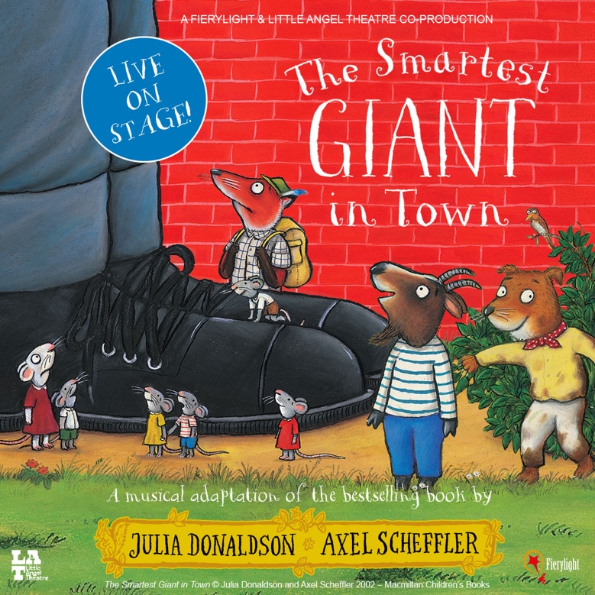

NOMINATED FOR BEST FAMILY SHOW
AT THE 2023 OLIVIER AWARDS

AND BASED ON THE BESTSELLING PICTURE BOOK BY
JULIA DONALDSON AND AXEL SCHEFFLER

ON TOUR FROM 08 OCTOBER 2024
AND HEADED BACK TO THE WEST END THIS CHRISTMAS!
AT THE ST MARTIN’S THEATRE
FROM 29 NOVEMBER 2024 – 05 JANUARY 2025

Fierylight and Little Angel Theatre’s musical adaptation of Julia Donaldson and Axel Scheffler’s classic story, The Smartest Giant in Town will tour the UK this year, starting at The Radlett Centre, Radlett on 08 October 2024 and continuing up and down the country until April 2025.

Nominated for an Olivier Award for Best Family Show in 2023, the production also completed a successful UK tour last year, where it was enjoyed by children across the country.

The Smartest Giant in Town, will return for Christmas at the St Martin’s Theatre from 29 November 2024 – 05 January 2025 where it will once again play in tandem with The Mousetrap which has run at the theatre since 1974.

Casting and additional tour date to be announced.

The Smartest Giant in Town is a heart-warming and vibrant story about friendship and helping those in need. Little Angel artistic director Samantha Lane, and award-winning musician Barb Jungr bring the bestselling book to life in this musical, puppet-filled adventure. This production previously toured during 2022, and the most recent tour ran until February 2023, with a stint in the West End last Christmas.

George wishes he wasn’t the scruffiest giant in town. So when he sees a new shop selling giant-sized clothes, he decides it’s time for a new look: smart trousers, smart shirt, stripy tie, shiny shoes. Now he’s the smartest giant in town . . . until he bumps into some animals who desperately need his help – and his clothes!

Julia Donaldson and Axel Scheffler are the UK’s leading picture book partnership. Their books together, which include modern classics The Gruffalo and The Gruffalo’s Child, are popular globally and have sold over 75 million copies worldwide. The Smartest Giant in Town was first published by Macmillan Children’s Books in 2002.
The Smartest Giant in Town has been adapted and directed for the stage by Little Angel artistic director Samantha Lane, and award-winning musician Barb Jungr, who has also composed new music for the production. Set and costumes are designed by Kate Bunce, puppets are designed by Judith Hope, with lighting design by Sherry Coenen.

NOTES TO EDITORS

JULIA DONALDSON

Julia is the author of some of the world’s best-loved children’s books, including modern classics ‘The Gruffalo’ and ‘The Gruffalo’s Child’, which together have sold over 17 million copies worldwide, and the hugely successful ‘What the Ladybird Heard’ adventures. Julia also writes fiction, including the Princess Mirror-Belle books illustrated by Lydia Monks, as well as poems, plays and songs – and her brilliant live shows are always in demand. She was Children’s Laureate 2011-13 and has been honoured with a CBE for Services to Literature. Julia and her husband Malcolm divide their time between West Sussex and Edinburgh.

AXEL SCHEFFLER

Axel is a star illustrator whose instantly recognisable, warm and witty illustrations have achieved worldwide acclaim and numerous awards. Axel is the illustrator of wonderful novelty, gift and poetry books for Macmillan, such as ‘Fish Dream of Trees’ (Two Hoots) and the bestselling ‘The Bedtime Bear’, ‘The Tickle Book’ and ‘Mother Goose’s Nursery Rhymes’ – and of course, he is the illustrator of some of the world’s best-loved picture books, including the modern classic ‘The Gruffalo’, with over 27 million books sold worldwide across the series. Axel’s artwork is exhibited internationally; he has illustrated for many charities, and designed the Royal Mail Christmas stamps in 2012. Born in Hamburg, Axel now lives with his family in London.

SAMANTHA LANE (CO-ADAPTOR AND DIRECTOR)
Samantha began her tenure as Artistic Director at Little Angel Theatre in 2015. She was formerly Director of Projects at the Almeida Theatre where she made theatre for, by and with young people aged 14-25; and Education Manager at the Queen’s Theatre, Hornchurch, where she created numerous Theatre-in-Education shows for primary and secondary schools, as well as directing community plays with casts of 60+ people. Her adaptation and directing credits at Little Angel Theatre include: The Bed, The Slightly Annoying Elephant, Me..., The Flying Bath, and The Singing Mermaid. And her writing and directing credits include: Let’s Fly, Junk, and The Pixie and the Pudding. She has also directed a number of digital shorts including Scoop’s Space, Scoop’s Space: Mr Gobble’s Garden, Clever Cakes and Mother Christmas.

BARB JUNGR (CO-ADAPTOR AND COMPOSER)

Barb Jungr is an award winning international performer, recording artist, composer and lyricist known for her ground breaking work on the songs of Jacques Brel, Bob Dylan and Leonard Cohen alongside which she has built a considerable resume of work in children’s and musical theatre. For Little Angel Theatre, Jungr co-adapted and wrote songs and music for The Singing Mermaid, co-wrote and wrote songs and music for The Pixie and the Pudding, wrote and composed songs and music for The Fabulous Flutterbys, and co-adapted and wrote songs and music for We’re Going on a Bear Hunt. She also co-wrote the original film script and wrote music for Little Angel’s 2020 Christmas short film, Mother Christmas. For Polka Theatre she adapted and wrote the music for Michael Rosen’s Chocolate Cake and How to Hide a Lion. She co-wrote the book and the songs for Liver Birds Flying Home, which ran for five weeks at Liverpool’s Royal Court Theatre in spring 2018. Jungr wrote the lyrics for Birmingham Stage Company’s Jungle Book, and for the song cycle Mabel Stark Tiger Tamer. She is currently working on several new pieces, as a lyricist for a new family musical, Maisie! and co-writing and writing the music for Dare at Polka Theatre.

KATE BUNCE (SET AND COSTUME DESIGNER)
Kate has designed over 50 shows. Companies include Royal & Derngate, Northampton; The New Vic; Almeida Young Company; Wizard Presents, The Wardrobe Ensemble; Southbank Centre; Birmingham Rep; Tutti Frutti Productions; Midlands Arts Centre; Battersea Arts Centre; Pentabus; Polka Theatre; and Kate is now thrilled to be working with Little Angel Theatre. Recent work includes The Further Adventures of the Owl and the Pussy-cat for Little Angel and Royal & Derngate, The Secret Garden for Wizard Presents and Tabby McTat for ABA Productions.
SHERRY COENEN (LIGHTING DESIGNER)
Sherry has been lighting shows in the US and UK since graduating with a BFA in Lighting Design from the University of Miami. Shows for Little Angel Theatre: The Singing Mermaid, WOW! It’s Night-time, Prince Charming, The Flying Bath, The Bed, The Pixie and the Pudding. Other shows include: Operation Mincemeat (New Diorama Theatre) *KOI nominated 2019*, Frankenstein (Battersea Arts Centre) *KOI winner 2019*.
JUDITH HOPE (PUPPET DESIGNER)
Judith Hope is a puppet designer and maker working in the UK and internationally. Her work is inspired by the strange and the curious, by folklore, fairytale and fable. Judith has created puppets for many companies, commercials and events, including Les Enfants Terribles, the RSC and the V&A Museum.
FIERYLIGHT (CO-PRODUCER)
Established in 2006 Fierylight are a market leader in the provision of live family entertainment. Based in London, Fierylight has been delighting young audiences in the UK, USA, and Australia by bringing some of the world’s most popular brands to life. Current and previous productions include seven Peppa Pig live shows, Peppa Pig: My First Concert, Teletubbies, Roald Dahl’s The BFG, Lazytown, The Octonauts, Ben & Holly’s Little Kingdom and Spongebob Squarepants.

LITTLE ANGEL THEATRE (CO-PRODUCER)

Little Angel first opened its doors on Saturday 24th November 1961 when a troupe of enthusiastic puppeteers under the leadership of John Wright found a derelict temperance hall in Islington and transformed it into a magical little theatre, specially designed for children and for the presentation of marionette shows. Now under the leadership of artistic director Samantha Lane and executive director Peta Swindall, boundary-pushing puppetry is at the heart of this unique theatre, which ignites the imaginations of the youngest minds and equips tomorrows puppeteers with the skills to become world-class artists.

As well as being an internationally recognised theatre with productions touring throughout the UK and across the globe, Little Angel has its roots in Islington and works closely with its local, diverse community on participation events and activities throughout the year, giving away thousands of tickets so all can benefit and enjoy this remarkable art form.

LISTINGS
THE SMARTEST GIANT IN TOWN
UK TOUR
08 OCTOBER 2024 – 27 APRIL 2025
ST MARTIN’S THEATRE
29 NOVEMBER 2024 – 05 JANUARY 2025

Address: St Martins Theatre, West St, London WC2H 9NZ
Box Office: 020 7836 1443

Performance schedule: For full performance schedule see: SmartestGiantOnStage.co.uk

Ticket Prices: From £10

Running Time: 55 mins (no interval)

Age Recommendation: 2 – 8 years old

Website: SmartestGiantOnStage.co.uk
Artwork: Available to download HERE
Past Production Images: Available to download HERE

Twitter @FierylightHQ / @littleangeltheatre
Instagram @fierylighthq / @littleangeltheatre
#SmartestGiantinTown

TOUR DATES 2024

08 – 09 October Radlett, The Radlett Centre

12 – 13 October Halifax, Victoria Theatre

16 – 17 October Shrewsbury, Severn Theatre

19 October High Wycombe, Wycombe Swan

26 – 27 October Winchester, Theatre Royal

30 – 31 October Aldershot, Princes Hall

01 – 03 November Bristol, Redgrave Theatre

06 November Wellingborough, Castle Theatre

09 – 10 November Milford Haven, Torch Theatre

16 – 17 November Tunbridge Wells, Trinity Theatre

29 November 2024 – 05 January 2025 London, St Martin’s Theatre

TOUR DATES 2025

31 January – 01 February Brighton, Theatre Royal

05 – 06 February York, Grand Opera House

12 – 13 February Buxton, Opera House

22 – 23 February London, Blackheath Halls

12 – 13 March St Helens, Theatre Royal

25 – 27 April Taunton, Brewhouse

More dates to be announced.
_______________________________________________________________________

PRESS CONTACT: EMMA HOLLAND PR (EHPR)
www.emmahollandpr.com

Emma Holland Didi Ralph emma@emmahollandpr.com didi@emmahollandpr.com
M: 0791 709 4203 M: 0787 289 5051


