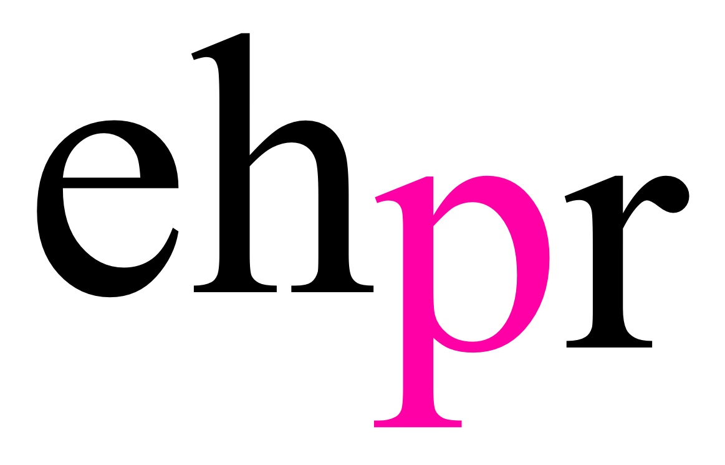
COVENT GARDEN SOLOISTS PRODUCTIONS PRESENT

THE HIGHLY ANTICIPATED WORLD PREMIERE OF

TRIOPERAS
TURANDOT, BUTTERFLY & CARMEN

PAMELA TAN-NICHOLSON’S RADICAL NEW ADAPTATION OF
THREE LEGENDARY OPERAS

OFFERING A FRESH LOOK AT THEIR FORMIDABLE
FEMALE PROTAGONISTS

OPENING AT THE PEACOCK THEATRE FROM 23 MAY – 1 JULY 2018

For the first time ever, three of the world’s most famous female-led operas have been dramatically revised with their stories told through the eyes of composer and interpreter, Pamela Tan–Nicholson, for the world premiere of TriOperas, in celebration of the 100th anniversary of the UK’s women’s suffrage, Women’s History Month and International Women’s Day on 8th March.

This radical new show, inspired by three of the best known female characters in opera, Turandot, Madam Butterfly and Carmen, opens at the Peacock Theatre on 23 May, for a limited season until 1 July, with press night on 29 May 2018.

TriOperas portrays the three women as reluctant heroines generations ahead of their time. Turandot is a cross-dressing daredevil warrior-princess, Madame Butterfly is an ambitious and proud Japanese geisha, and Carmen, the free-spirited Spanish gypsy party girl. This innovative production, which challenges conventional depictions of the female protagonists, features a glorious fusion of classical music, musical theatre, circus, martial arts and dance.

Uniquely, TriOperas has been designed for all female cast members to rotate roles in the three operas. Nine multi-talented female performers from a variety of artistic disciplines and backgrounds feature in the production – Sianna Bruce, Keedie Green, Sara Hamilton, Lucy Kay, Martina Mennell, Sarah Naudi, Shoreina Pereira, Katie Shalka and Chiarra Vinci.

Each role has a distinct emotional journey and every actor faces different artistic, dramatic and technical challenges. Cast rotation is intended to keep portrayal of each role sharp, fresh and non-routine. This is especially important in opera where musical performance drives the story and emotions are expressed in a multitude of ways. This also ties in with Tan-Nicholson’s philosophy that every woman can identify, in one way or another, with each female character in TriOperas.

In this challenging production, many of the roles are not gender-specific and male/female cast members interchange, understudy and double for each other. The performers require superb vocal skills to meet the demanding operatic repertoire, convincing dramatic authority over a range of extreme emotions, and physical discipline to perform a dazzling variety of dance and stunts.

Pamela Tan-Nicholson said, “What I have tried to achieve with TriOperas is to provoke a fresh understanding of these three eponymous women, and as well to push the boundaries of what opera is and can be for a 21st century audience – a contemporary, all-inclusive, all-action art form. Traditionally, the women in these operas are represented one-dimensionally – predictable and almost pantomime-like characterisations relying on sexist and racist stereotypes. Puccini and Bizet, male composers of the original operas, portrayed women as villains or victims, bitches or losers. In their era, men had little insight (or interest) either in women or in their unspoken emotions and ambitions behind the façade of society norms.

I am so pleased to finally announce the female cast taking on these challenging roles. The auditions were a long and grueling process, but we have certainly found the most inspiring and interesting group of performers I have come across in my career. Courage and grit mixed with femininity and grace are notions central to TriOperas’ underlying theme, and run through all three stories, and all nine women bring a unique combination of skills, which I am very excited to explore in the rehearsal process.”

TriOperas, produced by the Covent Garden Soloists (CGS), merges opera singing with punk, rap, rock and hip-hop and an incredible display of acrobatics, kung-fu, puppetry, breakdancing, tap, ballet, salsa, Chinese lion wushu and parkour. Stories are brought to life by a stellar production team, including choreographers such as Royal Ballet Principal Steven McRae, Sadler’s Wells' Breakin’ Convention Director Jonzi D, Masters Siow and Tang from Kun Seng Keng Lion and Dragon Dance Association (holders of 65 world titles and still counting), and music director Vasko Vassilev, the Royal Opera House’s concertmaster and creative producer.

In 2017, UNESCO granted official patronage to the fully staged theatrical version of TriOperas. The project encompasses a complementary onsite exhibition supported by the V&A Museum and the Royal Opera House, TriOperas – Women Power World Opera, which will be running at the Peacock Theatre during TriOperas’ run from 23 May – 1 July.

The BRIT School enjoys the support of TriOperas, which is providing opportunities for students from different Departments of Study (Music, Musical Theatre, Dance and Technical Production) to gain access to practical training in the production. Students will be working with TriOperas mentors in pre-production, curating and rehearsals leading up to the opening of the exhibition and show in May.

NOTES TO EDITORS

PAMELA TAN NICHOLSON – Pamela has composed, produced and performed all over the world in a career that has spanned four decades. She is recognised in the industry for her ability to transcend music genres, making traditional and classical music accessible to millions. Pamela was born in Singapore and has lived in London since 1983. She began staging her own plays at age 8, trained as an actress and dancer, and in her teenage years became the first person to host a bi-lingual TV series in Singapore. She also co-founded the Singapore Philharmonic Orchestra. In the 1990s, Pamela focused on motherhood and was the creative force, which powered her daughter Vanessa-Mae to international stardom. Writing her daughter’s best-selling music, Pamela also directed and produced her most successful concerts and videos including a documentary and end-title track for Disney’s Mulan. Before turning to a full-time music career, Pamela was an international lawyer in Baker and McKenzie.

Cast in alphabetical order:

SIANNA BRUCE – Sianna trained at the Liverpool Institute for Performing Arts after graduating from The Scottish School of Contemporary Dance. She combines powerful vocals with special acrobatic and aerial disciplines in her performing arsenal. She has performed with Fidget Feet Aerial Dance Theatre and Europa Studio Productions all over the Republic of Ireland, Germany and at the Perth Arts Festival in Australia. Sianna brings a whole new dimension to the physical possibilities of female character dramatization in TriOperas. She is well travelled professionally and her creativity and stage personality are richly infused with colourful cultural influences from all over the world.

KEEDIE GREEEN – Early in her career, Keedie met Tan-Nicholson, who launched Keedie’s Royal Albert Hall debut and her first experience of performing with a symphony orchestra. Since then, Keedie has gained experience over diverse styles and repertoire, touring with Aled Jones, supporting Tina Turner, Whitney Houston, Dame Shirley Bassey and Meatloaf; and performing with Girls Aloud, Boyzone, West Life and other pop bands. Keedie recorded the film theme for Mogdiliani and achieved recording success with a No.2 hit in the UK popular charts (duetting with Duncan James), along with a Christmas hit. When auditioning for TriOperas, Keedie blew the panel away with a voice that has clearly developed even beyond the high expectations of its early potential. She is the mother of two young girls.

SARA HAMILTON – Dancer and actress, Sara also trains and teaches tap, jazz and hip hop, choreographing annually for the All England National Dance Finals and World Dance Championships, with a winning tally to date of 27 medals. She is a Modern Theatre BA Honours graduate of Brunel University and worked as a choreographer/director/performer in the prestigious Arcada Theatre in Chicago before returning to the UK, where she then trained in vocals with Catherine Jenkins. Sara’s physical strength and discipline lend her great versatility to meet the demands of TriOperas crossing over from tap and hip hop into aerial acrobatics, trampolining, wushu martial arts and covering acrobatic virtuosic roles for both men and women in the cast.

LUCY KAY – Lucy trained at the Royal Conservatory of Scotland as an opera singer. Whilst at college, she learnt her craft by performing in a variety of operatic roles. Since placing second in Britain’s Got Talent, Lucy’s career has developed in other directions. Lucy released an album that went to No.1 in the classical charts and lead her to make televised appearances in concerts and on tours with the likes of Andrea Bocelli, Aled Jones and Rydian Roberts. Lucy recently played the role of The Narrator in the touring version of Joseph and the Technicolor Dreamcoat.

MARTINA MENNELL – Martina is a veteran of musicals in her native Italy and toured extensively as Scaramouche in We Will Rock You. Martina also played the lead in Heidi and in Rapunzel at the Teatro Nuovo in Milan. Television credits include 8 episodes in the role of Live Band Lead Singer in Colorado Café Live. Her wide-ranging career also includes engagements with Cirque du Soleil’s Giulio Scatola. Martina is impressively multi-lingual and is also an accomplished pole-dancer and aerialist. If that were not enough, she also plays the oboe and is a skilled seamstress and costumier.

SARAH NAUDI – Sarah grew up in Malta where she trained initially with Stagecoach before moving to London to complete her professional studies at Arts Educational School. Sarah is an accomplished actress and has impressed in films and television. As a singer Sarah demonstrates great range whether performing as Edith Piaf or when taking on different lead characters for In The Heights, a Tony award winning musical by Lin-Manuel Miranda. Sarah was nominated for Best Actress in a New Musical and is also multi-lingual.

SHOREINA PEREIRA – One of the youngest in the TriOperas cast, Shoreina is an interesting multi-threat performer. A native Australian, Shoreina has a classical background in opera and ballet, as well as a career as a television presenter. Shoreina’s theatrical range however goes beyond that and encompasses musical comedy, tap, song and dance and aerial work. All her talents will be on display in TriOperas in which she makes her West End debut.

KATIE SHALKA – Katie is a product of the Brit School, known for its pop alumni such as Adele and the late Amy Winehouse. As a child, Katie was cast at the age of 10 as Louisa Von Trapp in The Really Useful Group’s production of The Sound of Music in the West End. This has stood her in good stead and although just recently graduated from the London School of Musical Theatre, Katie already has a strong stage presence, which belies her age. Mature beyond her tender years, Katie is an arresting performer on stage and a calm presence off stage, and is also a professional make-up artist.

CHIARA VINCI – A British soprano of mixed French-Italian parentage, Chiara has made a name for herself in traditional opera circles. She was shortlisted in 2017 for Best Female Opera Singer by the Wales Theatre Awards. Chiara’s list of credits to date demonstrate the versatility of her voice which she uses to good effect in diverse repertoire ranging across Wagner’s Tannhauser, Monteverdi’s L’Incoronazione di Poppea and Donizetti’s L’Elisir d’Amore and more experimental territory such as Unsung Heroes of The Planet and Liquid History for Gestalt Arts, which premiered at Green Man and Totally Thames Festivals respectively.

TriOperas male cast members will be announced in due course.

LISTINGS

TRIOPERAS - TURANDOT, BUTTERFLY & CARMEN
PEACOCK THEATRE
23 May – 1 July 2018
CREATED & DIRECTED BY PAMELA TAN-NICHOLSON

Press Night: Tuesday 29 May 2018

Running Time: 2 hours 35 minutes (Three 35 minute acts, including two 25 minute intervals)

Performance:
Tuesday – Saturday: 7:30pm (Except Thursday 14 June)
Every Saturday: 2:30pm (and Wednesday 20 June only)
Sunday: 2:00pm and 7:00pm

Ticket Prices: From £15
Concession and group tickets available

Age Recommendation: Ages 5+

Address: Portugal Street, London, WC2A 2HT

Box Office: 020 7863 8222

Website:
www.trioperas.com
www.peacocktheatre.com

Facebook: facebook.com/trioperas

Instagram: instagram.com/trioperas

Twitter: twitter.com/trioperas
@Trioperas
@peacocktheatre

Trailer: https://we.tl/hvPY7ynozK

PRESS CONTACT: EMMA HOLLAND PR (EHPR)
W: www.emmahollandpr.com

Emma Holland Georgie Robinson

E: emma@emmahollandpr.com E: georgie@emmahollandpr.com

M: 0791 709 4203 M: 0751 211 2776

Jocasta Marron Natasha Haddad
E: jocasta@emmahollandpr.com E: assistant@emmahollandpr.com
M: 0772 517 1327

