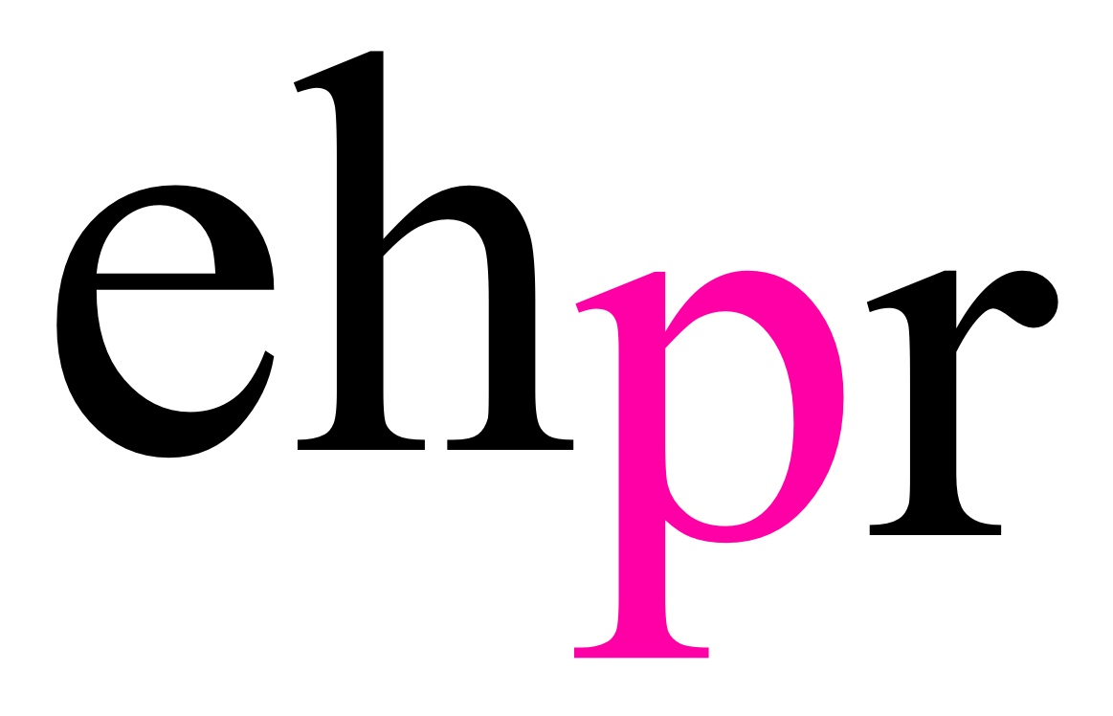

TWENTY ONE MILES BY ARRANGEMENT WITH HERVÉ PRODUCTIONS PRESENTS THE UK PREMIERE OF

VOCAL IMRESSIONIST & SINGING SENSATION
VÉRONIC DICAIRE’S CRITICALLY ACCLAIMED SHOW

VÉRONIC VOICES

OPENING AT THE HIPPODROME CASINO FOR A TWO-NIGHT SHOWCASE ON 12 & 13 MARCH 2018

ONE SINGER…FIFTY VOICES

After opening for Céline Dion to standing ovations at the O2 Arena in 2017, vocal impressionist Véronic DiCaire is bringing her smash-hit Las Vegas show Véronic Voices to London, in her first headline show in the UK at the prestigious theatre in the Hippodrome Casino on 12 and 13 March 2018.

Co-produced by Céline Dion, Véronic Voices debuted in 2013 at the world-renowned Jubilee Theater at Bally’s Las Vegas to critical acclaim, being named one of “Las Vegas’ Don’t Miss Shows” by USA Today, and winning “Best Impersonator” and “Best Singing Show” at the Best of Las Vegas Awards in 2014. Véronic has since embarked on a hugely successful world tour, performing to packed performance halls and arenas in France, Belgium, Switzerland and Quebec and finally arrives in London for the highly anticipated UK premiere.

Véronic DiCaire said, “I am thrilled to be back in London with my own show! I was so impressed with the energy of the crowd at the O2 Arena last summer when I was the support act for Céline's tour... and I promised myself to be back. Here I am!”

Céline Dion said, “Véronic has one of the greatest voices in the world. From a singer’s point of view, it’s incredible what she does. Her performance is authentic; she showcases all the love she has for these artists and strives to live up to their talent. It's a daunting task.”
One singer… Fifty Voices

Véronic Voices will transport you and your imagination to another dimension of extraordinary entertainment as talented singer-impersonator/entertainer Véronic Decaire pays tribute to the most popular female recording artists in the world, signing their songs in their voices.

Whether she’s performing as Celine or Lady Gaga, Barbra Streisand or Rihanna, Tina Turner or Katy Perry, Whitney Houston or Taylor Swift, Véronic’s amazing repertoire of voices will take you on a jaw-dropping, captivating entertainment journey like no other.

Véronic Voices is produced by Twenty One Miles by arrangement with Hervé Productions.

NOTES TO EDITORS

Véronic DiCaire

Passionate about singing from an early age, Véronic impressed the judges of the Ontario Pop singing competition when she was only 17. Then she moved into musicals, receiving ovations throughout Quebec for her portrayal of Sandy in the Quebecoise adaptation of Grease.

Her first folk-rock album, released by Warner Music Canada, earned her two nominations at the ADISQ awards in 2002 and five Trille d’Or trophies at the Franco-Ontarian music industry award ceremony in 2003. In March of the same year she returned to the world of musical theatre to play Roxie Hart in the francophone production of Chicago – The Musical opposite comedian Anthony Kavanagh (in Montreal) and Stéphane Rouseau (in Paris), having previously dubbed the singing voice of Renée Zellweger in the French version of the film.

In the spring of 2005-2006 she released her second album and went on tour, while also performing in galas, hosting her first TV show, appearing in a TV series and a theatre revue and later doing her first imitations in 2007 at the Just For Laughs Festival in Montreal and the Grand Rire Festival in Québec.

All this attracted the attention of Céline Dion and René Angélil, who invited Véronic to open for Dion during the Taking Chances Tour. Her success immediately established her as an uniquely gifted artist and allowed her to have a sold-out tour in French Canada between 2009 and 2010. In the spring of 2010, she created a new show and decided to try her luck in France, Belgium and Switzerland. After less than a year, Véronic was already a appearing on X-Factor France as a judge and wowing crowds wherever she performed!

Between June of 2013 and 2015, Véronic performed as a headliner at the Jubilee Theatre of the Bally’s Hotel & Casino in Las Vegas, which earned her Best Singer and Best Impersonator/ Successor to Danny Gans (staff pick) for the 2014 Best of Las Vegas Awards. In 2015 she also competed in Dancing With The Stars – France.

In 2017, Véronic opened for Celine Dion during her Celine Dion Live 2017 European Tour.

Twenty One Miles presents and promotes music, comedy, and arts live events from across the channel in French and English. Since it started in 2016, Twenty One Miles has produced many sold-out events at the Hippodrome Casino and other venues across London. In 2018 they will continue presenting top talent from France and now French speaking Canada.

www.twentyonemiles.co.uk

The Hippodrome Casino is the UK’s largest and most popular casino and entertainment venue. Located in Leicester Square, in the heart of the capital’s West End, The Hippodrome has three casino floors, a restaurant judged The Best Steak House in London, a 180-seat cabaret theatre, six bars and an indoor smoking terrace. It's the biggest licensed premises in the West End and has presented some of the world's biggest musical theatre, dance, comedy and rock performers. Pop legend Prince performed his final ever UK gig at The Hippodrome in 2014.

LISTINGS

VÉRONIC DICAIRE’s VÉRONIC VOICES
THE THEATRE AT THE HIPPODROME CASINO
12 – 13 March 2018

Over 18s Only – If you are lucky enough to look under 25 you must bring photo ID

Press Performances: Monday 12 & Tuesday 13 March

Performance Time: 8pm

Running Time: 2 hours plus interval

Ticket Price: From £35

Address: The Hippodrome Casino, Cranbourn Street, Leicester Square, London, WC2H 7JH

Box Office: 020 7769 8888

Website:
www.veronicdicarie.com
www.hippodromecasino.com

Facebook:
/VeronicDicaire
/TheHippodromeCasino

Twitter:
@VeronicDicaire
@hippodromeLDN

PRESS CONTACT: EMMA HOLLAND PR (EHPR)
W: www.emmahollandpr.com

Emma Holland Georgie Robinson

E: emma@emmahollandpr.com E: georgie@emmahollandpr.com

M: 0791 709 4203 M: 0751 211 2776

Jocasta Marron Natasha Haddad

E: jocasta@emmahollandpr.com E: assistant@emmahollandpr.com

M: 07725 171 327

